비이온 역마이크로에멀젼을 이용한 Y₂O₃:Eu 나노사이즈 형광체의 제조

이명한, 오성근, 이성철, 서도석*, 홍진표*
한양대학교 화학공학과, 한양대학교 물리학과*

Preparation of Eu-doped Y₂O₃ Luminescent Nanoparticles in Nonionic Reverse Microemulsions

Myung-Han Lee, Seong-Geun Oh, Sung-Chul Yi, Do-Seok Seo* and Jin-Pyo Hong*
Department of Chemical Engineering, Hanyang University
Department of Physics, Hanyang University*

INTRODUCTION
Nano-sized particles exhibit properties which differ from the bulk materials.¹⁻³ Nano-sized particles find technological applications in many different areas such as ceramics, catalysts, magnetic recording, semiconductors and superconductors. Nano-sized semiconductor, a new class of luminescent material, has been demonstrated to have changed properties such as higher quantum efficiency of photoluminescence, ultrafast recombination time and increased energy band gap for luminescence due to the tiny size of particles.^{1,4,5}
Many luminescent particles of different chemical compositions, shape and size distribution have been prepared by many different kinds of methods.⁶⁻⁸ In comparison, the synthesis of nano-sized luminescent particles in reverse microemulsion is more attractive than many other methods, in terms of being able to have homogeneous morphology and small size.
Microemulsion is defined as a thermodynamically stable and optically isotropic solution of two immiscible liquids stabilized by an interfacial film of surfactant.⁹ Surfactants reduce the interfacial tension by residing at the oil/water interface, thus stabilize dispersion of the inner phase in the continuous phase. In reverse microemulsion, aqueous phase is dispersed as microdroplets, which is usually less than 0.1μm, surrounded by a monolayer of surfactant molecules in continuous oil phase. In this case, the dispersed water droplets behave as nanoreactors for the synthesis of inorganic particles, as the surfactant monolayer provides a barrier restricting the growth of particles.
In this study, luminescent nanomaterials of europium-doped yttrium oxide (Y₂O₃:Eu) were prepared in nonionic reverse microemulsion based on an polyoxyethylene (5 mole) nonyl phenol ether (NP-5) and poly-oxyethylene (9 mole) nonyl phenol ether (NP-9) with yttrium nitrate(Y(NO₃)₃) and europium nitrate(Eu(NO₃)₃) dissolved in water droplet. With Eu-doped Y₂O₃ nanoparticles obtained, particle size, shape and photoluminescence (PL) were measured and compared with those of particles formed by bulk precipitation method.

EXPERIMENTAL
Two types of reverse microemulsion with identical composites but different aqueous phase , were first prepared separately. To form reverse microemulsion, the mixture of NP-5/NP-9 (IL CHIL CHEMICAL. CO., Korea) a weight ratio of 2:1 as surfactants, cyclohexane as continuous oil phase and salt solution as the dispersed aqueous phase were used. But aqueous phase in microemulsion Ⅰ is 0.1M yttrium nitrate hexahydrate and 0.0042M europium nitrate hexahydrate and aqueous phase in microemulsion Ⅱ is 0.5M ammonium hydroxide. The nonionic surfactants were selected because the system is less sensitive towards the variations of pH and ionic strength in the water pools of microemulsions.
Equal amounts of microemulsion Ⅰ and Ⅱwere mixed together with continuous stirring at 30ºC for 2hrs. Though the particles were formed in water droplets, they were not sedimented and the mixed microemulsions containing the particles remained transparent due to the adsorption of surfactant molecules at the oil/water interface. After reaction, the acetone was added to break the microemulsion structure and make yttrium-europium hydroxide to be sedimented. Then, sedimented particles were washed by acetone repeadedly to remove any oil and surfactant adsorbed on the surface of the particles. The washed particles was collected and dried at 90℃ for 3hrs and crushed by marble mortar. Finally, ytttrium-europium hydroxide particles were calcinated at 700, 900 ºC for 2hrs to get Eu-doped Y₂O₃ particles.
Eu-doped Y₂O₃ particles obtained by mixing of yttrium nitrate/europium nitrate solution and ammonium hydroxide solutions were compared with particles formed in reverse microemulsion.

RESULTS AND DISCUSSION
Eu-doped Y₂O₃ luminescent nanoparticles were prepared in reverse microemulsion based on nonionic surfactant mixture. Nonionic surfactants have the advantage over ionic surfactants in that they are compatible with all other types of surfactants and are generally little affected by pH and the presence of salts. However, nonionic surfactants are sensitive to temperature on the phase behavior. Thus, in this study the formation of reverse microemulsion had been affected by temperature due to the use of nonionic surfactants NP-5/NP-9 mixture. When temperature was inadequate, phase separation or phase conversion occurred. When temperature was about 30℃, microemulsion was formed and had stability.
The powder morphology of yttrium-europium oxide prepared in reverse microemulsion is shown in figure 1 (C) and (D). It shows that particles prepared in microemulsion had a narrow size distribution, spherical form and nanosize. These results were from the fact that particles were formed only in the limited space of aqueous droplets. And with the increase of calcination temperature from 700 to 900℃, particles of 9-15 nm size range grew to about 25 nm and were packed very densely, but growth of particles did not result in a change of shape. Thus, calcination temperature is the important factor for controlling the size. On the contrary, Eu-doped Y₂O₃ particles synthesized in bulk precipitation method had irregular shapes and a wide size distribution as shown in figure 1 (A) and (B). And particles were packed loosely and had a large void space.
Figure 2 shows the X-ray diffraction spectra of particles prepared in microemulsion and calcinated at different temperatures. Particles dried at 90℃ were amorphous with low degree of crystallinity and calcinated at 700℃ had crystalline structure. Particles calcinated at 900℃ had stronger XRD intensity peak than those at 700℃, indicating that the higher calcination temperature makes a better crystalline structure.
Figure 3 shows photo-luminescence (PL) emission spectrum of Y₂O₃:Eu. The excitation source used in experimental was 255 nm wavelength, and Y₂O₃:Eu particles showed prominent emission peak was about 611 nm as shown in figure 3. The better crystalline structure particles had, the stronger PL intensity particles showed in the both cases of particles prepared in microemulsion [C, D] and bulk precipitation method [A, B], respectively. Regardless of crystalline structure, PL intensity of particles formed in microemulsion was much higher than that of particles formed in bulk precipitation method. This might be resulted from the increase of packing density due to a narrow size distribution, spherical shape and small size. Lower packing densities and higher packing void cause a large amount of light to be scattered by the surface of the voids.

REFERENCES
- Bhargava, R. N. J. Luminescence , 1996, 70, 85.
- Goldburt, E. T.; Kulkarni, B.;Bhargava, R. N.; Taylor, J.; Libera, M. J.Luminescence, 1997, 72, 190
- Siegel, R. Nanostruct. Mater. 1993, 3, 1.
- Bhargava, R. N.; Gallagher, D.; Hong, X.; Nurmikko, A. Phy. Rev. Lett. 1994, 72,416.
- Bhargava, R. N.; Gallagher, D.; Welker, T. J.Luminescence, 1994, 60&61,275.
- Yong Dong Jiang; Fuli Zhang; Christopher J. Summers; Zhong Lin Wang, Appl. Phys. Lett. 1999, 74, 1677
- Rao, Ravi P. J. Electrochem. Soc. 1996, 143, 189.
- Gan, L. M.; Liu, B.; Chew, C. H.; Xu, S. J.; Chua, S. J.; Loy, G. L.; Xu, G. Q. Langmuir, 1997,13, 6427.
- MILTON M.J., In Surfactants and Interfacial Phenomena; JOHN WILEY & SONS;
New York, 1989; p322

ACKNOWLEDGMENT
M.H.LEE appreciates the financial support from CPRC at Hanyang University.
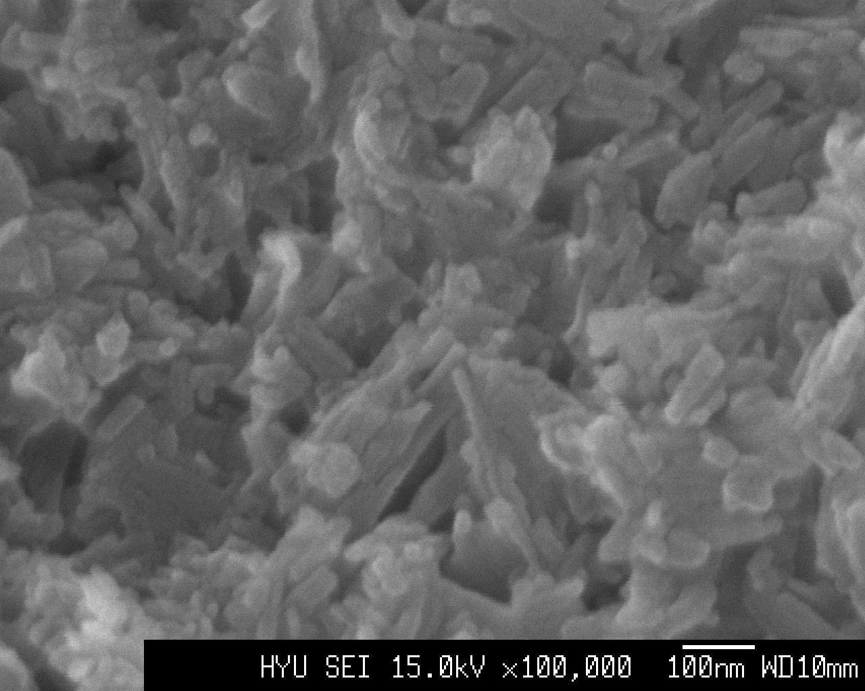
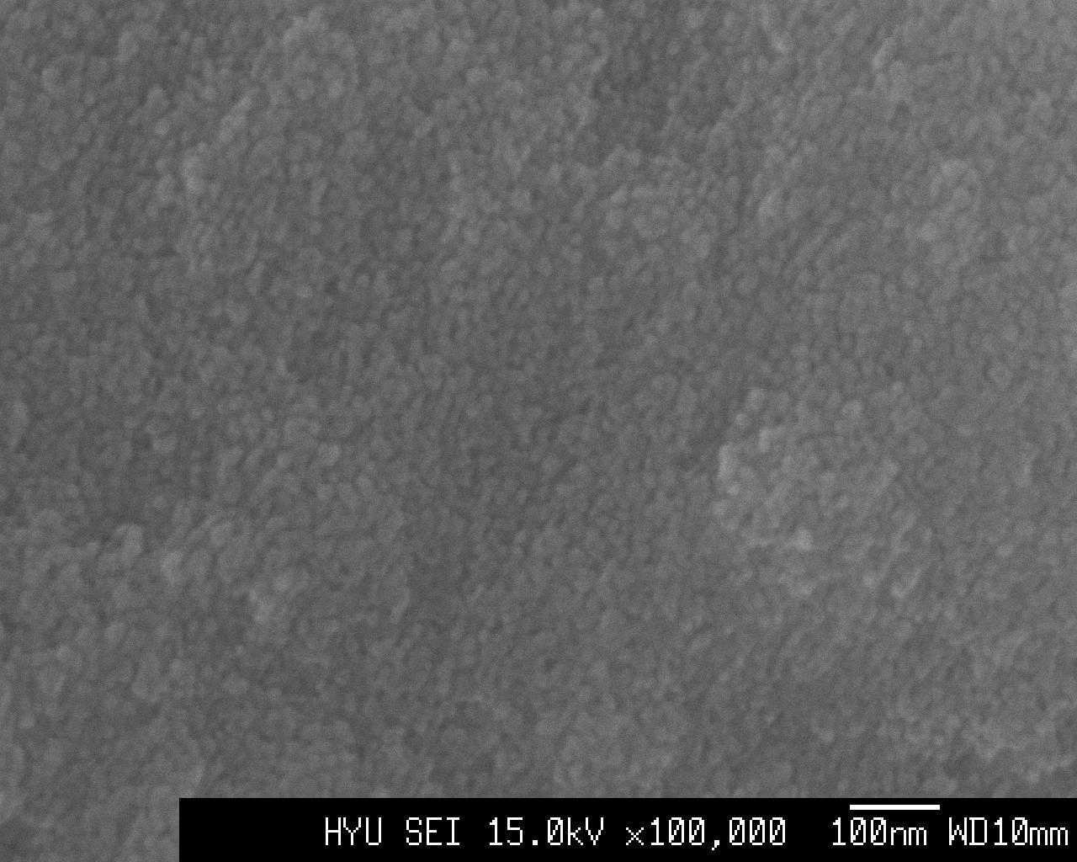
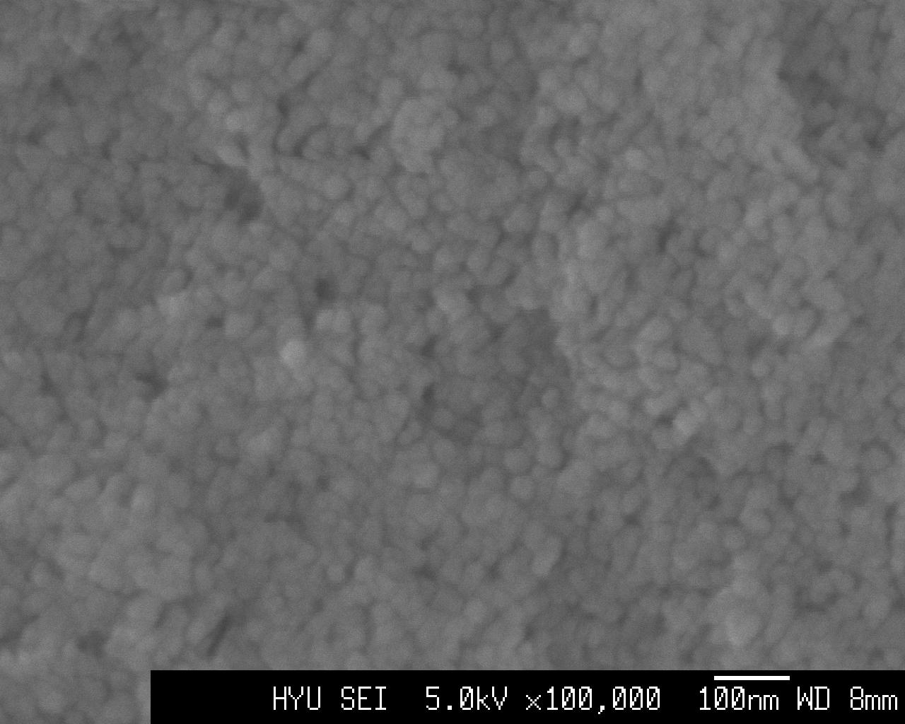
(A) (B) (C) (D)

Figure 1. SEM photographs of Y₂O₃:Eu luminescent particles. Particles formed in bulk precipitation method were calcinated at 700 ºC for (A) and 900 ºC for (B) and in reverse microemulsion were calcinated at 700 ºC for (C) and 900 ºC for (D)

Figure 2. X-ray diffraction spectra of Y₂O₃:Eu particles calcinated at different temperature. Particles obtained by precipitation from microemulsion were dried at 90 ºC for (A) and calcinated at 700 ºC for (B) and 900 ºC for (C).
Figure 3. Photoluminescence(PL) of Y₂O₃:Eu particles. Particles formed in bulk precipitation method were calcinated at (A) 700ºC and (B) 900ºC, and in reverse microemulsion were calcinated at (C) 700 ºC and (D) 900 ºC

