에어로솔 반응기를 이용한 다공성 입자의 제조

황문자, 이기라, 문준혁, 양승만
한국과학기술원 화학공학과

Preparation of ordered macroporous particles using an aerosol reactor

Moon Ja Hwang, Gi-Ra Yi, Jun Hyuk Moon, Seung Man Yang
Department of Chemical Engineering
Korea Advanced Institute of Science and Technology, Taejon 305-701

Introduction
Recently, a myrid of researches have been undertaken for the fabrication of macroporous materials. Interest in these microstructured materials stem from a wide range of their applications such as catalysts, photonic crystals and other emerging nanotechnologies [1]. Since ordered macroporous silica were produced in 1997, a variety of macroporous ceramics, metals, semiconductors, and polymers with well-defined pore sizes have been successfully synthesized by using self-assembled templates of colloidal spheres [2]. However, the structures of macroporous materials in the prior studies have been in the form of irregular shape. Although some papers reported the preparation of ordered macroporous particles that were regular shape [3], they can’t avoid the necessity of a complex chemistry process. Here we report on the one-step production of macroporous particles via aerosol reactor. Production via the use of aerosols has also been reported by Lu et al.[4] using a different precursor, i.e., a silica solution and a surfactant and F. Iskandar et al.[5] report on the production of spherical-shaped porous silica particles with nanoscale ordering porosity by means of a spray drying process. Our method relies on evaporation-induced self-assembly. Compared to the available methods that are typically time consuming, the method described here is simple and operates very fast.

Experiment
Our equipment consists of a nebulizer, temperature controlled furnace and filter (Figure 1). We prepared monodisperse polystyrene (PS) latex and which is mixed with colloidal silica (Ludox, HS-40) and titania precursor (titanium(IV) tetraisopropoxide, Aldrich) respectively. The mixture is atomized to generate droplets and the water of droplets evaporates in the furnace. And then the droplet condenses into composite particle of metal alkoxide and PS, finally PS particles are removed by excess heating.

Results
Table 1 contains the concentration ratio between PS latex and metal alkoxide in this work. Figure 2 shows representative scanning electron microscope (SEM) images of macroporous particles which is composed of silica nanoparticles. There is an optimum condition to reveal the well-ordered arrangement of pores both on the surface and inside of particle. The size of macroporous particles is 1μm on an average and pore sizes are similar to the PS latex particle sizes. It is noteworthy that although the surface covered with the pore rarely, the inside has the well-ordered pores relatively. In addition, the pore and the ordering increases with the increase in the PS concentration. However, when the PS latex is too much mixed with silica, the shape of produced particles can’t hold sphere.
During the evaporation of the droplets, there is a rearrangement of the PS particles inside the silica nanopaticles environment. So we tried to add some ethanol to the mixture to enhance the evaporation, which results in improving the arrangement of pores.
Instead of silica nanoparticles, we prepared titanium oxide macroporous particles with the sol-gel reaction. The crystal phase of titanium oxide was identified by a powder x-ray diffraction (PXRD). The sample displayed typical anatase peak, which is of practical significance as a potential application to photocatalyst. The sol was prepared using a titanium alkoxide precursor and the PS latex particles. Figure 3 shows the titanium oxide particles with well-arranged pore.

Conclusion
Ordered macroporous particles of titanium and silicon oxide were fabricated by using aerosol reactor. Compared to the available methods that are typically time consuming, the method described here is relatively simple and operates very fast. Particles in this work can be used as filter material, catalyst and photonic crystals.

Reference
[1] P.V. Braun, P. Wiltzius, Adv. Mater., 13, 482, 2001
[2] O. D. Velev, T. A. Jede, R. F. Lobo, A. M. Lenhoff, Nature, 389, 447, 1997
[3] G.-R. Yi, J. H. Moon, S.-M. Yang, Chem. Mater., 216, 2613, 2001
[4] F. Iskandar, Mikrajuddin, K. Okuyama, Nano Lett., 1, 231, 2001

Table 1. the concentration ratio between PS latex and metal alkoxide
 | HS-40 or TTIP : PS latex
Silica particle | 1 : 4 (vol. ratio)
Titania particle | 1 : 10 (weight ratio)

Fig. 1 aerosol reactor
Temperature controlled furnace

Aqueous suspension containing PS latex
and inorganic nano-sized particles

Fig 2. macroporous silica particle
Furnace
Moisture trap
hood
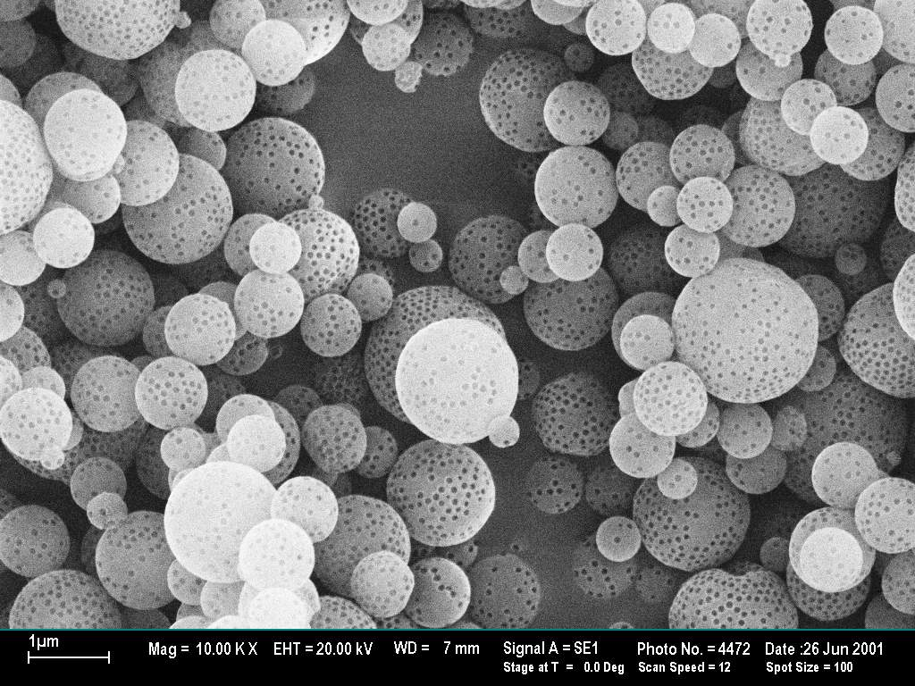

Fig 3. macroporous tiania particle
