다중루프 제어시스템의 자동동조를 위한 삼단계 비집중 릴레이 피드백법

하경호, 구도균, 이지태
경북대학교 화학공학과

Three-Step Decentralized Relay Feedback Method for Autotuning of Multiloop Control Systems

Kyung Ho Ha, Doe Gyoon Koo and Jietae Lee*
Department of Chemical Engineering, Kyungpook National University

Introduction
Relay feedback autotuning method is well established for the single-input single-output (SISO) processes^{1, 2}. Its extension to multi-input multi-output (MIMO) processes has been studied in various ways. One very successful extension is the sequential autotuning method^{3, 4}. In this method, loops are tuned sequentially by the SISO relay feedback method. However, it requires several relay tests.
Another natural extension is the decentralized relay feedback (DRF) method⁴. In this method, all loops in MIMO processes are closed at the same time by relays. Then, for usual interacting processes, stable oscillations can be obtained and multiloop PI control systems are designed by applying the Ziegler-Nichols method. However, since the oscillation periods of loops are all the same, the integral times of loops are the same and they will not be desirable for some processes. Here, a method which uses three DRF tests is proposed to remove this disadvantage of the DRF method.
Palmor et al. presented a method to determine the oscillation period and amplitude of the DRF system⁵. They used the modified Z-transformation to obtain necessary conditions for stable oscillations of DRF systems. Wang et al. presented a method to identify process models from several DRF tests by changing relay amplitudes⁶. They used the identified models to design full multivariable controllers.
To use the DRF oscillations in designing multiloop control systems effectively, the iterative continuous cycling (ICC) method by Lee et al. is incorporated⁷. The ICC method extends the trial-and-error tuning method for SISO processes⁸ to multiloop systems. It determines the proportional gains and the integral times sequentially from their ultimate values. For multiloop control systems, Lee et al. used the generalized Nyquist array method to find approximate ultimate gains⁷. Here, Steps to find the approximate ultimate gains are replaced by the DRF tests. Since no process models are required, the method can be used for autotuning of multiloop control systems.

Iterative Continuous Cycling Method
Iterative continuous cycling (ICC) method of Lee et al. is utilized to improve the decentralized relay feedback method of Loh and Vasnani⁹. The procedure of the ICC method is as follows.
Step 1) Consider a multiloop PI control system. Remove the integral actions and find the largest stable P gains of the process by the generalized Nyquist array method⁷. Set the P controller gains at the half of the largest stable gains.
Step 2) Find the smallest stable integral times for the process compensated by the above P controllers. Set the integral times at 2.5 times of the smallest stable ones.
Step 3) Find the largest stable controller gains for the process compensated by the above PI controllers. Set the controller gains at the half of the largest ones.
This design method provides excellent multiloop PI control systems for various processes. However, it requires process models and the generalized Nyquist array method to find the largest stable gains requires complex computations.

Decentralized Relay Feedback Oscillations
From relay oscillations for SISO processes, we can obtain approximate ultimate gains and ultimate periods of processes and PID controllers can be designed. When relays are placed simultaneously in multiloop systems, stable oscillations are also obtained^{6, 10}. We can extract various informations about process from these oscillations. Palmor et al. presented necessary conditions for the oscillations and obtained the exact oscillation period and amplitudes⁵. Loh and Vasnani analyzed the decentralized relay feedback (DRF) system by the describing function method and found the range of oscillation period⁹.
From the oscillation amplitudes we can obtain approximate ultimate gains⁹. Let the i-th relay amplitude be d_{i} and the oscillation amplitude of i-th loop be a_{i}. Then the gain of i-th loop which will be marginal between stable and unstable systems can be approximately
q_{i}=4d_{i}/πa_{i}
These gains information are useful for designing multiloop control systems. Oscillation periods also have information about the process but they are not as useful as the amplitude information because the oscillation periods of loops are the same.

Three-step Decentralized Relay Feedback Autotuning
We combine the ICC method and the above DRF method. The step to find the largest stable gain by the generalized Nyquist array method is replaced by the DRF method. Design procedure is as follows.
Step 1) Set C(s)=K_{c}+K_{I}/s. Let K_{I}=0 and, applying the decentralized relay feedback, obtain oscillations and approximate ultimate gains, Q=diag{q_{i}}. Set the proportional gains to half of the approximate ultimate gains, K_{c}=Q/2.
Step 2) Applying the decentralized relay to the integral terms, obtain oscillations and approximate ultimate gains. Set the integral gains, K_{I}, to the 1/3.5 times of the approximate ultimate gains.
Step 3) Applying the decentralized relay to the process G(s)(I+K_{I}K_{c}⁻¹/s), obtain oscillations and approximate ultimate gains. Set the controller gains to the 1/2.5 times of the ultimate gains.
Figure 2 illustrates the design procedure for the 2x2 processes.

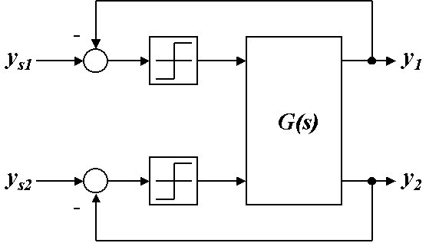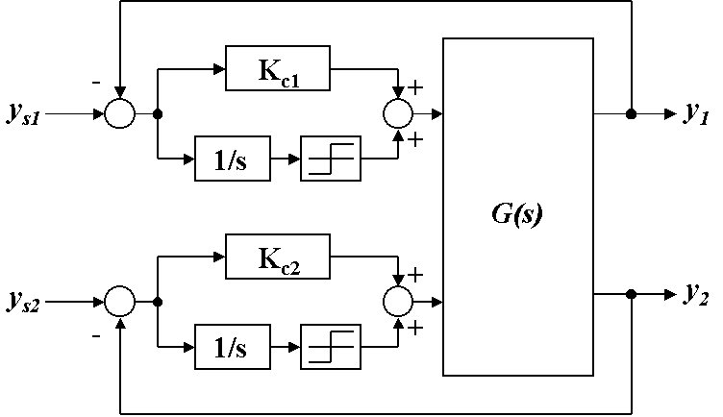
(a) (b)
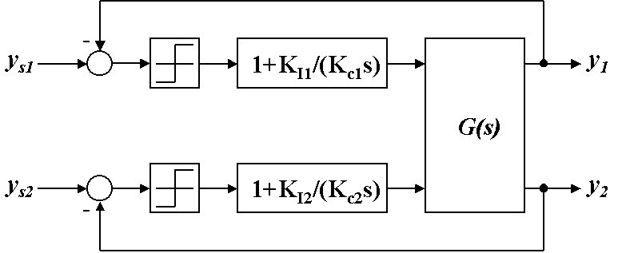
(c )
Figure 1. The three step decentralized relay feedback(3DRF) method for 2x2 processes.

The proposed method is applied to various stable processes of orders up to 4 and its performances are compared with the decentralized relay feedback (DRF) method of Loh and Vasnani⁹, the biggest log-modulus tuning (BLT) method (Luyben, 1986) and the sequential autotuning (SAT) method³. Example processes are selected from Luyben¹¹.

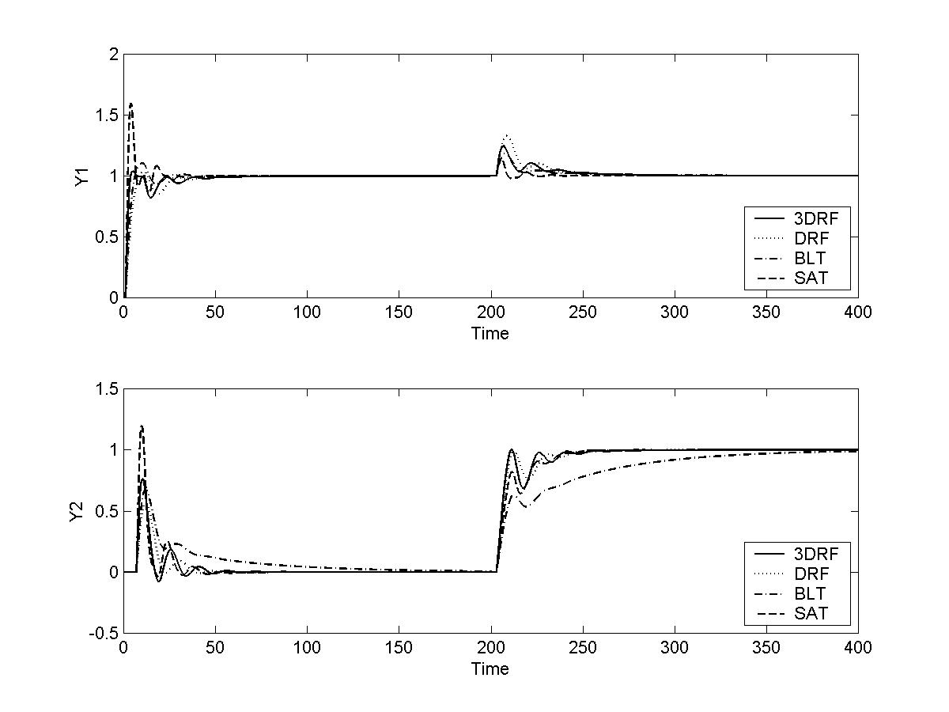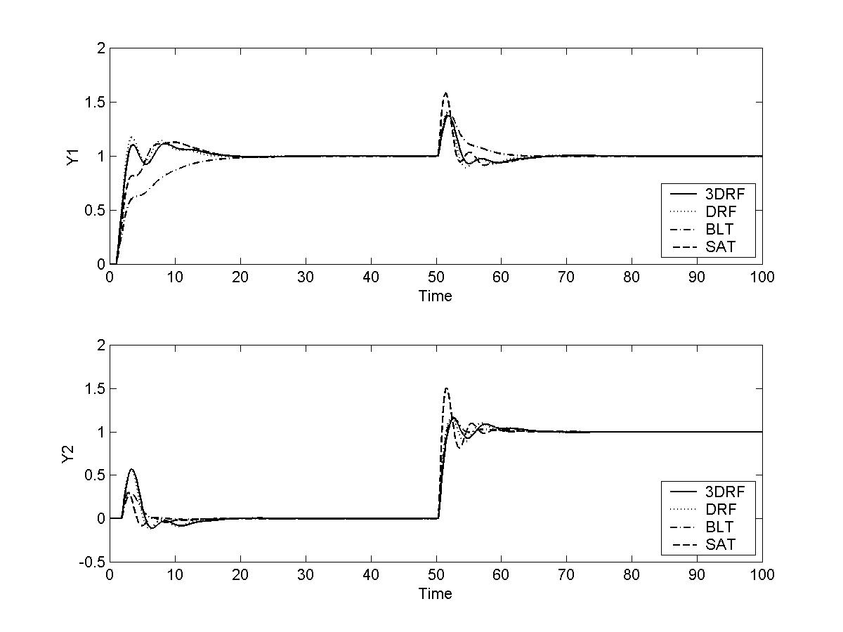
(a) (b)
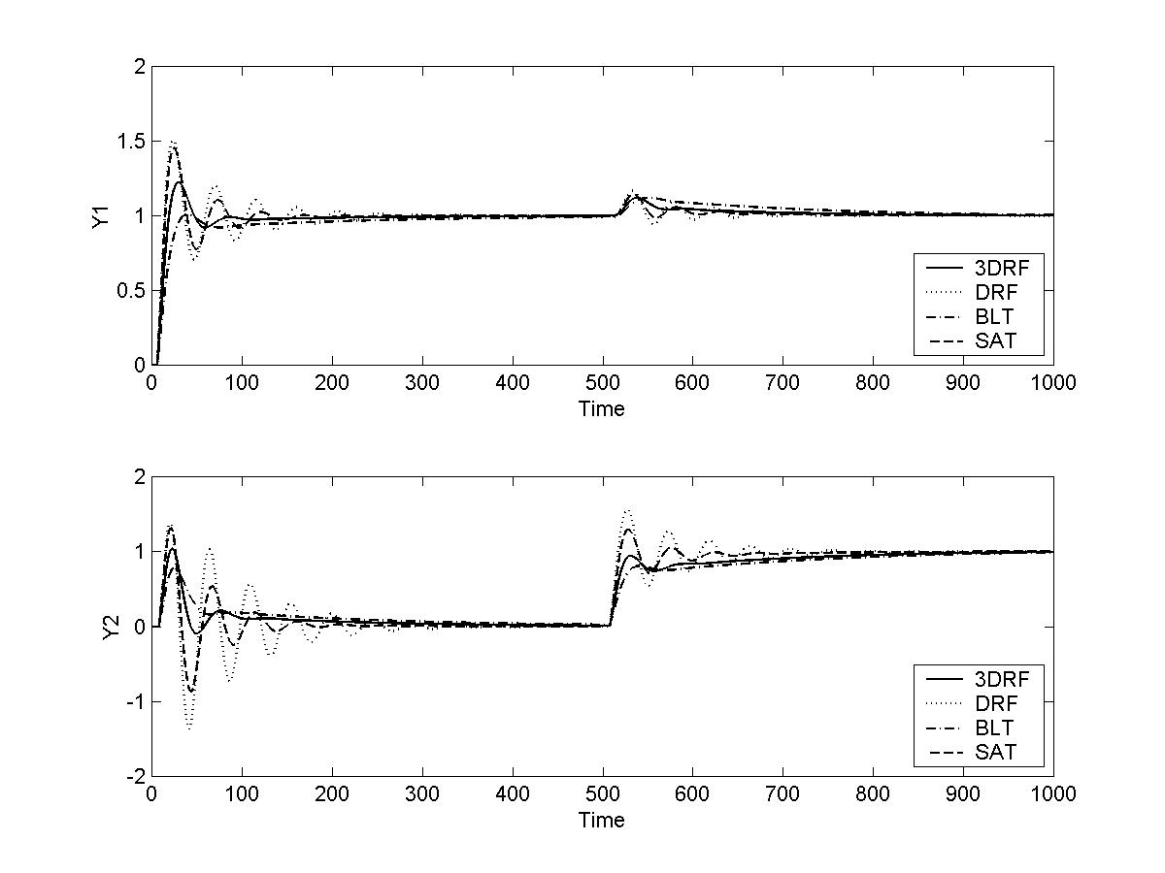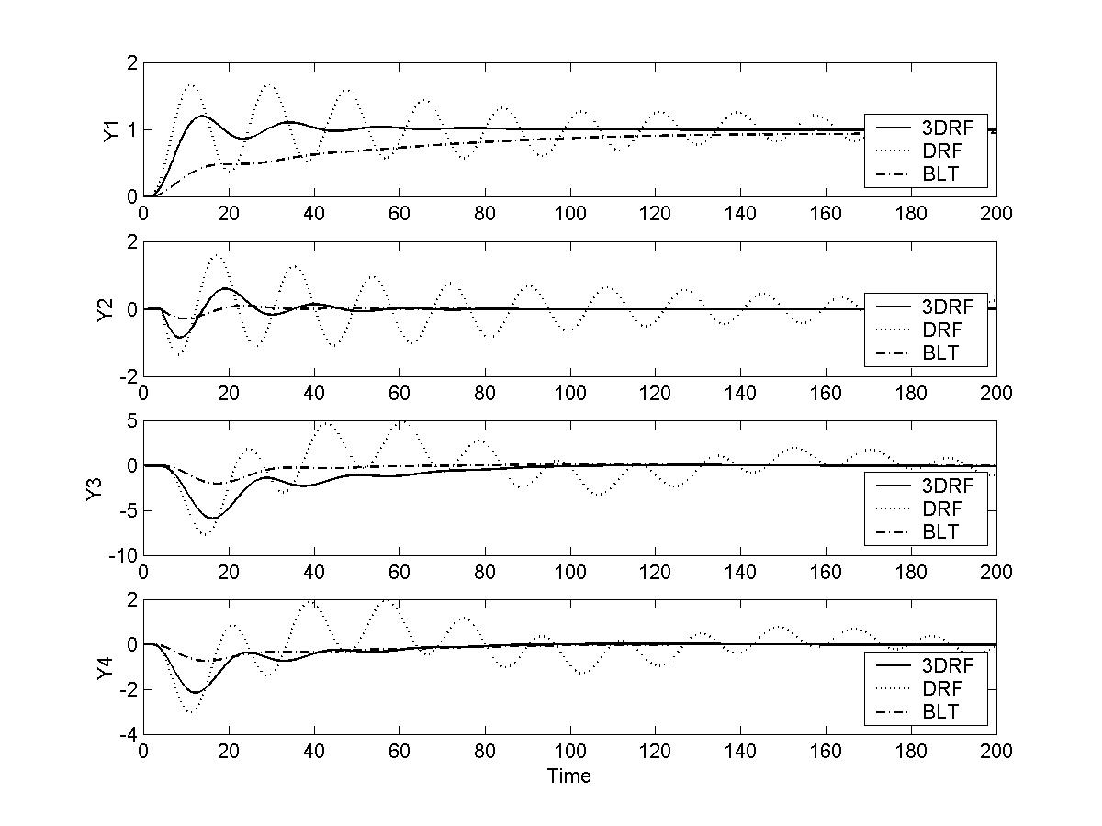
(c) (d)
Figure 2. Set point responses for various distillation column examples. (a)WB column. (b) VL column. (c) WW column. (d) A2 Column.

Conclusion
Three-step decentralized relay feedback method which combines the iterative continuous cycling (ICC) method and the decentralized relay feedback (DRF) method is proposed. The step to find the approximate ultimate gains in the ICC method is replaced by the DRF method. Simulations show that the proposed method provides multiloop PI control systems with performances comparable with well-known methods such as the biggest log-modulus tuning method and the sequential loop closing autotuning method. Since no process models are required, the method can be used for autotuning of multiloop PI control systems.

Literature Cited

1 Åström, K. J.; Hägglund, T. Automatic Tuning of Simple Regulators with Specifications on Phase and amplitude Margins. Automatica, 20, 1984, pp. 645-651.
2 Åström, K. J.; Hägglund, T. Automatic Tuning of PID Controllers, Instrument Society of America, 1988.
3 Loh, A. P.; Hang, C. C.; Quek, C. K.; Vasnani, V. U. Autotuning of Multivariable Proportional-Integral Controllers Using Relay Feedback. Ind. Eng. Chem. Research, 32, 1993, pp. 1002-1007.
4 Shen, S. H.; Yu, C. C. Use of Relay-Feedback Test for Autotuning of Multivariable Systems AIChE J., 40, 1994, pp. 627-646.
5 Palmor, Z. J. ; Y. Halevi; T. Efrati. A General and Exact Method for Determing Limit Cycles in Decentralized Relay Systems. Automatica, 31, 1995, pp. 1333-1339.
6 Wang, Q. G.; Biao Zou; Lee T. H.; Qiang Bi et al. Auto-tuning of Multivariable PID
Controllers from Decentralized Relay Feedback. Automatica, 33, 1997, pp. 319-329.
7 Lee, J.; Cho, W., Edgar, T. F., Multiloop PI controller tuning for interacting multivariable processes, Ind. Eng. Chem. Process Research, 22, 1998, pp. 1711-1723.
8 Seborg, D. E.; Edgar, T. F.; Mellichamp, D. A. Process Dynamics and Control. Prentice-Hall, N. J., 1989.
9 Loh, A. P.; Vasnani, V. U. Describing Function Matrix for Multivariable Systems and its Use in Multiloop PI Design. J. Process Control, 4, 1994, pp. 115-120.
10 Atherton, D. P. Nonlinear Control Engineering. Van Nostrand Reinhold, London, 1975.
11 Luyben, W. L. Simple Method for Tuning SISO Controllers in Multivariable Systems. Ind. Eng. Chem. Process Des. Dev., 25, 1986, pp. 654-660.

