이산화탄소 흡수를 위한 PVDF와 PTFE중공사막의 물질전달계수의 결정

연 순 화, 서 봉 국, 박 유 인, 김 민 정, 이 기 섭, 이 규 호
한국화학연구원 분리막다기능소재 연구센터

Determination of Mass Transfer Rates in PVDF and PTFE Hollow Fiber Membranes for CO₂ Absorption

Sun-Hwa Yeon, Bongkuk Sea, You-In Park ,Min Joung Kim, Ki Sub Lee and Kew-Ho Lee*
Membranes and Separation Research Center, Korea Research Institute of Chemical Technology, Taejon 305-600, Korea

1. INTRODUCTION
Many countries in the world recently agreed to reduce emissions of greenhouse gases into the atmosphere or at least to keep them at the current level at the Kyoto Conference. Carbon dioxide has been proven to be 80% of a greenhouse gas, contributing to the increase of the earth’s surface temperature. And it is reported that half of the CO₂ emissions are produced by industry and power plants using fossil fuels [1].
The amount of interfacial area in the hollow fiber modules is about 10000m²/m³, while 1000 m²/m³ is reported in that of the conventional absorbers [2]. These advantages of the hollow fiber membrane contactor have been proved through many researches. Karoor and Sirkar [3] studied the absorption of CO₂ and SO₂ from CO₂/N₂ and SO₂/air mixtures, respectively into water using a paralled flow module employing microporous polypropylene fibers.
The mass transfer rate in the membrane contactor module is limited by the mass transfer resistance in the gas, liquid phase and additional resistance introduced by the membrane itself. Although the interfacial area of the membrane is much more than conventional absorbers, the increase of its additional resistance can cause to decrease the mass transfer capacity of the membrane due to the resistance of the membrane itself, a resistance which is increased if the liquid wets the membrane. Therefore, we need to control the non-wetted condition of pores of membrane to keep the good performance of the membrane for gas absorption.
In the present study, the gas absorption accompanied by chemical reaction using hollow fiber membrane absorbers was investigated in the theoretical and experimental aspects. Numerical model for mass transfer in gas absorption was developed and the CO₂ absorption rate was simulated according to gas, liquid velocity and external mass transfer coefficient including mass transfer in gas and membrane. Using PTFE and PVDF membrane module, CO₂ removal efficiency and flux with liquid and gas velocity were experimentally investigated and overall mass transfer coefficients were calculated. Through the comparison between the experimental results and the numerical model, we predicted the external and liquid resistances in CO₂ absorption by PTFE and PVDF hollow fiber membrane.

2. THEORY
Mass transfer in chemical reaction of liquid phase
In the hollow fibers used in this study, the liquid of absorbent flow laminarly through the lumen side and the gas phase flow at the shell side in the module(Fig[1]). Firstly, the radial velocity profile v_{r} which is formed by forced convection under assuming a fully developed laminar flow in tube is described by Eq.(1)
$v_{r}=2\bar{v}\left[1−(\frac{r}{R})^{2}\right]$ (1)
Next, we can obtain Eq.(2) and Eq.(3) by establishing the differential mass balance of CO₂ and MEA in the condition of chemical reaction. Conveniently, the CO₂ and MEA are denoted as component A and B, respectively.
Component A (CO₂): $v_{r}\frac{∂C_{A}}{∂z}=D_{A}(\frac{1}{r}\frac{∂}{∂r}(r\frac{∂C_{A}}{∂r}))−k_{1}C_{A}C_{B}$ (2)
Component B (MEA): $v_{r}\frac{∂C_{B}}{∂z}=D_{B}(\frac{1}{r}\frac{∂}{∂r}(r\frac{∂C_{B}}{∂r}))−ν_{B}k_{1}C_{A}C_{B}$ (3)
The following boundary conditions for three regions are imposed on the membrane system.
At the membrane-liquid interface
Fig 1. Cylindrical coordinate system in a membrane.
Component A : $D_{A}(\frac{∂C_{A}}{∂r})=k_{\text{ex}}(C_{A,g}−C_{A,g,i})$ (4a)
where $k_{\text{ex}}=\frac{1}{\frac{1}{k_{g}}+\frac{1}{k_{m}}}$ (4b)
Component B : $(\frac{∂C_{B}}{∂r})_{r=R}=0$ (4c)
At the centerline of the tube
Component A: $(\frac{∂C_{A}}{∂z})_{r=0}=0$ (4d)
Component B: $(\frac{∂C_{B}}{∂z})_{r=0}=0$ (4e)
At z=0 : $C_{A}=0$ and $C_{B}=C_{B0}$ (4f)

The concentration profiles of component A and B are obtained numerically by using Crank-Nicholson method.

3. EXPERIMENTAL
The experimental sep-up for CO₂ removal and recovery was shown in reference[6], in which it constituted hybrid process of membrane contactor and thermal stripping column. In the case of absorber, the gas containing 25% of CO₂ (balance N₂) was passed upstream in the tube side of the membrane module and the absorbent of MEA (2-monoethanalamine) 5wt% was supplied downstream in the shell side. The membrane contactors used as CO₂ absorber in this study are the PTFE (Polytetrafluoruethylene, Sumitomo Co. Japan) and PVDF (Polyvinylidinefluoride, Krict Korea) hollow fibers. Table 1 shows the properties for each module.
Table 1. Dimension and properties of absorber modules

Fiber
Number of fiber
Packing density
Porosity (%)
Pore size (㎛)
O.D. (㎛)
I.D. (㎛)
0.4
0.64
-
70
139
70
0.03
1
1070
1913
830
1000
PVDF PTFE

4. RESULT AND DISCUSSION
The calculated concentration profile of CO₂ absorbed in liquid is presented in Fig. 2. In the direction of the diameter of one fiber, this figure shows the largest concentration gradient at the wall side of the fiber. This means that the gas-liquid mass transfer at membrane interface is conducted mostly at the wall side of the fiber in which the numerous pores exists. In the direction of the fiber length, the absorbed CO₂ concentration is steeply increased at up side of fiber and then slightly increased along down side direction in the fiber’s wall. This initial sudden behavior results from the active mass transfer between the fresh liquid and gas phase coming into the fiber’s entrance.
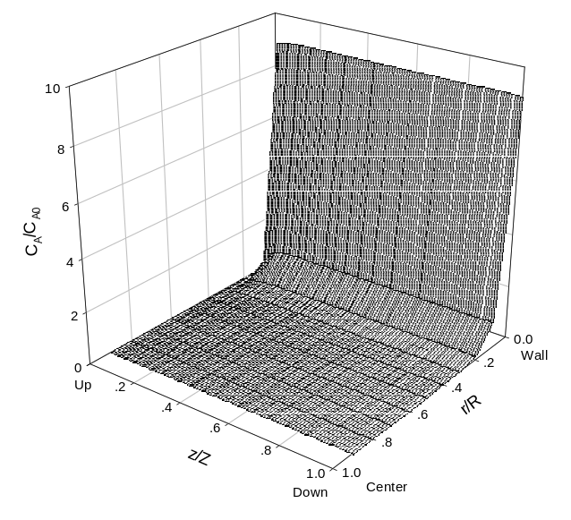
It is expected that the PTFE membrane possessing relatively large pore size decrease the CO2 absorption flux by increasing the membrane resistance. It could be proven by observing the phenomena that the absorbent easily penetrates into gas phase in the absorption test using PTFE membrane contactor. Hence, we have to control not only the hydrophobic state of membrane but also membrane pore size in order to form the stable interface between gas and liquid phase
Fig 2. Absorbed CO2 concentration profile in a hollow fiber.

Fig. 3 showed the comparison of numerical and experimental fluxes in PVDF and PTFE membrane as a function of liquid velocity. When the numerical external mass transfer coefficients are 0.001m/s in PVDF and 0.0005 m/s in PTFE, respectively, the results of numerical and experimental fluxes are well agreed. As previously stated, in the numerical result the PTFE membrane had the lower mass transfer coefficient than the PVDF membrane. Finally, If we define the sum of membrane and gas phase resistance as external resistance, 1/k_{ex}, the liquid phase resistances can be obtained through the numerical external resistance and experimental overall mass transfer resistance on these two membranes.
Fig 4. The flux comparison of PTFE and PVDF membranes
as a function of liquid velocity.

Fig 3. The flux comparison of PTFE and PVDF membranes
as a function of liquid velocity.

5.REFERENCES
1. Desideri U., Paolucci A., Energy Conversion & Management, 40 ,1899-1915,(1999)
2. Deshmukh S.P., Li K., J. Membrane Sci., 150, 75-85, (1998)
3. Karoor S. Sirkar K.K., Ind. Eng. Chem. Res., 32, 674-684,(1993)
4. Qi Z, Cussler E.L., J. Membrane Sci., 23, 321-332,(1985)
5. Qi Z. Cussler E.L., J. Membrane Sci., 23, 333-345. (1985)
6. S. H. Yeon, B. K.Sea, K.S. Lee, Y. I. Park, K.H. Lee, Theories and Applications of Chem. Eng., Vol.7, No.2 (2001)

