웹 기반 공정제어 training 도구

윤좌문¹, 이기홍¹, S. Rohani² , 이문용^{*1}
영남대학교¹, University of Western Ontario, Canada²
mynlee@yu.ac.kr

Web-based process control training tool kit

C.M. Yun¹, K.H. Lee¹, S. Rohani², M.Y. Lee^{*1}
Yeungnam University¹, University of Western Ontario, Canada²
mynlee@yu.ac.kr

Introduction
The conventional approach to process control education of operators and students has been to practice the materials of process control that were developed as non-internet-based programming. Current rapidly changing education and information environment makes it evident that the way process control is taught to process control operators and students needs to be updated to one more flexible and more convenient.
Professionals and educators increasingly connect to the internet, through internet browsers such as Microsoft Internet Explorer and Netscape Navigator, to access resources, to share information, to schedule meeting, and leave message. Using Java, a web-based programming language, people can now customise and interact with web-based computer programs as they would with traditional, non-internet-based programs, In particular, Java allows website designers to incorporate interactively the training of the process control, enhancing the site for targeted audiences as well as other interested users. Thus, the web-based interface permits one to operate the training of the process control from anywhere an adequate internet connection is available.

The Main Subject

(1) Applications
The web-based process control training tool kit can be used as a support tool for process control courses and a training tool for process control practitioners on the internet. It can be used for classroom demonstrations, for providing realistic hands-on laboratory exercise or for self study demonstrations.
(2) Program Architecture
The program architecture of the web-based process control training tool was implemented on the Java program language, as schematically shown in Fig. 1. The language has enormous appeal for many reasons. One major reason is that it largely platforms independently, which means that an application written for one computer is very likely to run unchanged on another computer. Thus, an engineer can write a single application that will execute across all of company’s computers. This
JAVA
JAVA Script
JDK 1.3
Data Interaction
Html
IIS
HTTP
JAVA Applet
Compile
Fig. 1. Implementation of Program Architecture.

“write once, run anywhere” philosophy means that an organization is not looked into a single type of computer hardware. Most advantage of Java is that it is possible to create applets that can be exchanged and executed freely across the internet. This adds enormous appeal in today’s interconnected world.
(3) Process Model
Process model mathematically defines the algebraic and dynamic equations which represent the physical phenomena of a actual process; it may include only steady state terms or both steady state and dynamic terms. In the developed tool kit, a process model can be modified as parameters of a transfer function using Select Parameters and Change Parameters menu. The process model can be also changed using Select Model choice bar. When a new process model is retrieved, or whenever there is a change in control strategy, the process model is initialized to a steady state value. To do so, select Process Select Model Tab from the Menu panel, then “Initialize Model.”
FOLPDT - A pure first order lag plus dead time model consists of a first order lag, followed by dead time. A linear FOLPDT model might be just too simple to describe the higher order, time varying and nonlinear behaviours of the real world. Though only an approximation, and for some processes a very rough approximation, the value of the FOLPDT model is that it captures those essential feature of dynamic process behaviour that are fundamental to control. When forced by a change in the controller output, a FOLPDT model reasonably describes the direction, how far, how fast and with much delay the measured process variable will respond. Compatible with Feedback control strategy, including measurement noise.

Fig. 2. Example of Transfer Function Diagram for FOLPDT Process Model

GENERIC - A generic linear process model which is compatible with all control strategies. The process variable and load ranges are in the English system of engineering units. The engineering unit designations and the controller name are indicative of a temperature process. It has a number of parameters which can be changed from the web-based process control tool kit, including activation of measurement noise.
Fig. 3. Example of Transfer Function Diagram for GENERIC Process Model
(4)Tool Kit GUI Design
The main graphical user interface presents a realistic, interactive human interface, similar to that found in actual control rooms for chemical, refining, power generation and other types of operating plants. The user interface replicates real control elements, including a instrument faceplates, a multi-trace strip chart recorder and various command buttons for making mode (auto/manual) and set point changes, accessing tunning parameters, etc.
Multi-trace strip chart recorder
Instrument faceplate
PID Tuning parameters
Operating data changes
Tab menu panel

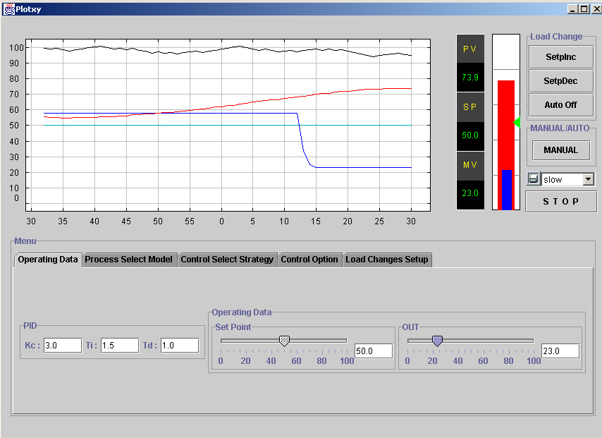

Fig. 4. Main Graphical User Interface of the Web-Based Training Tool Kit

(5) Process Control Strategy
Process control strategy is a philosophy of control implemented by a configuration of control components. The developed tool kit provides control strategy of Feedback, Feedforward and Cascade. The Feedback control strategy was included a choice controller Type (Non-interacting PID, Interacting PID, Proportional Only, Integral Only, Parallel PID) and measurement option.(Noise filter, Measurement open, Ramp input enable)
FEEDBACK – The principle of feedback is one of the most intuitive concepts known. An action is taken, more than likely to correct a less-than-satisfactory situation; then the results of the action are evaluated. If the situation is not corrected, then further action may be warranted. The feedback control strategy uses one feedback controller for control of a single process variable. Load changes can be introduced manually or automatically.
FEEDFORWARD – Feedforward control is a form of control in which the control action is based upon a measurement of the process disturbance, rather than a deviation between set point and process variable. The feedback & feedforward control strategy utilizes a primary and a secondary controller. The primary controller contains both a feedback and a feedforward section, so that the primary controller output is the combined output from both sections. Each section can be turned on or off independently. The feedforward controller provides tuning parameters for adjustment of the steady state gain plus dynamic compensation terms of lead, lag and dead time.
CASCADE – A control configuration in which one feedback of the primary controller sets the set point of a lower level feedback of the secondary controller. The objective is to prevent load changes to the secondary control loop from affecting the primary process variable. The cascade control strategy uses a secondary controller for control of a fast inner loop and a primary controller for control of a slower outer loop.
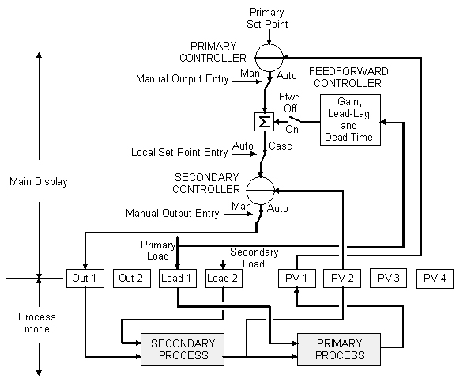
Fig. 5. Function Block of Feedback & Feedforward Control Strategy
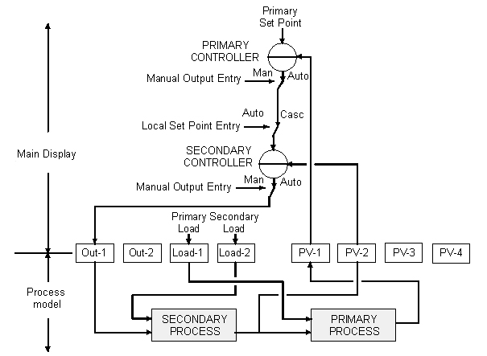
Fig . 6. Function Block of Cascade Control Strategy

Conclusion
A web-based process control training tool kit was developed to be flexible and multi-purpose software useful to web based training and simulation of process control systems. User interface replicates almost real control elements for operator training. Extensive set of options permits establishing a real-world environment by choice of controller options, process characteristics, non-linearities, measurement noise, and a variety of process upset conditions. The web-based tool kit permits one to operate the training of the process control from anywhere an adequate internet connection is available.

Acknowledgement
This work was supported by Korea Research Foundation Grant. (KRF-2001-041-200309)

References
Pradeep B. Deshpande, Raymond H. Ash. Computer Process Control With Advanced Control Applications. Instrument Society of America (1988)
Harold L. Wade. Regulatory and Advanced Regulatory Control : System Development. Instrument Society of America (1994)
PC-ControLab 2 and Builder-Process Control Loop Simulation and Training Program. Wade Associates (1998)
Doug Cooper, Danielle Dougherty, Enhancing Process Control Education with the Control Station Training Simulator. Comput. Appl. Educ., 7, 203-212 (1999).

