균일계 공비증류 시스템에서의 분기현상

이 문용, Cornelius Dorn*, and Manfred Morari*
영남대학교 화학공학부, 경북 경산시 대동 214-1, 712-749
*스위스 연방공대 자동제어 연구실, 쮸리히 CH-8092

Bifurcation Behavior of Homogeneous Azeotropic Distillation Systems

Moonyong Lee, Cornelius Dorn*, and Manfred Morari*
School of Chemical Engineering and Technology, Yeungnam University
214-1, Kyongsan 712-749, KOREA
*Automatic Control Laboratory, ETH-Z, Swiss Federal Institute of Technology
CH-8092 Zurich, Switzerland

INTRODUCTION
Azeotropic distillation is one of the most widely used and important separation processes in the chemical and the specialty chemical industries. Since their understanding is a necessary prerequisite for proper column design and operation, the steady state and dynamic behavior of azeotropic distillation has been studied extensively over the past decades (Laroche et al., 1992). In particular, multiplicity of steady states has been a subject of much recent research interest and verified experimentally (Bekiaris et al., 1993; Guttinger et al., 1997). In addition to multiple steady states, another well known phenomenon which nonlinear systems are likely to exhibit is branching to periodic solutions which accompany sustained oscillations (limit cycles). However, in spite of significant nonlinearities in the distillation models, all the solutions discovered so far are stationary. Until now, no periodic solution has been associated with any class of open-loop column models while it has been well recognized in the chemical reactor literature for several decades. The evidence of other behavior such as underdamped oscillation has also been rare whereas it commonly occurs in other nonlinear systems. In light of these discussions, it is natural to ask whether open-loop distillation is able to exhibit periodic solutions (Hopf-bifurcation). In this paper, the presence of periodic solutions in an open-loop distillation model is first demonstrated. We also investigate the bifurcation behavior of homogeneous azeotropic distillation columns.
BIFURCATION BEHAVIOR
Three 001 class ternary mixtures (methanol-methylbutyrate-toluene; acetone-heptane-benzen; methanol-benzen-butyraldehyde) are chosen for simulation study. Based on the constant molar overflow (CMO) model, dimensionless variables and parameters are defined for bifurcation analysis. For the dynamic simulations, the CMO model is integrated using DDASSL (Stewart et al., 1995). Further, AUTO (Doedel and Wang, 1994) is used for a steady-state bifurcation analysis of the CMO model.
Figure 1 shows an example of bifurcation diagram for methanol-methylbutyrate-toluene mixture system. For the bifurcation diagram, the weighted average temperature of all trays, the reboiler, and the condenser is chosen as a scalar index for the state variables of the column: T^{avg} = (ΣT^{j}M^{j})/(ΣM^{j}).
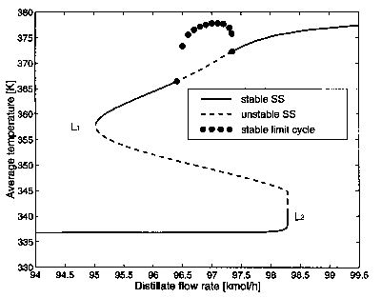
Figure 1. Steady state bifurcation showing the average temperature in the column.

In Figure 1, one can see two turning points(L₁ and L₂) which accompany multiple solutions. This type of bifurcation is well recognized in distillation. An interesting new type of bifurcation observed here is the Hopf-bifurcation. The upper branch bifurcates to limit cycles for D/F ∈ (0.9641, 0.9735). The limit cycles are plotted as solid dots in Figure 1. The distance of the dots from the steady state branch depicts half of the difference between the maximum and minimum average temperatures during the sustained oscillation and thus indicates the size of the limit cycle. The qualitatively different kinds of dynamic behaviors caused by the existence of one or three steady states which can be stable or unstable nodes, saddles, foci etc. are illustrated with dynamic simulations. For selected values of the bifurcation parameter, nonlinear dynamic simulations were carried out starting from different unsteady initial conditions. The average liquid composition in the column x_{c}^{avg} = (Σx_{c}^{j}M^{j})/(ΣM^{j}) is plotted in the composition space in Figure 2.
For values of D/F to the left of the turning point L₁, only a single stable steady state exists. Figure 2.a shows selected phase plan trajectories in this case. The column has a single stable node. In the region corresponding to Figure 2.b, three steady states exist: those on the low and high branches are stable and those on the intermediate branch are unstable. The trajectories converge to either the stable node or the stable focus as seen in the figure. An interesting observation is the appearance of the focus corresponding to the stable steady state on the high branch which has been rarely observed in open-loop distillation.
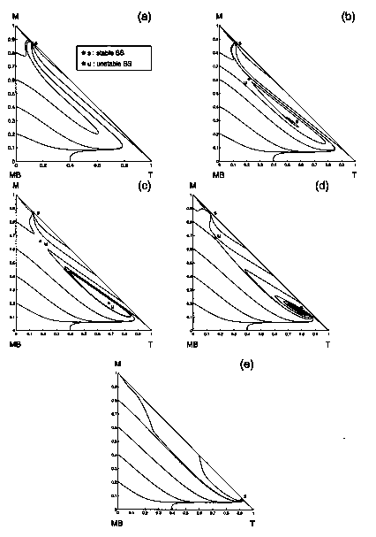
Figure 2. Phase diagrams of the average liquid composition in the column.
D/F are (a) 0.945, (b) 0.962, (c) 0.97, (d) 0.974, (e) 0.99, respectively.

In the region corresponding to Figure 2.c, branching to periodic solutions occurs, the steady state on the high branch becomes unstable and a limit cycle grows around it. Therefore, two types of attractors exist: a stable node and a stable limit cycle. In the region corresponding to Figure 2.d, the limit cycle disappears and the steady state on the high branch is stable again. Thre steady states exist: one stable node, one saddle, and one stable focus. Finally as D/F is increased still further, past light turning point L₂ , only one stable steady state exists on the high branch in the form of stable node.
In addition to the result mentioned above, the system showed more complicate bifurcation phenomena under some combination of parameters in the main parameter space. The solution criteria for Jacobian matrix of the model divide a parameter space into several region, each of which is distinguished by qualitatively different dynamic behavior. It is observed that all the mixture systems tested have qualitatively same bifurcation patterns in the parameter space.
The effect of main operation parameters on the bifurcation behavior is also investigated. The emphasis is on the prediction of plausibility and location of oscillation behavior from column internal profile pattern. It is qualitatively explained using the characteristics of pinch and inflection zone. We also confirm that the bifurcation behavior from the simple CMO model carries over to more realistic model including energy balance, liquid hold-up hydraulics and inventory control.

CONCLUSIONS
In this paper, we study the dynamic behavior of a ternary homogeneous azeotropic distillation systems. Our computations reveal several interesting nonlinear phenomena including a Hopf-bifurcation not reported in previous studies of distillation. The system shows complicate bifurcation behaviors with some consistent pattern through all mixtures tested. These behaviors could be classified and predicted by performing the bifurcation analysis in the main parameter space. Incorporating more sophisticated modeling does not change the bifurcation nature of the system qualitatively. The plausibility and location of the oscillation is predicted from the column internal profile of the entrainer.
Acknowledgment
Financial support from KOSEF through the Automation Research Center at POSTECH is gratefully acknowledged.
References
- Bekiaris, N.; Meski, G.A.; Radu. C.M.; Morari. M. Multiple Steady States in Homogeneous Azeotropic Distillation. Ind. Eng. Chem. Res.. 1993, 32(9), 2023.
2. Doedel, E.J. and Wang, X. AUTO94: Software for Continuation and Bifurcation Problems in Ordinary Differential Equations, Computer Science Department of Concordia University, Montreal, Canada. 1994
3. Guttinger, T.E.; Dorn, C.; Morari, M. Experimental Study of Multiple Steady States in Homogeneous Azeotropic Distillation, Ind. Eng. Chem. Res.. 1997, 36(3), 794
4. Laroche, L.; Bekiaris, N.; Andersen, H.W.; Morari. M. The Curious Behavior of Homogeneous Azeotropic Distillation. AIChE J., 1992, 38(9), 1309.
5. Stewart. W.E.; Caracotsios, M.; Sorensen, J.P. DDASSAC Software Package Documentation, University of Wisconsin, Madison, WI53706, USA, 1995.

