Lennard-Jones 사슬 유체의 분자 동력학 모사와 상태 방정식

장 재 언, 김 화 용
서울대학교 화학공학과

Molecular Dynamics Simulation and Equation of State
of Lennard-Jones Chain Fluids

Jaeeon Chang and Hwayong Kim
Department of Chemical Engineering, Seoul National University

Introduction
During the last decade, there has been a considerable interest in developing molecularly based equations of states for chain molecules and polymers. These include generalized Flory-Dimer (GF-D) theory [Honnell and Hall, 1989] and thermodynamic perturbation theory (TPT) [Wertheim, 1987]. The essential feature of the TPT theory is that the Helmholtz energy of chain fluids can be approximated in first order (TPT1) by the Helmholtz energy and the pair correlation function of the reference fluid which is composed of nonbonded monomers. Extension of the TPT theory to more realistic chain models has been recently studied including the TPT-D theory for hard-sphere and square-well chains [Chang and Sandler, 1994; Tavares et al., 1995], the TPT1 theory for the Lennard-Jones (LJ) chains [Johnson et al., 1994]. In the present work we provide molecular dynamics simulation results for freely jointed LJ chains, and test the accuracy of equations of state obtained from the TPT1 theory. In order to get the thermodynamic and structural properties of the reference fluid (LJ spheres), we use the Week-Chandler-Anderson (WCA) perturbation theory [Weeks et al., 1971] and the Ornstein-Zernike equation with the Percus-Yevick approximation. The compressibility factor of LJ chain fluids calculated through the TPT1 theory is compared to computer simulation results, and the validity and accuracy of approximations in the theory are examined.

Theory
We consider two chain models, ‘full’ and ‘repulsive’ LJ chains. In the ‘full’ LJ chains the intermolecular and nonbonded intramolecular segments interact with each other by the LJ potential
$u_{\text{ref}}^{\text{LJ}}\left(r\right) = 4ε \left[{\left(\frac{σ}{r}\right)}^{\text{12}} − {\left(\frac{σ}{r}\right)}^{6}\right]$ (1)
where σ and ε are size and energy parameters of the LJ potential, respectively. In the ‘repulsive’ LJ chains segments interacts with each other by ‘repulsive’ LJ potential given as
$u_{\text{ref}}^{\text{RLJ}}\left(r\right) = \begin{aligned}\left\{ u_{\text{ref}}^{\text{LJ}}\left(r\right) + ε ,r < 2^{1/6} σ | \right.\end{aligned}$ (2)
In the present work we consider the case that chains are constructed such that bond distance is fixed and equal to the size parameter, $l = σ$, and that there is no bond angle restriction.
The TPT1 theory gives in first order the Helmholtz energy of the chain fluid of length m [Wertheim, 1987; Chapman et al., 1988] by
$A_{c}^{r} = A_{\text{ref}}^{r} − N \left( m − 1 \right) k_{B}T \text{ln}y_{\text{ref}}\left(l\right)$ (3)
where $A_{c}^{r}$ and $A_{\text{ref}}^{r}$ are the residual Helmholtz energies of the chain and monomer reference fluid, respectively, with respect to those of the ideal gases at the same temperature and density, N is the number of chain molecules, $k_{B}$ is the Boltzmann constant, and $y_{\text{ref}}\left(l\right)$ is the pair cavity correlation function of the reference fluid at bond distance l. Notice that for the LJ spheres the value of the cavity correlation function at $r=σ$ is simply equal to that of radial distribution function (RDF), i.e., $y_{\text{ref}}\left(σ\right)=g_{\text{ref}}\left(σ\right)$. The last term of Eq. (3) represents free energy change of polymerization at fixed temperature and volume, and it can be simply interpreted as the total number of bonds in N chains times the free energy of forming a single bond in the reference fluid [Chang and Sandler, 1994]. From the differentiation of the Helmholtz energy with respect to volume, the compressibility factor of chain fluid $Z_{c}$ is given by
$Z_{c} = m Z_{\text{ref}} − \left(m−1\right) \left[ 1 + ρ \frac{∂ \text{ln}y_{\text{ref}}\left(l\right)}{∂ ρ} \right]$ (4)
where $Z_{c} = p/ρ_{c}kT$, p is the pressure, $ρ_{c}$ is the number density of chains, $Z_{\text{ref}}$ is the compressibility of the reference system, and ρ is the number density of monomers.

Simulation
Molecular dynamics simulations are performed for repulsive and full LJ freely jointed chains in order to calculate the thermodynamics properties. Unlike simple fluids, chain molecules have many internal degrees of freedom associated with fast vibrational and moderate rotational motions. In this simulation the high frequency vibrational motions are frozen at their equilibrium bond distances because they have little effect on the thermodynamic properties.
In order to predict the time evolution of chains with fixed bond distance, we use method of constraint dynamics in cartesian coordinates. In this study, we used the rattle [Andersen, 1983] algorithm combined with Nose-Hoover’s constant temperature molecular dynamics [Hoover, 1985]. Thermodynamic properties such as temperature, configurational energy, and pressure can be calculated from the time averages of the corresponding microscopic quantities. The temperature of the system is obtained from the sum of the kinetic energy of all segments, referred to as ‘atomic temperature’, and is given by
$T = \frac{2}{k_{B} \left[N\left(2m+1\right)−3\right]} \left\langle K \right\rangle$ (5)
where the angular bracket denotes time average and K is the kinetic energy of the system. The pressure is obtained by taking average of ‘atomic virial’, given by
$p = \frac{1}{3V} \left\langle 2K + \sum_{i}^{N}{\sum_{α}^{m}{ r_{iα} ⋅ F_{iα}}}\right\rangle$ (6)
where $F_{iα}$ is force exerted on the segment α of molecule i including all constraint forces.

Results and Discussion
Molecular dynamics simulations for the repulsive LJ and full LJ chains of lengths 4, 8, and 16 are performed. In Fig. 1, we show the predictions of the theory and computer simulation results for the compressibility factor of the repulsive LJ chains of m = 4 and 16. In calculating the compressibility factor by the TPT1 theory, the RDF of the repulsive LJ spheres is obtained from the approximation suggested by Weeks et al. [1971]. It is seen that the TPT1 theory gives accurate predictions for the repulsive chains particularly at high densities, and that the theory is able to account for the temperature dependence of the compressibility factor satisfactorily. The higher the temperature, the lower the compressibility factor. This is because the effective hard sphere diameter of the LJ spheres decreases with increasing temperature. The theory gives very accurate predictions at high densities where the intermolecular contributions are dominant. Also shown are the results of molecular dynamics simulation of Gao and Weiner [1989] at T* = 1.25 and of force-biased Monte Carlo simulation of Li and Chiew [1994a]. A consistent agreement is found between these simulation results.
The simulation results for LJ chains of m = 4 and 16 are compared to the predictions of the theories in Fig. 2. Also shown are for the comparison the results of molecular dynamics simulation results of Johnson et al. [1994] and of Monte Carlo simulation of Li and Chiew [1994b]. Again, the simulation results from different sources including those of the present work agree well with one another, while the details of the chain models and the simulation schemes are different.
In order to predict the compressibility factor two different methods are used. In the first method referred to as TPT1-WCA, the RDF of the reference fluid is calculated in the same manner as for the repulsive LJ chains. Since it is known in the WCA perturbation theory that the RDF obtained in this way is reasonable at high temperatures and at liquid-like densities, a good accuracy is thus expected at such conditions for chain fluids. In the second method referred to as TPT1-PY, the RDF of the LJ spheres is calculated by solving the Ornstein-Zernike equation with the Percus-Yevick (PY) closure approximation. To get the compressibility factor of the LJ spheres, we used Nicolas et al.’s [1979] equation of state, an empirical equation of state fitting computer simulation data. As expected, TPT1-WCA well predicts the compressibility factor at high temperatures and at liquid-like densities. TPT1-PY gives more accurate predictions than TPT1-WCA particularly at low and moderate densities. This is clearly because the RDF of the LJ fluids obtained from the integral equation is more reliable than that from the perturbation theory at low and intermediate densities.

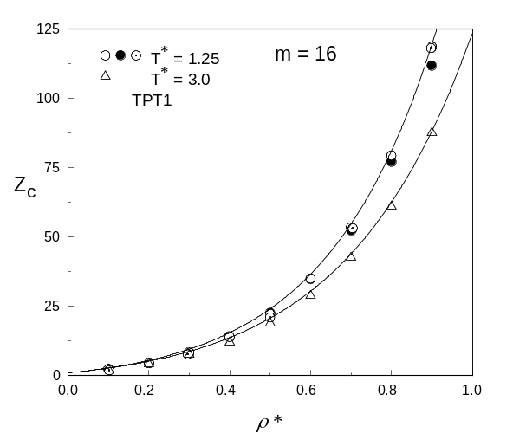
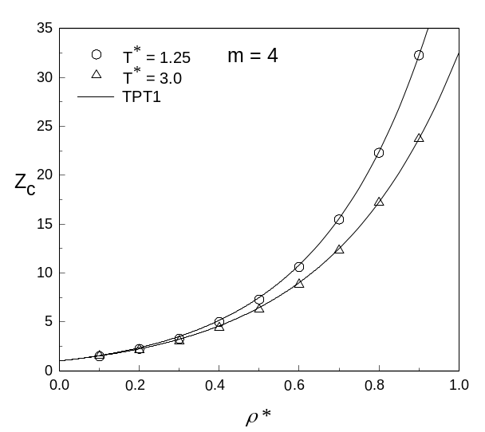

Figure 1. The compressibility factors of the 4-mer and 16-mer repulsive LJ chains.
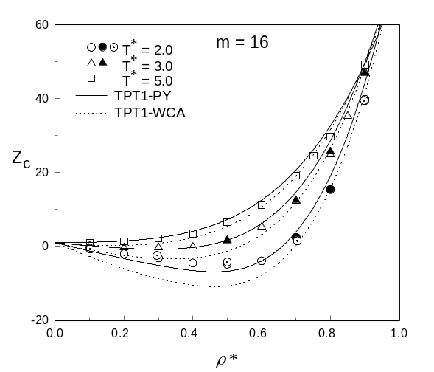
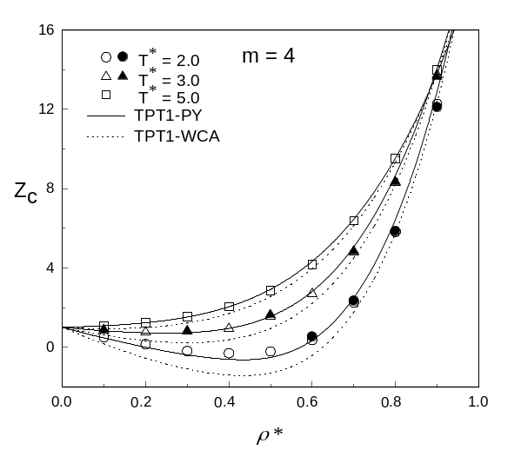

Figure 2. The compressibility factors of the 4-mer and 16-mer full LJ chains.

References
Andersen, H. C., J. Comput. Phys. 52, 24 (1983).
Chang, J. and Sandler, S. I., Chem. Eng. Sci. 49, 2777 (1994).
Chapman, W. G., Jackson, G. and Gubbins, K. E., Mol. Phys. 65, 1057 (1988).
Gao, J. and Weiner, J. H., J. Chem. Phys. 91, 3168 (1989).
Honnell, K. G. and Hall, C. K, J. Chem. Phys. 90, 1841 (1989).
Hoover, W. G., Phys. Rev. A31, 1695 (1985).
Johnson J. K., Muller, E. A. and Gubbins, K. E., J. Phys. Chem. 98, 6413 (1994).
Li, X. and Chiew, Y. C., Chem. Eng. Sci. 49, 2805 (1994a).
Li, X. and Chiew, Y. C., J. Chem. Phys. 101, 2522 (1994b)
Nicolas, J. J., Gubbins, K. E., Streett, W. B., and Tildesley, D. J., Mol. Phys. 37, 1429 (1979).
Tavares, F. W., Chang, J. and Sandler, S. I., Mol. Phys. 86, 1451 (1995).
Weeks, J. D., Chandler, D. and Andersen, H. C., J. Chem. Phys. 54, 5237 (1971).
Wertheim, M. S., J. Chem. Phys. 87, 7323 (1987).

