알칼리 연료전지의 운전조건에 대한 모사연구

조 장호, 이 성철, 문 세기
한양대학교 화학공학과

A Simulation Study on Operating Condition of an Alkaline Fuel Cell

Jang-Ho Jo, Sung-Chul Yi, Sei-Ki Moon
Dept. of Chem. Eng., Hanyang Univ., Seoul 133-791, KOREA

1. Introduction
Operating conditions such as temperature, pressure and electrolyte concentration, of a fuel cell considerably affect the cell performance. AFCs(alkaline fuel cells) are also affected by the operating conditions. Although there have been several experimental and simulation studies to find out the influences of such operating conditions on a single electrode of AFC [1, 2], the influences in AFC single cell were hardly known in detail. Thus, an investigation on the effects of the operating condition was conducted by using the one-dimensional model developed from our previous work [3], where Orbiter Fuel Cell of IFC(International Fuel Cell Corp.) was considered as a base-case model. Operating temperature was excluded in this study since the model is an isothermal one.

2. Description of System
The AFC single cell considered in this study consists of 5 layers, which are anode gas-diffusion layer, anode catalyst layer, separator layer, cathode catalyst layer and cathode gas-diffusion layer. A schematic diagram of the cell is illustrated in Fig. 1.

3. Mathematical Modeling
The equation of continuity for species i can be written in the general form for a porous medium as

$\frac{\text{¶e}C_{i}}{¶t}\text{=-Ñ}N_{i}+R_{i}^{p}+R_{i}^{e}$ (1)

In gas phase, Stefan-Maxwell equation can be employed for N_{i}.

${Ñy}_{i}=\sum_{j}{\frac{\text{RT}}{{PD}_{\text{ij}}^{g}}(y_{i}N_{j}^{g}−y_{j}N_{i}^{g})}$ (2)

In liquid phase, Nernst-Plank equation can be employed.

$N_{i}^{l}\text{=-}D_{i}^{l}{ÑC}_{i}−z_{i}u_{i}{\text{FC}}_{i}ÑF−C_{i}v^{n}$ (3)

If an equilibrium is assumed at a gas-electrolyte interface, mass transfer rate at a gas-liquid interface, R^{p}_{i}, in Eq.(1) can be approximately described as following,

$R_{i}^{p}\text{=-}a^{g}D_{i}^{l}\left(\frac{H_{i}P_{i}−C_{i}}{d}\right)$ (4)

Electrochemical reaction rate, R^{e}_{i}, in Eq.(1) can be represented as following,

$R_{i}^{e}\text{=-}\frac{s_{i}a^{l}i}{\text{nF}}$ (5)

Local current density, i, is described by Butler-Volmer equation,

$i=i_{o}\left[\prod_{i}{{\left(\frac{C_{i}}{C_{i}^{r}}\right)}^{q_{i}}\text{exp}\left(\frac{α_{a}Fh}{\text{RT}}\right)}−\prod_{j}{{\left(\frac{C_{j}}{C_{j}^{r}}\right)}^{q_{j}}\text{exp}\left(−\frac{α_{c}Fh}{\text{RT}}\right)}\right]$ (6)

where overpotential, η, is given by

$h=E−F−U$ (7)

Theoretical open-circuit potential, U, at given concentrations is given by

$U=U^{q}−\frac{\text{RT}}{\text{nF}}\sum_{i}{s_{i}\text{ln}\left(\frac{C_{i}}{C_{i}^{q}}\right)}$ (8)

In an electrically conductive medium, ohmic drop can be described by Ohm’s law.

$ÑE\text{=-}\frac{I}{s}$ (9)

These general equations presented above were employed to describe the respective layers

4. Model Parameters
Some of the base-case parameters are listed in Table 1. Orbiter Fuel Cells are operated typically at the temperature of 80 ºC and gas pressure of 4.1 atm with 7 M KOH solution. Hence, these were considered as the base-case operating condition of this work.
Table. 1. Some of the base-case parameters
Parameter | Gas-Diffusion Layer | Catalyst Layer | Separator Layer
L (cm) | 0.025 | 0.005(anode)  0.010(cathode) | 0.005
ε^{g} | 0.7 | 0.1
ε^{l} |  | 0.6 | 0.8
a^{g} (cm⁻¹) |  | 7.0×10³
a^{l} (cm⁻¹) |  | 2.4×10⁵
δ (cm) |  | 5.0×10⁻⁵
i_{o} (A/cm²) |  | 5.0×10⁻⁴(anode)  5.0×10⁻⁸(cathode)

5. Method of Solution
The model developed in this study consists of 11 variables, 25 governing equations and 38 boundary conditions. The governing equations and boundary conditions were discretized, then, these were solved by Newman’s BAND algorithm [4].

6. Results & Discussions
Fig. 2 illustrates the influence of the initial electrolyte concentration, C^{r}_{e}, on the cell polarization. As shown in Fig. 2, by lowering C^{r}_{e} the performance is enhanced in the ohmic and concentration polarization region except the case of 1 M. On the other hand, the current density, I, in the active polarization region steadily increases with the lowering of C^{r}_{e}. Such a tendency can be seen clearly in Fig. 3. In this figure, it is shown that diluting the electrolyte from 6 M to 4 M dramatically increases I at a low cell voltage, however, diluting the electrolyte below 3 M reduces I to a large extent. The optimum C^{r}_{e} is also found to be between 3.0 M - 3.5 M except the case of 1.0 V. These values are considerably different from the well-known value 6 M - 7 M, which is used mostly in common AFC systems. KOH solution at the concentration between 6 M - 7 M is used due to a maximum ionic conductivity at this concentration [5].
The experimental data on the effects of C^{r}_{e} on the performance in an AFC single cell are not readily available, however, it has been reported that the electrolyte concentration at the highest performance of Raney nickel hydrogen electrode is ca. 4 M as studied by Kenjo [1]. Although the different electrode and operating pressure were used, this value is similar to that of the present study. Thus it is considered that the concentration of 6 M - 7 M, which is commonly used in many AFC systems, may not be an optimum value. Simultaneously, it should be noted that low electrolyte concentration could yield some problems such as flooding of the catalyst layer or difficulty in water management due to an increase in P_{w}. Since these problems are, however, beyond the scope of this work, they were not considered in this study
Fig. 4 shows the polarization curves as a function of the operating gas pressure, P^{r}. An enhancement of the cell performance with increasing P^{r} is observed in the figure, as generally known. In particular, an increase in the limiting current density, I_{L}, and a decrease in the slope of ohmic polarization region, R_{ohm}, are noticeable.
The I_{L} could be increased by an increase in the liquid phase diffusivity or the solubility of the reactant gases. The solubility, H_{i}P_{i}, is composed of Henry’s constant, H_{i}, and partial pressure of the gas, P_{i}. Note that H_{i} and liquid phase diffusion coefficient, D^{l}_{i}, are functions of C_{e}. According to our analysis, there is no change in C_{e} distribution throughout the cell with increasing P^{r} at a constant I. Thus H_{i} and D^{l}_{i} of the gases remain constant with increasing P^{r}. Moreover, since no changes in the electrode structure, which could affect I_{L}, was assumed in this study, any influences by the structural parameter were absent. Therefore, it is concluded that the increase of I_{L} is caused solely by the increase of P_{H} and P_{O} due to the increasing P^{r}.

7. References
- Kenjo, T.: J. Electrochem. Soc., 133, 2051(1986)
- Shibli, S.M.A. and Noel, M.: J. Power Sources, 45, 139(1993)
- Jo, J.-H. and Yi, S.-C.: J. Power Sources, Accepted (1999)
- Newman, J.: Ind. Eng. Chem. Fundam., 7, 514(1968)
- H. van den Broeck, in Fuel Cell Systems, L. J. M. J. Blomen, M.N. Mugerwa, Editor, p250, p42, Plenum Press, New York(1993)

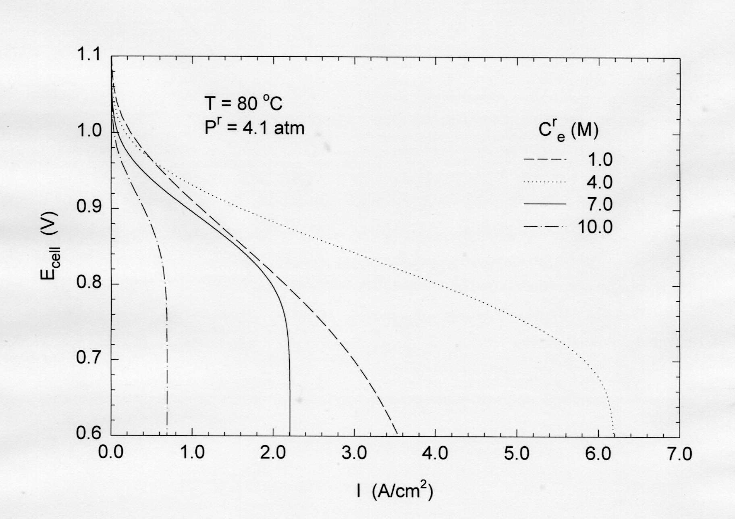
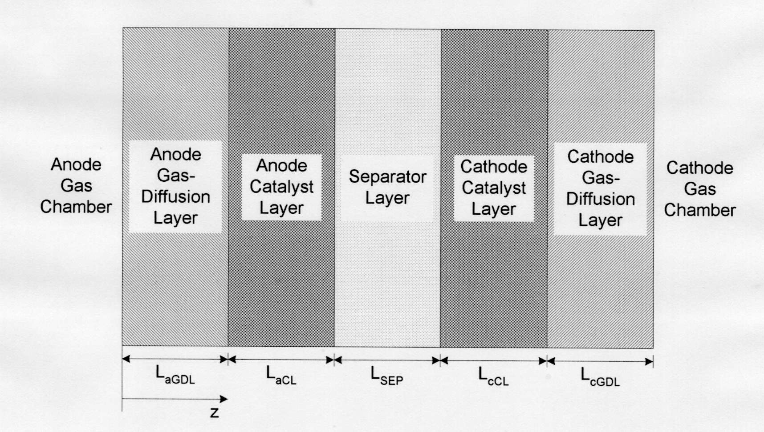
Fig.1. Schematic diagram of AFC single cell

Fig.2. Influence of initial electrolyte concentration of the polarization of the AFC
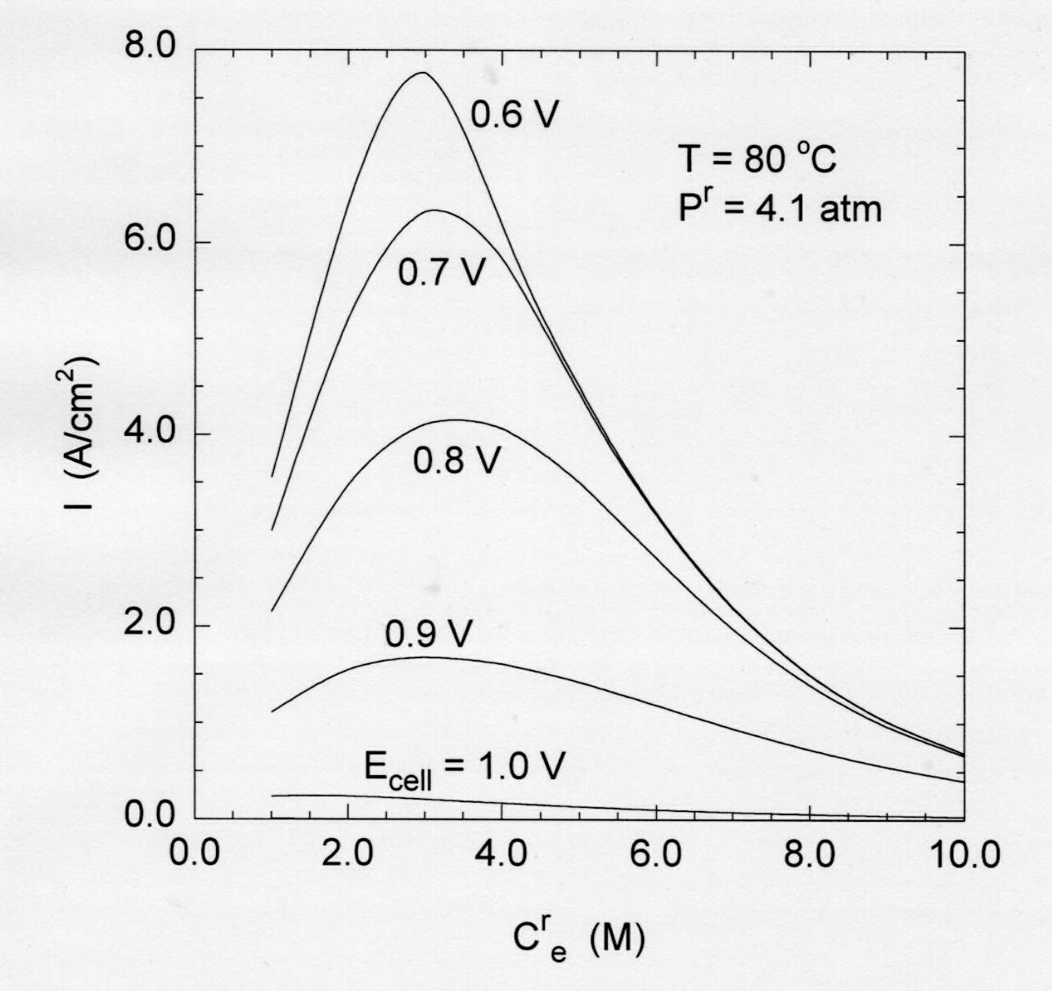
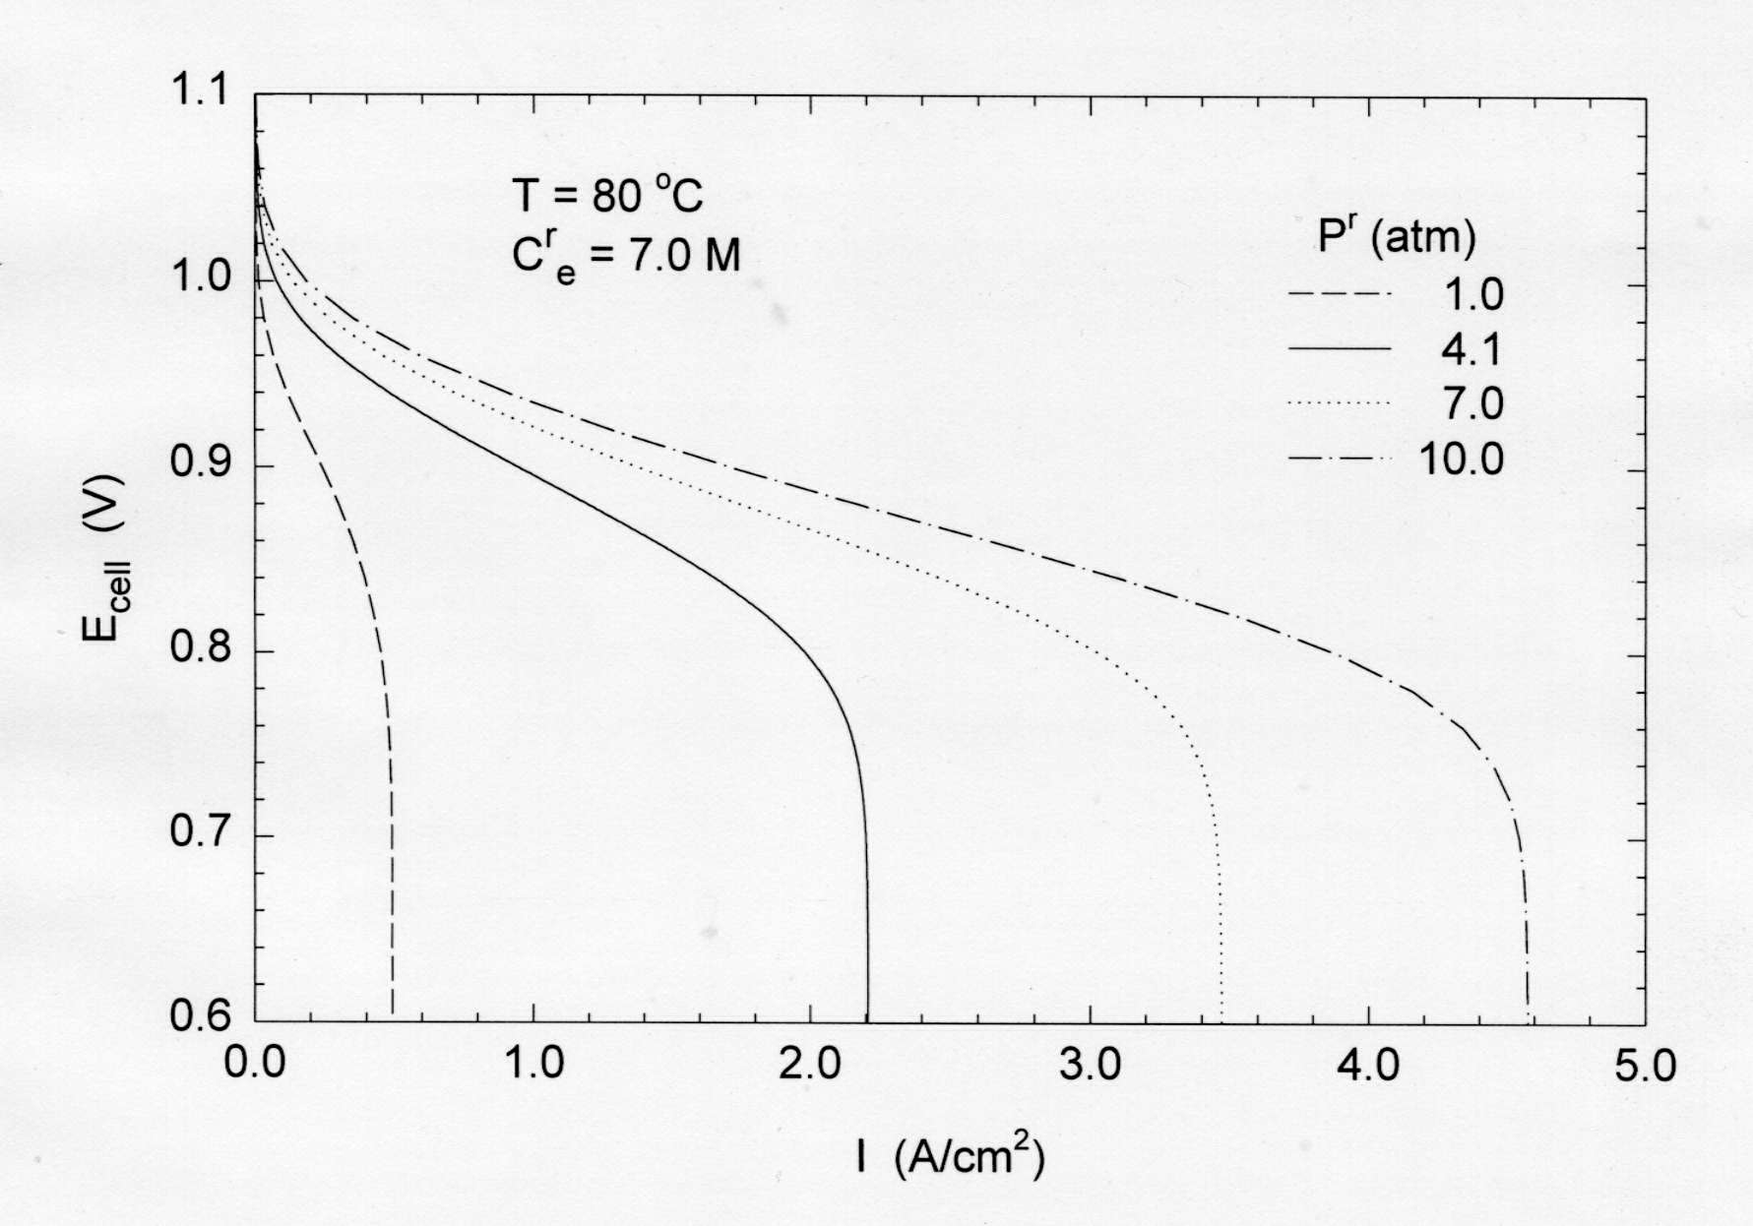

Fig.3. Current density as a function of Fig.4. Influence of operating pressure
initial electrolyte concentration for on the AFC
several cell voltages

