강유전성 액정셀 제조를 위한 폴리이미드 LB막의 표면 특성에 관한 연구

김현욱, 김종득

대한민국 대전광역시 유성구 구성동 373-1

한국과학기술원 화학공학과

Study on Surface Characteristics of Polyimide Langmuir-Blodgett Films

for Preparing FLCD cells

Hyun-Wuk Kim and Jong-Duk Kim
Department of Chemical Engineering, KAIST,
373-1 Kusong-dong, Yusong-gu, Taejon, 305-701 Korea

INTRODUCTION
Except for rubbing technique, there are several methods. From the experimental point of view, SiO obliquely evaporated films[1] and Langmuir-Blodgett (LB) films[2] seem to be suitable for the alignment of SSFLC, since the anchoring strength of these alignment films has been measured in the nematic phase and estimated to be weak[3]. The switching behavior of FLC is dependent on the anchoring force of alignment layer[4]. It was assumed that when the surface anchoring strength is weakened, the surface FLC molecules can switch smoothly to realize uniform switching. So, in this work, polyimide(PI) LB film as an alignment layer of FLC was prepared at different condition and its optimum condition as FLC alignment layer was investigated. It is the objective to study the surface characteristics of PI LB film for the alignment of FLC.

experimental
Langmuir trough and deposition system used was KSV 5000(KSV instrument LTD., Finland). Poly(amic acid) used as the precursor of polyimide is pyromellitimide dianhydride(PMDA-ODA). Hexadecyl amine(DMC 16, Tokyo Kasei Co.) was attached to poly(amic acid), which is hydrophillic, as alkylamine salt[5] to give some degrees of hydrophobicity and form a stable monolayer. N,N’-dimethylformamide (DMF, Tokyo Kasei Co.) was used as solvent for poly(amic acid) alkyl amine salt to be spread on purified water. LB films were built up onto ITO(Indium-tin oxide)-coated glass and Si-wafer. The deposition of Poly(amic acid) alkylamine salt on the substrate was performed at various surface pressures. Curing of PMDA-3,3′-ODA PAAS to polyimide was carried out at 300 ºC and for 1hr[6].

Contact angles at various surface pressures, layer numbers and curing temperatures were measured by G403 Contact Angle Measring System(Marktech Co.).
In order to investigate surface roughness, AFM images with increasing LB layer on Si-wafer were obtained. AFM images were obtained by AutoProbe M5(Park Scientific Ins. USA) and non-contact mode.
In order to investigate the extent to which the films has defects, cyclic voltammograms of polyimide films by redox reaction were examined[7]. As working electrodes, bare ITO, PI LB films with 2, 4, 6, 8, 10 layers, and PI spincoated ITO glasses were used. Silver/silver chloride coil and platinum electrode were employed as reference and counter electrodes, respectively. And 1mM K₄[Fe(CN)₆] / 100mM KCl aqueous solution was used as electrolyte. Redox reaction was proceeded between potassium ferricyanide and ferrocyanide. Cyclic voltammograms were obtained by BAS100 system.

results and discussion

Contact Angle
Contact angle was measured by contact angle meter(Marktech Co.) and deionized water was used as a drain. 10 tests were done per a sample and experimental variables were surface pressure, layer number, and curing temperature. As the layer number is increased, contact angle is increased and gradually saturated(see Figure 1(a)). Also is surface pressure(see Figure 1(b)). These phenomena can be considered with a change of packed state. Because polyimide is more hydrophobic than ITO glass, if more polyimides are coated on ITO glass, the surface property of substrate becomes more hydrophilic. So, the cases having higher surface pressure and more layer number show higher contact angle values.
In the case of curing temperature(see Figure 1(c)), because the polar component of the surface energy was directly related to the atomic percentage of the polar groups, the polar groups such as oxygen and nitrogen in polyamic acid could be known to be much more exposed on the surface with low degree of the imidization below low temperature[8]. But, at high temperature, polyamic acid is rapidly cyclized to polyimide and so, polar groups little exist in the deposited films. Then, the surface of alignment layer becomes more hydrophilic.

AFM(Atomic Force Microscopy) images
Figure 2. shows AFM images of polyimide LB films onto Si-wafer according to the deposited layer number. In the case of one layer of LB film, the film surface was relatively rough. But, as the layer number was increased, film surface was increasingly smooth. It is thought that this result is due to LB film deposition enough to cover original roughness of Si-wafer substrate. This result can be verified from Figure 3. From this figure, RMS roughness was decreased by one deposition and gradually saturated by more depositions. When rubbing after LB deposition, AFM image showed sharp grooves to the rubbing direction. It is thought that these grooves are due to scratches by fibrils of rubbing machine.

Cyclic voltammetry
The defects of LB films were examined by cyclic voltammetry(CV) about two cases, that is, PI films by layer number(see Figure 4.) and surface pressure(see Figure 5.) changes. As surface pressure and layer number were increased in both cases, the specific peak of cyclic voltammogram decreased. This indicates that high surface pressure and many layer numbers show insulation properties enough to exclude defects of LB films. PI spincoated film shows almost perfect insulation property.

CONCLUSION
In the measurement of contact angle, as the transferred layer number, surface pressure, and curing temperature were increased, it could be known that the surface became hydrophobic compared with bare ITO surface, which was due to the effects of polyimide. At the result of investigation of LB films on Si-wafer, it could be known that the surface roughness was decreased as the transferred number of layer was increased, and in the case of treatment with rubbing on the surface of LB film scratches to the rubbing direction were produced. In the measurement of defects of LB films on the ITO surface using redox reaction, defects were decreased as the transferred layer was increased.

REFERENCES
1. J.L. Janning, “Thin Film Surface Orientation for Liquid Crystals”, Appl. Phys. Lett., 21, 173-174, 1972.
2. H. Ikeno, A. Ohsaki, M. Nitta, N. Ozaki, Y. Yokoyama, K. Nakaya, and S. Kobayashi, “Electrooptic Bistability of a Ferroelectric Liquid Crystal Device Prepared Using Polyimide Langmuir-Blodgett Orientation Films”, Jpn. J. Appl. Phys., 27, L475-L478, 1988.
3. H. Yokoyama and H.A. van Sprang, “A Noble Method for Determining the Anchoring Energy Function at a Nematic Liquid Crystal–Wall Interface from Director Distortions at High Fields”, J. Appl. Phys., 57, 4520-4526, 1985.
4. M. Kimura, M. Nishikawa, T. Akahane, and S. Kobayashi, “Dynamic Response of Surface-Stabilized Ferroelectric Liquid Crystals : Effect of Alignment Layer”, Jpn. J. Appl. Phys., 33, L949-L952, 1994.
5. G.Y. Tae, S.M. Kim, Y.M. Koo, and J.D. Kim, “The Preparation and Transfer Characteristics of Polyimide Langmuir-Blodgett Film for Liquid Crystal Alignment”, Mol. Cryst. Liq. Cryst., 67, 157-162, 1995.
6. S.M. Kim and J.D. Kim, “Surface Properties of Rubbed Polyimide for Alignment of Liquid Crystal”, Mol. Cryst. Liq. Cryst., 287, 229-237, 1996.
7. Y. Nishikawa, M. Kakimoto, A. Morikawa, and Y. Imai, “Preparation and Characterization of Poly(amide-imide) Multilayer Films”, Thin Solid Films, 160, 15-20, 1988.
8. S.M. Kim, Y.M. Koo, and J.D. Kim, “Characteristics of Polyimide Alignment Layers with Different Surface Treatments”, Polymer Surface and Interface : Characterization, Modification and Application, 283-294, 1997.

(a) (b) (c)

Figure 1. Dependence of contact angle on (a) layer number, (b) surface pressure,
and (c) curing temperature
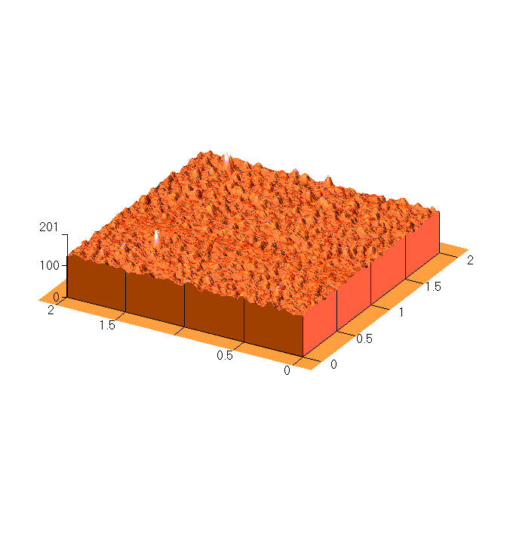
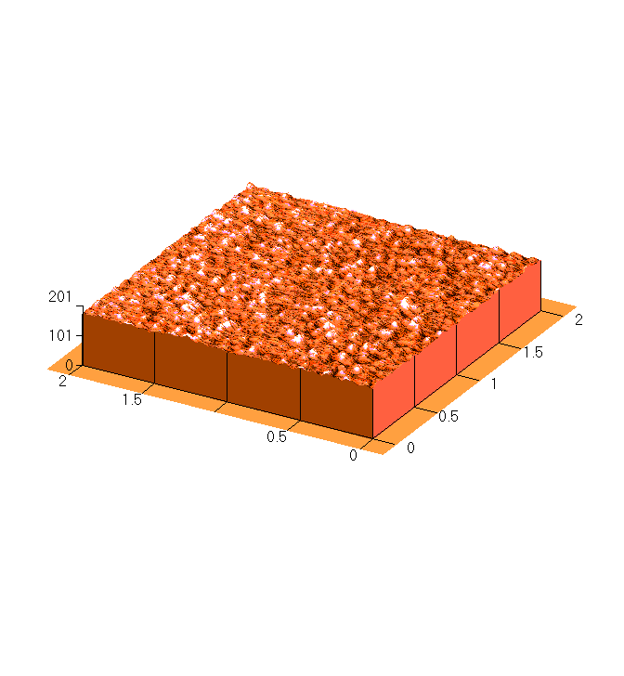
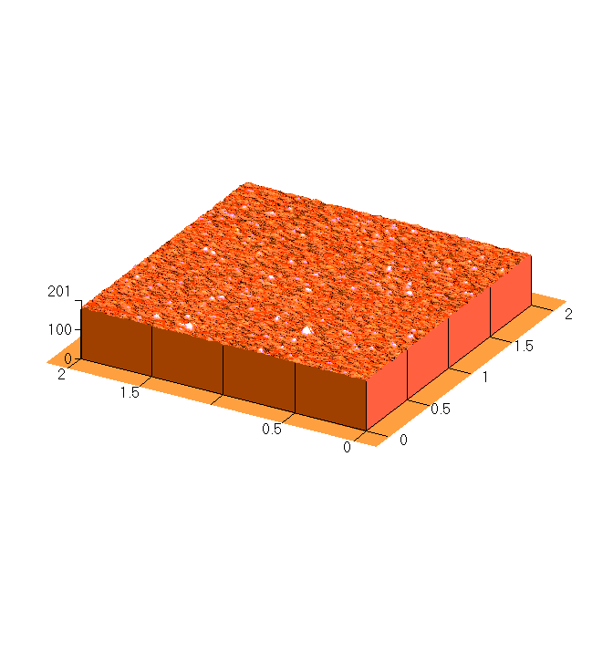
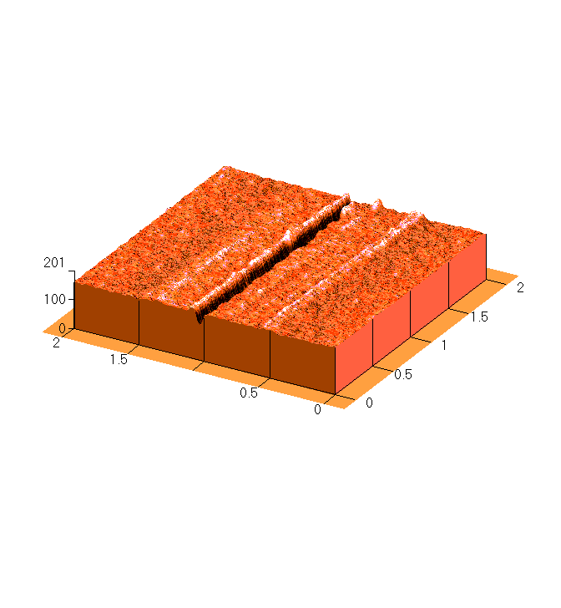
μm
Å

Figure 2. AFM images of polyimide LB alignment layer on Si-wafer :
(a)LB 1layer, (b)LB 2layers, (c)LB 7layers, (d)rubbing treatment after LB 7layers
Figure 3. RMS roughness of polyimide LB alignment layers on ITO-glass

Figure 4. Cyclic voltammogram of PI LB film according to layer number
: ITO-glass, : 30mN/m, 2layers PI,
: 30mN/m, 4layers PI, : 30mN/m, 6layers PI,
: 30mN/m, 8layers PI, : 30mN/m, 10layers PI,
: PI spincoated ITO-glass
Figure 5. Cyclic voltammogram of PI LB film according to surface pressure
: ITO-glass, : 5mN/m, 5layers PI,
: 15mN/m, 5layers PI, : 25mN/m, 5layers PI,
: 35mN/m, 5layers PI,
: PI spincoated ITO-glass

