에스 케이 주식회사 합성수지 공정의 다변수제어
모델 및 공정모사에 대한 연구
김 지영
SK 주식회사

Feasibility Study With DMCplus Simulation of LLDPE in SK Corporation
Ji-Young Kim
CIM Development Department, SK Corporation

The trial of APC application to LLDPE plant by SK CIM development Department has been doing 3years ago. But Only with a existing method called “ Violation Reduction”, we can not justify the feasibility of APC success actually and persuade operation team to make sure that APC can serve as an aid to operation.
Therefore the simulation with historical data was established for 2.5months in reaction area and recycle area.
Commercially some of APC vendors have an architecture comprise of a recipe management system and on-line property estimator in order to cover a transition zone and infrequent laboratory feedback often result in wide variation of product consistency.
Through this simulation, the possibility of substitution one model to those systems(a recipe management system and on-line property estimator) could be proven depending on separation of non-linear zone even if the performance might have a difference with the case used those systems(a recipe management system and on-line property estimator).

- Reaction Area
- Data
The historical data was used in identification Model with 5months and 5min.
Data scan frequency can be diversified on a process characteristics.
SK Polymer plant has a Infoplus and PHD simultaneously so the constraint of historical data quantity is somewhat free.
In order to discard a garbage data, only 90% of normal operation data was used in model identification.

- Model I/D(below MI 3.3) 3. Prediction
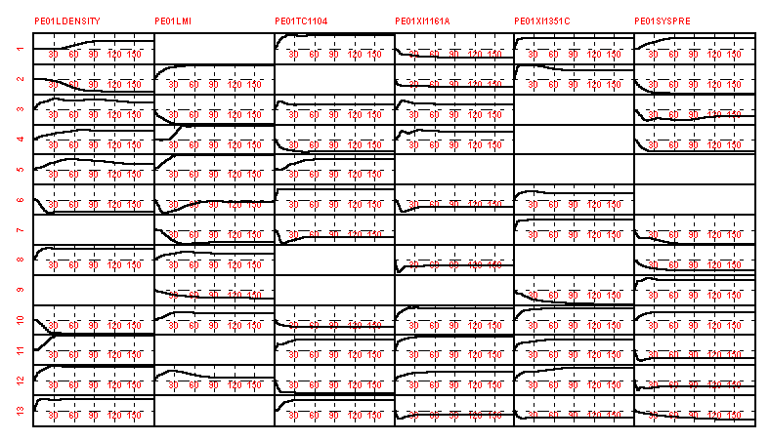
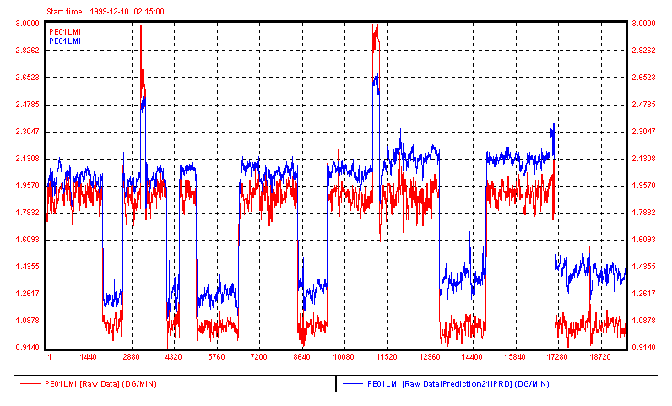

Raw Data Model Prediction

4. Transition Zone Control(MI 3.3 이하)
MI 1.6~2, Density 0.918->0.92 -> MI 2.3~3.3, Density 0.918~0.92
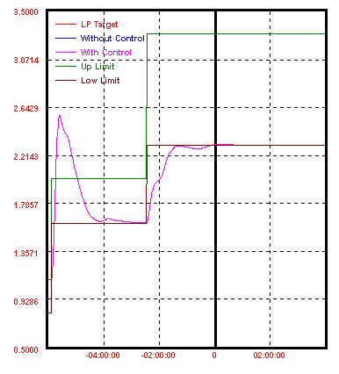
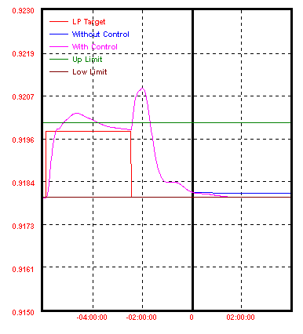
MI Range(2.3~3.3) : Optimal MI Target is
2.31
On-line Estimator
In order to feedback property process variables to APC controller during an Laboratory cycle time or Analyzer cycle time, some dummy tag should be made in DCS or Process computer are supposed to reflect a value received from property inferential value result from delta manipulate variables with a existing model.

The equation is as below :
CV=A*∆MV + (y(k/k-1)+( Y(k) -y(k-1))
A : Model Coefficient
y(k) : CV(MI,Density) value at k
Y(k) : Laboratory value or Analyzer value at k
The error minimization between a an Laboratory value or Analyzer value and Inferential value is done by using External Target subject to receive an Laboratory value(Dead time should be taken in account) or Analyzer value.

Transition Zone Control
Like as explained above, the performance of transition zone control depends on dividing a non-linear zone. According to the number of period assumed to be a close-linear zone, the number of model is decided. Moreover a model shifting function can be done in CCF.(Controller Configuration File) When the model coefficient is changed into next grade model one on the last time of one grade, the controller can predict a SST(Steady State Target) of next grade with the changed model coefficients and control the transition zone with Optimizing control until arrival in SST.

B. Recycle Area(CM Column)
1. Introduction
LLDPE plant comprise of 5columns with 2contol modes.(Butene, Octene)
The peculiar point of column operation is on the Side-cut operation just open it’s
flow when tray temperature arrive in the target value. Therefore Side-cut opening
was exclueded in a material balance in model identification and calculation of
Economic Optimize Factor. However, It can be substituted to program in DCS or
CCF with designation a timing for opening Side-cut flow.
In order to feedback 6minutes Analyzer cycle time to controller, we can use not only
a On-line estimator but also the way was described as above.
In reflux flow control, the reflux flow of impurity was used as a Disturbance
Variable to control a overhead Octene-1 property prediction and improve a
overhead product wt%. in Octene mode. In Butene mode Similarly, the bottom
isomer flow and cyclohexane flow was used as a Disturbance Variable to control a
overhead Butene-1 property prediction and improve a overhead product wt%.
It is very effective to improve a controller prediction function and a good idea can be
adopted to other columns.
2. Data
The historical data was used in identification Model with 5months and 12min.
average and 90% of normal operation data.
3. Butene mode Model and Overhead Butene-1 Prediction
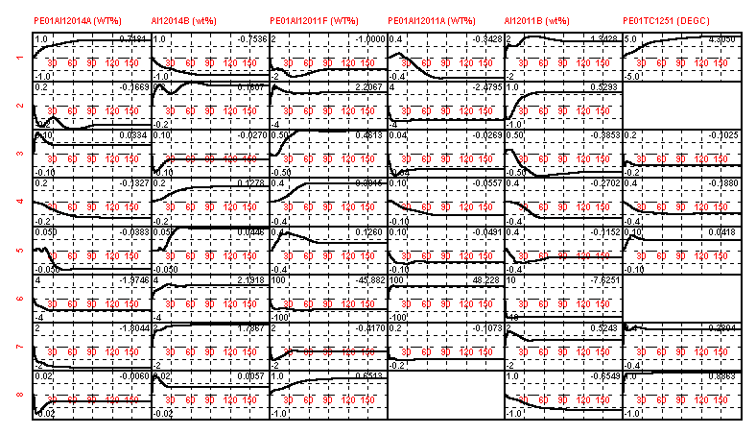
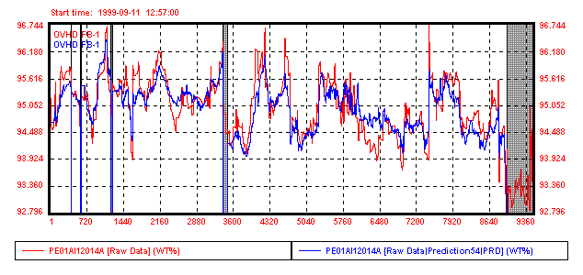
4. Octene mode Model and Overhead Butene-1 Prediction
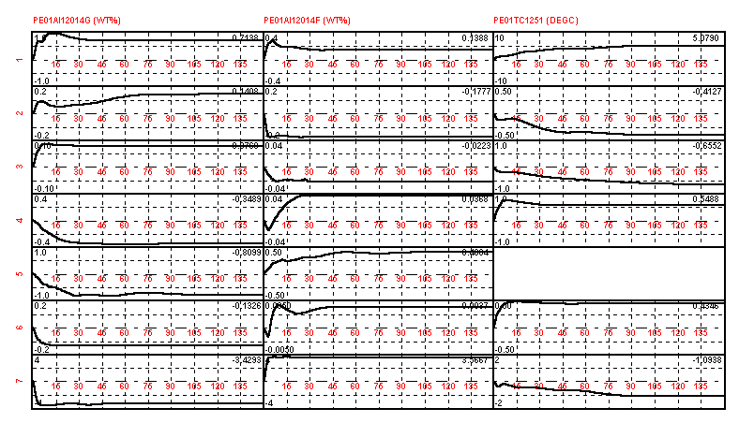

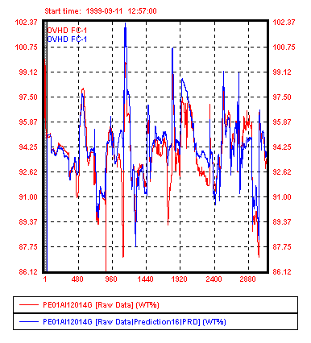
5. Butene-1 Benefit 6. Octene-1 Benefit
Increase Buten-1
94.95 -> 95.4(wt%)
Increase Ocyene-1
93.8->96.01(wt%)
