고분자 물성제어에 적용된 Blue 필터를 사용한 모델 예측제어

송인협, 유기윤, 이현구
서울대학교 응용화학부· 화학공정신기술연구소

Model Predictive Control Using BLUE Filter for Polymer Quality Control
In-Hyoup Song, Kee-Youn Yoo, and Hyun-Ku Rhee
School of Chemical Engineering and Institute of Chemical Processes,
Seoul National University

INTRODUCTION
In case of using system identification method to get system matrices, an output feedback controller is used to control the system because full states are usually not available. In order to apply an output feedback controller, an observer must be implemented in the control system. If we employ a stochastic observer for estimating the state of a process to install an output feedback controller, we can construct a controller easily just by augmenting integral white noise term in an identified system model.
In this study, we consider a multi-input multi-output styrene polymerization reactor system for which the monomer conversion and the weight average molecular weight are controlled by manipulating the jacket inlet temperature and the feed flow rate. The system is identified by using a linear subspace identification method, and then the output feedback model predictive controller is constructed on the basis of the identified model. Although Kalman filter is very popular and powerful stochastic estimator in industry, a priori information, i.e., the mean and covariance, about the initial state is often unknown since it may not be measurable. In that case, the Kalman filter is not unbiased and the best unless the mean of the initial state is completely known. Here we use the Best Linear Unbiased Estimation (BLUE) filter instead of the Kalman filter. A BLUE filter has a finite impulse response (FIR) structure which utilizes finite measurements and inputs on the most recent time interval [i-N, i] in order to avoid long processing times.
This controller also includes an integral action to remove the steady-state offset, which may be present when a linear model based controller is used to a nonlinear system. A typical way to add integral action is that a controller was designed by using the estimates of the system to which integral white noises are augmented.

INTEGRAL ACTION AND BLUE FILTER
The system matrices in the identified model form the backbone of the predictions into the future. To this basic structure we add the capability of estimating the effect of disturbances on future outputs. For the linear disturbance model we will use “type 1” model which has been used in the linear MPC design (for example, Morari and Lee, 1991; Ricker, 1991).

(1)
(2)
The integral white noise terms are augmented to the identified model and this type of disturbance description is able to capture any constant bias between the plant and the identified model. Therefore, if the combined effects of the external disturbance and the plant-model mismatch reach a constant value, the type 1 assumption along with a controller with integral action yields an offset free performance. When stochastic observers estimate the states of above augmented system, it is well known that the integral action occurs and a controller compensates the steady-state offset.
A BLUE filter has a finite impulse response (FIR) structure which utilizes finite measurements and inputs on the most recent time interval [i-N, i] in order to avoid long processing times. The system (1) will be represented in a batch form on the most recent data. On the horizon [i-N, i], the finite number of measurements are expressed in terms of the state x(i) at the current time i as follows:

(3)
where
(4)

and and are expressed as

The noise term in (3) can be shown to be zero-mean with covariance given by
(5)
where Q and R are the covariance of process noise and measurement noise, respectively. An FIR filter with batch form for the current state x(i) can be expressed as a linear function of the finite measurements Y(i-1) and the inputs U(i-1) on the horizon as follows:

(6)

where H is a gain matrix of a linear filter. It is noted that the filter defined in (6) is a finite impulse response structure without any a priori statistics information about the horizon initial state x(i_{N}). The gain matrix H will be designed in such a way that is an unbiased estimation filter of the current state x_{k} as

Therefore, the following constraint on H is required:

(7)

which will be called the unbiasedness constraint.
The objective is to obtain the best gain matrix H_{B} , subject to the unbiasedness constraint (7), in such a way that the estimation error of the estimate has minimum variance as follows:
. (8)

In regard to (7) and (8), the best gain matrix H_{B} is

(9)

in which is of full rank, if the pair {A, C} is observable and.

SIMULATION RESULTS
We consider a multi-input multi-output styrene polymerization reactor system for which the monomer conversion and the weight-average molecular weight are controlled by manipulating the jacket inlet temperature and the feed flow rate. Tracking control performance without integral white noise is presented in Figure 1. There exists a steady-state offset when the set-point is changed.
When the integral white noise term is introduced and the Kalman filter is used, the steady-state offset is significantly reduced but still exists since the mean and covariance of the initial state is arbitrarily chosen. It’s indicates that estimates of states is biased. Finally, using a BLUE filter, an output feedback model predictive controller with integral action is implemented. As one can see in Figure 1, the steady state offset is eliminated. All the simulation studies are performed with the best tuning weighting factor at each controller under the same conditions.
The BLUE filter observes the state successfully without any a priori information of initial states. In contrast to the Kalman filter, the BLUE filter eliminates the offset by observing the state of augmented system regardless of a priori information of the initial state for an integral white noise augmented system.
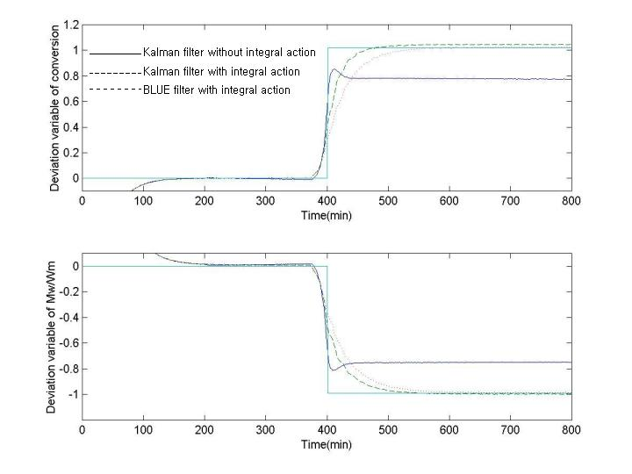
Figure 1. Tracking control performance: the solid line-without integral action, the dashed line-with integral action using the Kalman filter, the dotted line-with integral action using BLUE filter.

In this study, we identified the styrene polymerization reactor by using the input/output data only and designed the output feedback model predictive controller for an unconstrained system. The BLUE filter was used as a stochastic observer and the integral white noise term played its role successfully with the BLUE filter.
In the same way as the Extended Kalman filter, a BLUE filter may be applied to a nonlinear system by using a Jacobian matrix. Furthermore, the subspace identification method can be applied to determine a BLUE filter.

ACKNOWLEDGEMENT
We are thankful for the financial aid from the Brain Korea 21 Program supported by the Ministry of Education.

REFERENCES
[1] M. Morari and J. H. Lee, System and Control Lett., 11, 229 (1988).
[2] W. H. Kwon and K. B. Kim, IEEE Trans. Automat. Contr., 44(9), 1787 (1999).
[3] J. H. Lee, M. Morari, and C. E. Garcia, Automatica, 30, 547 (1994).
[4] Frank L. Lewis, “Optimal Estimation: with an Introduction to Stochastic Control Theory”, Wiley-Interscience, New York, 1986.
[5] P. Van Overschee and B. De Moor, “Subspace Identification for Linear Systems: Theory, Implementation, Applications”, Kluwer Academic Publishers, Dordrecht, 1996.

