덴드리틱 고분자 용액에 대한 Associating Compressible Lattice Cluster Model

장정규, 배 영찬
한양대학교 응용화학공학부 분자열역학연구실

Associating Compressible Lattice Cluster Model
For Dendritic Polymer Solutions

Jeong Gyu Jang, Young Chan Bae
Division of Chemical Engineering and Molecular Thermodynamics Lab.,
Hanyang University, Seoul 133-791, Korea

Introduction

In recent years, many researchers take an interest in exploring and developing a variety of uses for dendritic macromolecules, highly branched, tree-like molecules (dendrimers and hyperbranched polymers)
Many applications for dendritic polymers are proposed. These include nanoscale catalysts and reaction vessels, micelle mimic, magnetic resonance imaging agent, immuno-diagnostics, agents for delivering drugs into cells, chemical sensors, information-processing materials, high-performance polymer, adhesive and coating, separation media, and molecular antennae for absorbing light energy. These applications are due to the highly branched chain architecture and numerous chain ends that can be functionalized.
Dendritic polymers may find utilities in the areas where the structural uniqueness of these polymers gives merits. There has been much progress in the structural understanding and the methods of synthesis of these polymers; however, functional understanding and the method of synthesis of these polymers are still in infancy. Better understanding on physical properties of these polymers, and functional group dependency to the thermodynamic properties is needed for further development of the subject.
These applications spring from the unusual highly branched architecture and properties of dendritic macromolecules. In addition, they have a lot of chain-ends that may take part in hydrogen-bond formation or specific interactions, so that the effect of the end-group is too large to ignore in the thermodynamic properties in dendritic polymer solutions. In this study, we investigated liquid-liquid equilibria of dendrimer polymer solutions hypothetically.
Recently, Freed et al. have developed a systematic expansion of the partition function of lattice polymer using well-known lattice cluster theory (LCT). This model takes into account effects of branching and compressibility on the thermodynamic properties of polymer solutions. To predict phase behavior we modified the LCT model to account for strongly interacting hydrogen bonds between solvents and endgroups of hyperbranched polymer by employing the concept of Veytsman’s hydrogen bonding model.

Model Development

Lattice cluster theory
Freed et al.³ have proposed a lattice cluster theory (LCT) of compressible systems. It showed effect of monomer structure and compressibility. We apply this model to homogeneous dendrimer polymer solution. The free energy is given in a double expansion series with 1/z and βε_{ps}(β=1/kT). We truncate the series at the fourth order in 1/z and the second order in βε_{ps}. The free energy of mixing for polymer-solvent system is given by

$$\begin{aligned}\frac{F}{N_{l}k_{B}T}=φ_{v}\text{ln}φ_{v}+\frac{φ_{1}}{M_{1}}\text{ln}φ_{1}+\frac{φ_{2}}{M_{2}}\text{ln}φ_{2}+φ_{1}φ_{2}\sum_{i=0}^{4}{\sum_{j=0}^{4}{g_{\text{12}}^{(i,j)}}}φ_{1}^{i}φ_{v}^{j} \\ \begin{matrix} & & \begin{matrix}\begin{matrix}\begin{matrix}\begin{matrix}\begin{matrix} & & \end{matrix} & & \end{matrix} & & \end{matrix} & & \end{matrix} & & \end{matrix}\end{matrix}+\sum_{k=1}^{2}{φ_{k}φ_{v}\sum_{i=0}^{2}{\sum_{j=0}^{3}{g_{\text{kv}}^{(i,j)}}}φ_{k}^{i}φ_{v}^{j}}+f_{1}φ_{1}+f_{2}φ_{2}\end{aligned}$$
where $φ_{v}$,$φ_{1}$ and $φ_{2}$ are void , solvent and polymer volume fractions, respectively. Parameter g_{ij} is calculated by structure of polymer and interaction energy parameter ε_{ij}.
The combinatorial numbers, N_{α} and N_{α,β} , describe the architecture of polymers. T is an absolute temperature and k_{B} is a Boltzmann's constant. Hypothetical dendrimer structure is given in figure I and the structure factors are calculated as listed in Table I.

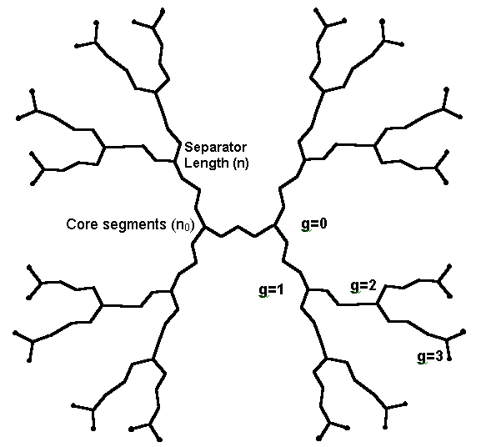
Figure 1. Schematic description of dendrimer: • represents end-groups that can be functionalized.

Table I. geometric factors of hyperbranched polymer structure
Parameter
M | 4 (2^{g-1}-1) ×n+2^{g}×2+n₀+2
N₁ | M-1
N₂ | 4 (2^{g-1}-1)×(n-1)+3× N⊥+n₀
N₃ | 4 (2^{g-1}-1)×(n-2)+6× N⊥+n₀-1
N⊥ | 4 (2^{g-1}-1) +2
N_{1,1} | 4 (2^{g-1}-1)(2(n-2)+(n-2)(n-3))/2+4 (2^{g-1}-1) n (4 (2^{g-1}-1)-1) n /2  -3(4 (2^{g-1}-1)-2-2^{g})-2+(n₀+1) 4 (2^{g-1}-1) n /2 -2×2+(n₀+1) n₀ /2 - n₀  +(2^{g}×2)( 2^{g}×2-2)/2+(2^{g}×2)( 4 (2^{g-1}-1)n)/2-2^{g}×2+( n₀+1)( 2^{g}×2)/2
N_{1,2} | 4 (2^{g-1}-1)(n-2)(n-3)+3(4 (2^{g-1}-1)-2-2^{g}) ×(4 (2^{g-1}-1)n)  -(4 (2^{g-1}-1)-2^{g})×3×5-2(3+3+4)+ 4 (2^{g-1}-1)(n-1)*( 4 (2^{g-1}-1)-1) n  -2×5+n₀×4(2^{g}-1)n-2×2+2(n₀-2)+(n₀-2)(n₀-3)+ 4(2^{g}-1)(n-1) ×2^{g}×2-2^{g}×2  +(4 (2^{g-1}-1)+2-2^{g}) ×3×2^{g}×2+2^{g}×3×4(2^{g-1}-1) ×n-2^{g}×5+2^{g}×3×(2^{g}×2-2)  +n₀×2^{g}×2+2^{g}×3×(n₀+1)
g : The number of generation
n: The number of segment between generation points
n₀: The number of core segments

Veytsman proposed an expression for hydrogen bonds’ contribution to the free energy of fluid, valid for the general case. We apply this model to the specific interaction contribution. In this model, we use the hydrogen-bonding model of Vaytsman7 to consider two types of specific interactions (endgroup-solvent, and solvent-solvent).
In order to apply this model to a dendrimer solution, we consider the binary mixture of dendrimer and solvent. Solvent has both donor site (d₁=2) and acceptor site(a₁=1). Dendrimer has only acceptor sites: a₂ is equal to the number of end groups of dendrimer molecule.
For this system, the chemical contribution to the free energy is
$A^{S}=kT(M_{\text{11}}+M_{\text{12}})+k_{B}T\left[N_{s}d_{1}\text{ln}\left(\frac{N_{s}d_{1}−(M_{\text{11}}+M_{\text{12}})}{N_{s}d_{1}}\right)\right]$$+k_{B}T\left[N_{s}a_{1}\text{ln}\left(\frac{N_{s}a_{1}−M_{\text{11}}}{N_{s}a_{1}}\right)+N_{p}a_{2}\text{ln}\left(\frac{N_{p}a_{2}−M_{\text{12}}}{N_{p}a_{2}}\right)\right]$
where $M_{\text{ij}}$ are determined by the set of quadratic equations
${\text{NM}}_{\text{11}}=(N_{s}d_{1}−M_{\text{11}}−M_{\text{12}})(N_{s}a_{1}−M_{\text{11}})\text{exp}\left(−\frac{F_{\text{11}}^{S}}{k_{B}T}\right)$${\text{NM}}_{\text{12}}=(N_{s}d_{1}−M_{\text{11}}−M_{\text{12}})(N_{p}a_{2}−M_{\text{12}})\text{exp}\left(−\frac{F_{\text{12}}^{S}}{k_{B}T}\right)$
M_{ij} : The number of (i,j) bonds
N_{i} : The number of component i molecules
d_{i} : H-donor sites of an ith kind molecule
a_{i} : H-acceptor sites of an ith kind molecule
F_{ij} : The free energy of an (i,j) bond formation

Results and Conclusion

In this study, we investigated the effect of compressibility and specific interaction between end group of dendrimer and solvents. The solubility increases with a number of polar end-group of dendrimer in polar solvent. The compressibility shows slight effect on LLE of dendrimer solutions. Therefore the dominant effect on phase behaviors of dendrimer solutions is specific interaction between end group and solvent molecules. Since our model takes into account both the contribution of the end-groups and the specific structure of polymer, we could apply this systematic tool to predict the phase behavior of hyperbranched polymer-solvent system

References
1. Tomalia, D. A.; Dvornic, P. R. Nature, 1994, 372, 617
2. Dudowicz, J.; Freed, K. F. Macromolecules, 1991, 24, 5076
3. Dudowicz, J.; Freed, M. S.; Freed, K. F. Macromolecules, 1991, 24, 5096
4. Dudowicz, J.; Freed, K. F. Macromolecules, 1991, 24, 5112
5. Dudowicz, J.; Freed, K. F. Theoretica Chimca Acta, 1992, 82, 357
6. Veytsman, B. A., J. Phys. Chem. 1990, 94, 8499

