Supercritical AntiSolvent(SAS) 재결정법을 이용한
연속적인 Poly(L-Lactic Acid) 미세입자 제조
송규호, 임종성, 이윤용, 이창하*, 이윤우
한국과학기술연구원, 초임계유체공정연구실
연세대학교, 화학공학과*

Preparation of Poly(L-Lactic Acid) Particles using A Continuous
Supercritical AntiSolvent (SAS) Recrystallization process
Kyu Ho Song, Jong Sung Lim, Youn Yong Lee, Chang-Ha Lee*, Youn-Woo Lee
Supercritical Fluid Research Lab., Korea Institute of Science and Technology
Chemical Engineering Department, Yonsei University*

Introduction
Supercritical fluids (SCFs) are these gases and liquids at temperatures and pressures above their critical points. In this region, the SCF exists as a single phase with several advantageous properties of both liquids and gases. SCFs are highly compressible, have high diffusivities, liquid-like densities, and viscosities intermediate between the gas and liquid extremes. The most widely used SCF is carbon dioxide (scCO₂) because of its low critical temperature (T_{c}=31.1℃), attractiveness for heat sensitive materials including products sourced from biologicals, as well as being non-flammable, non-toxic, and being inexpensive.
In general, the SAS technique has been applied in several different modes[1-4]. The first mode (semi-batch operation) is known as the Gas Anti Solvent (GAS) process in which the SCF is added continuously into a stationary bulk liquid phase at the operating pressure. The second mode is continuous operation, in which a spray of liquid solution is fed through a capillary nozzle as fine droplets into a vessel containing the supercritical fluid. This second mode is named as Aerosol Spray Extraction System (ASES). If either liquid or high-pressure gas is employed as antisolvent, alternative name of this second mode is Precipitation with Compressed Antisolvents (PCA). All these methods have been successfully used to produce finely comminuted particles of highly explosive and solid propellants, pharmaceutical compounds, proteins, and polymers.
The aim of this work is to give a contribution by studying the use of carbon dioxide as antisolvent in a SAS process for the precipitation of PLLA from methylene chloride solution. The effect of the operating temperature, pressure, and the concentration of solution on the particle size, particle size distribution, and morphology of the final product is experimentally investigated.

Experimental
The Poly(L-lactic acid) (M.W.: 85,000-16,0000, i.v.:1.645) used here is supplied by SIGMA. The untreated PLLA particles range from 50-100㎛. Technical grade (99.0%) carbon dioxide as an antisolvent is supplied by Shin Yang Co., Korea. Methylene chloride (analytical regent, Mallinckrodt) is used as the solvent.
A schematic of the experimental apparatus is shown in Figure 1. PLLA solution is pumped (Milton Roy, U.S.A) into the precipitator vessel (Jerguson Gage, 34ml) via an orifice (stainless steel, 0.03” I.D). The use of such nozzle allows introduction of the PLLA solution into the precipitator as small liquid droplets. CO₂ is compressed by high- pressure pump (Milton Roy, U.S.A) and conveyed into the precipitator. The precipitator is positioned in an insulated air chamber where the temperature is controlled with a PID temperature controller (Han Young Co.) The pressure of the precipitator is controlled by back-pressure regulators (Tescom; 26-1721-24). Upon injection into the precipitator, PLLA particles are formed and a fluid mixture of CO₂ and methylene chloride laden PLLA particles leaves the precipitator. PLLA particles are collected on filters (Tee-Type filter, 0.5㎛). This fluid mixture is depressurized and expanded to atmospheric pressure as it passes through a depressurizing tank (SUS 316; 300ml). The instantaneous and the total flow rate of CO₂ gas are measured with a rotameter (Metheson 604 SUS ball, U.S.A) and a dry gas meter (Taekwang Energy S/T-3, Korea), respectively. Typical flow rate of CO₂ and PLLA solution are 2.0 l/min @STP and 0.25ml/min, respectively. Morphological evaluation of the microparticles was conducted by a scanning electron microscopy (SEM) (HITACHI S-4200). The mean particle size of each sample was determined using a laser diffraction particle size analyzer (LS 230, Coulter Electronics, Hialeah, FL).

Results and Discussion
Considerable amount of research has been investigated to determine the effect of different process parameters on the antisolvent precipitation process, but still there is not much knowledge on the quantitative aspects of the process.
The mean particle size significantly change from 0.196 to 1.822㎛ as the pressure increased from 77.5bar to 150bar at 35℃. Similar tendency is observed at 40℃. However, at the temperatures of 25℃ and 33℃, there was no noticeable effect on the particle size.
Figures 3 a-d show SEMs of particles obtained in the experiments conducted at different four pressures at 35℃. Most of the particles are found to be spherical in shape and have a very narrow size distribution. Figure 2 shows clearly that the mean particle size of PLLA increased sharply as the system pressure increased whereas particle size distribution became broader as the system pressure increased.
In order to study the influence of temperature, the pressure was kept constant at the pressure of 150bar while the temperature was varied from 25℃ to 40℃. The mean particle size is insensitive to the temperature. However, in all the cases, spherical particles having a narrow size distribution are obtained.
The effect of initial solution concentration was investigated by conducting several experiments at different initial solution concentration at 150bar, 40℃. Figure 4 a-d show results obtained in the experiments. As shown in Figure 6, the particle size increases when the initial solution concentration increase from 0.3wt% to 1.0wt% at 150bar, 40℃. Agglomerates, which appeared as clusters of microparticles were observed only at 1.0wt% concentration. Other particles were obtained as free flowing particles.
From above results, we conclude that the continuous SAS process in which methylene chloride solution injected into carbon dioxide as an antisolvent prepared Sub-micron PLLA polymer particles. It is found that the particle size (0.2-2㎛) and the particle size distribution (standard deviation: ± 0.1-1㎛) can be manipulated easily by change of the pressure, temperature, and/or the initial solution concentration.

Acknowledgement
This works has been funded by Cleaner Production Technology(99-1-M-6). The authors acknowledge the Ministry of Commerce, Industry and Energy.

Reference
[1] Theodore W. Randolph, Alan D. Randolph, Michael Mebes, and Sinaron Yeung, Biotechnol. Prog., 9, 429-435 (1993)
[2] Roland Bodmeier, Hui Wang, David J. Dixon, Simon Mawson, and Keith P. Johnston, Pharmaceutical Research, 12, 1211-1217 (1995)
[3] E. Reverchon, G. Della Porta, A. Di Trolio, and S. Pace, Ind. Eng. Chem. Res., 37, 952-958(1998)
[4] Kyu Ho Song, Jong Sung Lim, Youn-Woo Lee, Jae-Duck Kim, Youn Yong Lee, and Chang-Ha Lee, Theories and Applications of Chemical Engineering, 6(1), 2089-2092 (2000)
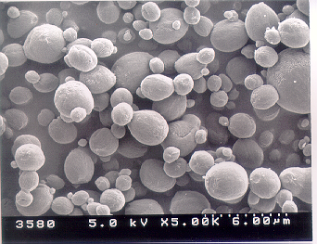
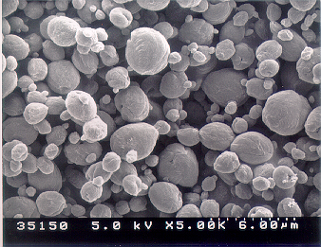
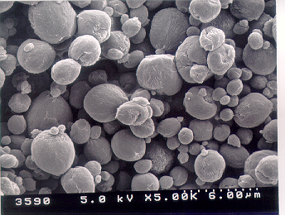
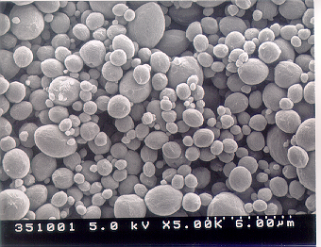
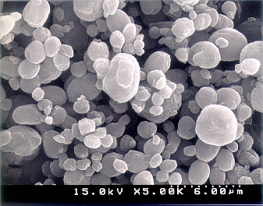
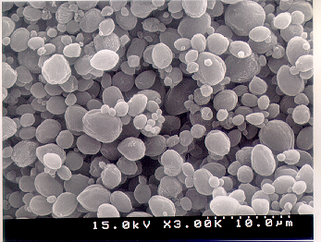
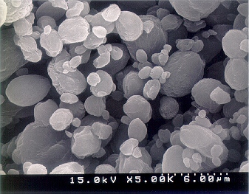
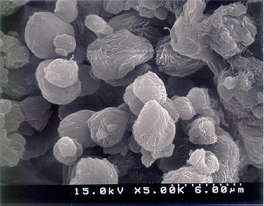
80bar
90bar
100bar
0.3wt%/wt
150bar
0.5wt%/wt
0.7wt%/wt
1.0wt%/wt
Figure 1. Apparatus for SAS recrystallization process of PLLA particles
Figure 2. Effect of particle size distribution on the PLLA particle at 35ºC, 0.5wt%.wt PLLA/CH₂Cl₂
Figure 3. Effect of pressure on the PLLA particle at 35ºC, 0.5wt%.wt PLLA/CH₂Cl₂
Figure 4. Effect of initial solution concentration on the PLLA particle at 150bar, 40ºC

