첨착활성탄에 대한 NOx의 선택적 흡착 특성 - II. 표면 반응

이영환, 최대기, 박진원*
한국과학기술연구원 환경공정연구부, 연세대학교 화학공학과*

Characteristics of Selective Adsorption for NOx on Impregnated Activated Carbon

- II. Surface reaction

Young-Whan Lee, Dae-Ki Choi, Jin-Won Park*
Envrionment and Process Technology Div., KIST,
*Dept. of Chemical Engineering, Yonsei University

Introduction
Nitrogen oxide research in surface science is closely tied to the fact that nitrogen oxides are important molecules in atmospheric chemistry and major components of air pollution. Studies of the surface reaction of nitrogen oxides with impregnated activated carbon are important for both monitoring the level of pollutants in that atmosphere and for reducing the emission of these compounds into the atmosphere. Thus, information gained in fundamental surface chemistry research regarding the bonding interactions with and energetics of molecules on activated carbon with impregnated chemical is necessary in order to improve the technology used in air quality control. Commercial adsorbents for treating harmful gas usually consist of small metal particles dispersed on a stable, high surface area support material such as activated carbon. The selective adsorption site of the adsorbent is generally at the surface of the metal particles. Therefore, the development of or improvement upon efficient impregnated activated carbons requires a good understanding of how adsorbates react on metal surfaces.
The purpose of this study was, through a breakthrough experiment by use of fixed bed adsorption column, to examine surface reaction phenomena according to surface characterization that was adsorbed between NOx and potassium hydroxide impregnated activated carbon (K-IAC).

Experimental
Commercial purpose GAC (Dongyang Carbon Co.) raw material of which was coconut shell was utilized as adsorbent and KOH was used as the impregnating chemical. GAC was divided into a sieve fraction 8/16 mesh, treated with flowing N₂ for an hour at 383K, and then for four hours at 413K. After that, it was dried at 383K and cooled in a desiccator. KOH was impregnated at an aqueous solution state in the GAC with a method of incipient wet impregnation, and was in use after it was dehydrated at 403K. Produced K-IAC was kept in a sealed container to prevent itself from reducing its life in the adsorption of moisture in the air and/or any alien substance around. At this time, cautions were taken to impregnation, drying, and storage of impregnated activated carbon because the processes have great influence on adsorption capacity. Through atomic absorption spectroscopy (AAS) analysis, potassium loading of impregnated activated carbon was confirmed to be 9.96wt. %.
Before and after adsorption, surface analysis was conducted for samples (C/C₀= 0.4∼1.0) by utilizing EPMA (Jeol, JXA-8600) and FT-IR, static type ToF-SIMS (Perkin-Elmer, PHI-7200 ToF-SIMS/SALI). AES/SAM(Perkin-Elmer, PHI-670), XPS (SSI, 2803-S).
The adsorption state of NOx was recorded with an FT-IR spectrometer ( Shimadzu, FT-IR 8200D ) using the KBr method. The phase in the sample was identified by an X-ray diffraction spectrometer (Rigakum RINT-1400) equipped with a rotating Cu anode and a monochromator.
ToF-SIMS analysis was carried out using a system equipped with a two-stage reflectron-type analyser. A low dose and pulsed Cs⁺ primary ion beam, whose impact energy was 10keV, was employed. The spectrometer was run at an operating pressure of 10⁻⁹mbar. The primary ion beam was directed on a square area of 50μm×50μm. The system was operated in high sensitivity mode with a pulse width of 50ns, and with a beam current of 0.5-0.6nA, resulting in a primary ion dose of approximately 4×10¹¹ ions cm⁻² analysis⁻¹. SIMS spectra were acquired over a mass range of m/z=1-300 in both positive and negative modes. In this test, background was corrected by measuring and comparing ICP-AES (Labtest Plasmascan model 710) and ToF-SIMS. At the time of analyzing NOx adsorbed K-IAC, their tendencies were interpreted by comparison with non-adsorbed K-IAC, increasing reliability of data.
The AES spectra and Auger sputter profiles were recorded using the following experimental conditions:primary beam energy Ep = 10keV, primary beam current Ip=0.1 μA and beam diameter ∼0.4μm. The resolution of the cylindrical mirror analyser was set to 0.6%. The argon ion beam, with an ion energy of 1.5keV and a current density of 0.6μAm², was produced by a differentially pumped ion gun. In this analysis, AES was used primarily to determine sample cleanliness. Then it was used quantitatively to help to determine the chemical state of oxygen and nitrogen on the K and C surface. SAM was applied for analysis of the morphology of the K-IAC.
XPS is performed using a double-pass cylindrical mirror analyzer. Survey spectra are taken in the retarding mode with a pass energy of 50eV, and high-resolution XPS spectra are taken with a pass energy of 25 eV using Al Kα X-rays. Data collection is accomplished using a computer-interfaced digital pulse-counting circuit followed by smoothing using digital filtering techniques.

Results and Discussion
This study was based upon this, to examine surface chemistry that is caused by surface characterization adsorbed between NOx and K-IAC (fig. 1.∼fig. 5.).
On K-IAC that is adsorbed to impregnated activated carbon, the following types of ions were discovered. In the first place, K⁺ was notable in the positive spectrum, and peaks of Na⁺, Mg⁺, Al⁺, Si⁺ that are impure materials were discovered as well as that of H⁺ that exists in existing K-IAC. In addition, OH⁻, CN⁻, K⁺, CNO⁻, CO₂⁻, NO₂⁻, KO⁻, CO₃⁻, NO₃⁻ and others were discovered in the negative spectrum. It is verified that fragment peaks mostly exist by aromatic compounds at the m/z that exceeds 1-300m/z.
Decrease of CO⁻ on K-IAC with progress of NOx adsorption has to do with conversion to increased CN⁻ and creation of CNO⁻ supports it. OH⁻ generates H₂O with reaction with NOx and vaporized and decreased at 403K which was the condition of the experiment.
When the pre- and post-adsorption status is compared, NO₂⁻ and NO₃⁻ that hardly existed before adsorption were generated after adsorption at high intensity. Therefore, we could understand that adsorption was under way at adsorption sites in the form of NO₂⁻ and NO₃⁻.
Adsorption site that was composed as KOH can be explained as a phenomenon in which NO₂⁻ and NO₃⁻ produce crystals of KNO₂ and KNO₃ by K⁺ and increase in surface distribution. The experimental result of surface chemistry showed that stronger base OH⁻ that was well developed on the surface due to impregnation of KOH to K-IAC showed high selectivity with NO₂ and improved adsorption source by leading alkaline atmosphere on K-IAC and delaying speed of oxidation reaction to KNO_{3.} In addition, K⁺ played a role that adsorbs crystals of KNO₂ and KNO₃ that are ionic compounds to surface.

Referenece
[1] Bergmans, R. H., Brands, A. L. G. P., Denier van der Gon, A. W., Ceelen, W. C. A. N.,
Brongersma H. H., Bielen, P. and Creemers, C.: Surf. Sci. 350, 1(1996).
[2] Arabczyk, W. and Narkiewicz, U.: Surf. Sci. 377, 578(1997).
[3] Yang, R. T. and Li, W. B., Chen, N.: Appl. Catal A 169, 215(1998).
[4] Overbury, S. H. Mullins, D. Huntley, R. and Kundakovic, D. R. Lj.: J. Catal 186, 296
(1999).
[5] Gayone, J. E., Sanchez, E. A. Grizzi, O., Passeggi Jr, M. C. G., Vidal, R. A. and Ferron,
J.: Scrf. Sci. 454, 137(2000).
[6] Pietrogiacomi, D., Tuti, S., Campa, M. C. and Indovina, V.: Appl. Catal. B 28, 43(2000).

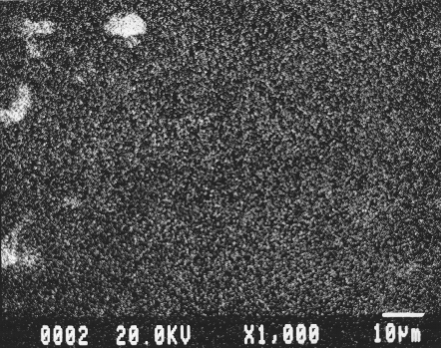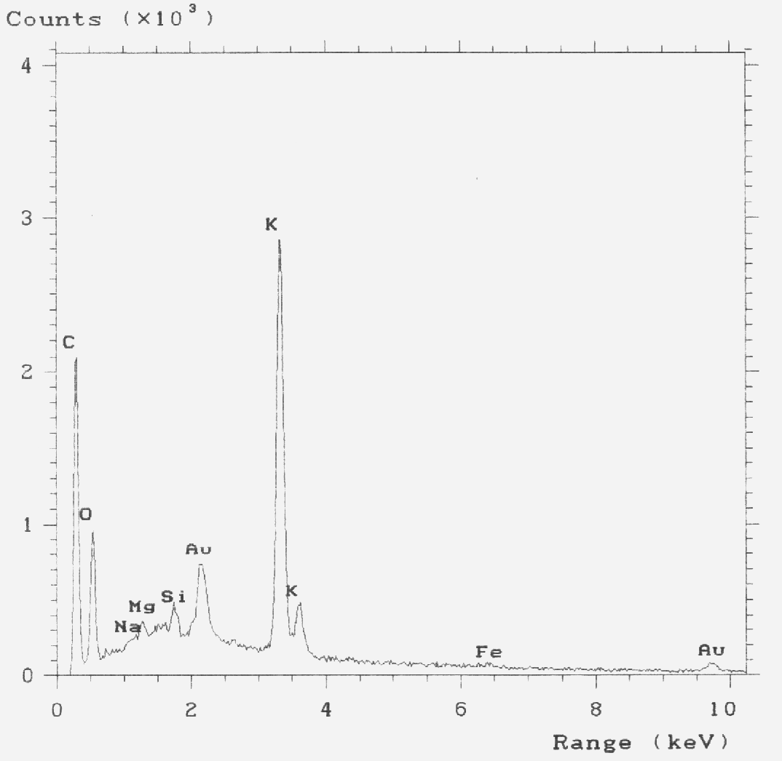

Fig. 1. K elemental dot mapping result Fig. 2. EDX spectrum for NOx adsorged
of K-IAC. on K-IAC.

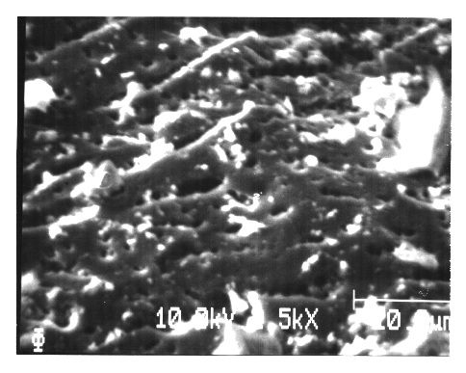

Fig. 3. SAM photograph of the K-IAC
surface. NO₂ : 400ppm, T : 403K,
L.V: 30cm/sec, 5hr adsorbed.

Fig. 4. SIMS depth profiles of NO₂⁻and NO₃⁻. Fig. 5. XPS spectrum for NOx adsorbed

K-IAC and Nitrogen 1s spectra

illustrating the effect of smoothing.

