유동층 촉매중합 반응에서 입자크기 분포에 기반한 분자량 분포

서동철, 강달영*, 이홍희
서울대학교 응용화학부, 성균관대학교 화학.고분자 및 섬유공학부*

Molecular Weight Distribution based on Particle Size Distribution in Fluidized-bed for Catalytic Polymerization

Dong-Chul Suh, Dhal-Young Khang*, Hong H. Lee
School of Chemical Engineering, Seoul National University,
Chemical Polymer Textile Engineering, Sungkyunkwan University*

Introduction
The gas phase polymerization processes, such as UNIPOL, HIMONT, etc., are the most recently developed. Among the many outstanding features of this new process, the low pressure operation (~30 atm) and no further requirements of the separation step after polymerization are the most distinguishing characteristics.
It is a well-known fact that this gas phase processes yield very broad molecular weight distribution (MWD). To explain this broad MWD, there were two suggestions: the existence of more than one types of active site on the catalyst surface, and the existence of concentration gradients within the growing polymer particles caused by diffusional phenomena. In this work, the other origin of the broad MWD is suggested and the hierarchical process modeling is developed.

Theory
Assuming no elutriation of fine particles and no particle breakage nor agglomeration, the population balance at steady state leads to the following dimensionless particle size distribution :
$f(R)=\int{a_{1}g_{i}(ξ)\text{exp}\left(−\int{g(x)\text{dx}+}\int{g(x)\text{dx}}\right)} dξ$ (1)
where $g(R)≡\frac{G^{'}(R)+1/{τ_{0}}}{G(R)}$, $G^{'}(R)≡\frac{\text{dG}(R)}{\text{dR}}$, $g_{i}(R)≡\frac{f_{i}(R)}{G(R)}$, $a_{1}≡\frac{Q_{c}}{V}$, $τ_{0}≡\frac{V}{Q_{0}}$
A few comments are in order here. Given the feed PSD, f_{i}, and the reactor operating conditions, the resulting PSD in the bed is that given by eq. (1). Those of reactor conditions are represented by τ₀ and a₁ in eq. (1).
The MWD of the particle in terms of weight fraction, w_{j}(R), which is a function of its size, can be written as
$w_{j}≡\frac{{\text{jS}}_{j}+{\text{jM}}_{j}}{\sum{{\text{jS}}_{j}+\sum_{j=2}{{\text{jM}}_{j}}}}=\frac{j\left(S_{j}+M_{j}\right)}{Y_{1}+Z_{1}}$ (2)
where j denotes the number of monomer unit, S_{j} and M_{j} are the concentration of living and dead polymer with j unit of monomer attached, respectively. The species are used interchangeably for concentration hereafter. Y_{n} and Z_{n} are the n-th moments of the living and dead polymers defined as
$Y_{n}=\sum_{j=1}^{∞}{j^{n}S_{j}}, Z_{n}=\sum_{j=2}^{∞}{j^{n}M_{j}}$ (3)
Note here that the summation in the definition of Z_{n} starts from 2, because j=1 is simply gaseous monomer, not a polymer of chain length one.
The MWD in the reactor in terms of weight fraction, M_{j}(R), which is a function of its size, can be written as
$M_{j}(R)=\frac{\int{w_{j}(R)f(R)\text{dR}}}{\int{f(R)\text{dR}}}$ (4)
where w_{j}(R) and f(R) denote MWD of a single particle in terms of weight fraction in eq (2) and PSD in the reactor derived in (1), respectively.

Results and Discussion
The bed operating conditions are shown in Fig. 2. In operating conditions labeled as 1 and 3, the only one particle size distribution exists at a given set of operating conditions. On the other hand, the particle size distribution curve labeled 2 and 4 corresponds to the two different sets of operating conditions, denoted by empty rectangle. In other words, the process operation at two different operating conditions (e.g., two different bed temperatures) yields the same particle size distribution result. Note that the values of the operating variables which lead to the particle size distribution multiplicity are in the realistic range, which means that this behavior is not academic interest only.
In a single polymer particle it can be seen that the distribution shifts to a lower molecular weight having a longer tail end when particle size becomes larger and monomer diffusional effects included. This can be explained as : in the presence of severe diffusion resistance, the outer region of the growing polymer particle experiences a higher monomer concentration than the inner regions does. Thereby, polymer having significantly different molecular weight might be produced in the particle, and this leads to the broader molecular weight distribution. As the particle grows, this effect is becomes more significant than in the small particles (see Fig. 3).
The molecular weight distribution in the reactor including particle size distribution is shown in Fig. 4. In case of neglecting particle size effect, molecular weight distribution seems to be narrow. It is found that the molecular weight distribution curves tend to be broadened in both the monomer diffusion-included and the diffusion-neglected cases. The monomer diffusion induce the molecular weight distribution in the reactor more broad as that in a single polymer particle This is because each particle with different radii have different effectiveness factors, and, from the surface of polymer particle to core, the reaction rates change continuously.

References
Nagel, E. J., V. A. Krillov, and W. H. Ray, Ind. Eng. Chem. Prod. Res. Dev., 19, 372 (1980)
Xie, T. and K. B. McAuley, J. C. C. Hsu, and D. W. Bacon, Ind. Eng. Chem. Res., 33, 449 (1994)
McAuley, K. B., D. A. Macdonald, and P. J. McLellan, AIChE J., 41, 868 (1995)
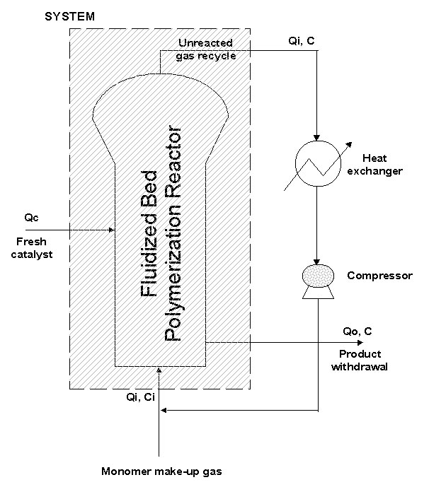
Fig. 1. The simplified diagram of the fluidized Fig. 2. The catalyst weight fraction as a
-beds gas-phase olefin polymerization process function of feed rate(bed temperature)
Fig. 3. The effect of monomer diffusion on MWD Fig. 4. The effect of PSD on MWD in the reactor
in a single polymer particle at k_{p} = 85 l/mol⋅s
1: 0.23cm, no diffusion, 2: 0.23cm, monomer diffusion 1: case of neglecting PSD
3: 0.21cm, no diffusion, 4: 0.21cm, monomer diffusion 2: case of including PSD (no diffusion)
5: 0.19cm, no diffusion, 6: 0.19cm, monomer diffusion 3: case of including PSD with monomer diffusion

