LLDPE의 Melt Fracture현상과 질화 붕소가 LLDPE의
가공성에 미치는 영향에 관한 연구

이상명, 김정곤, 이재욱

서울시 마포구 신수동 1번지 서강대학교 화학공학과

A Study on the Melt Fracture Phenomena and the Effect of

Boron Nitride on the Processability of LLDPE

Sang Myung Lee, Jung Gon Kim, and Jae Wook Lee
Dept. of Chemical Engineering, Sogang University,
1 Shinsu-dong, Mapo-ku, Seoul

Introduction
Over the years, due to the importance of polyethylene in the plastic industry, the studies on extrusion instability have received considerable attention. It is well known that the melt fracture of various shapes and related processing instabilities continue to limit processing rate in many commercially important polymer processing [1,2]. Therefore, over the critical processing rate occurring melt fracture or flow instability, the melt fracture was fallen off in quality and mechanical properties of final product. In this study, to increase processing rate and improve the quality of final product, a commercial LLDPE was modified by adding small amount of Boron Nitride(BN) during extrusion. When the neat LLDPE was modified by adding various BN contents, we investigated about the effects of BN on the rheological properties, extrudate swell ratio, processability of LLDPE. Also, processability of capillary flow was investigated as functions of temperature, applied shear rate and the length to diameter (L/D) ratio for the neat LLDPE. Additionally, The relationship between the apparent characteristic relaxation time and the critical shear rate for the onset of melt fracture and slip was discussed.

Theory
A characteristic relaxation time may be a relevant quantity to formulate a correlation for the onset of melt fracture and slip. Based on these studies, a hypothesis may be proposed that a balance between its viscous (viscosity) and elastic properties (recoverable shear) affect the melt fracture behavior of the polymer. This hypothesis was testified by calculating characteristic relaxation times for all polymers at the onset of melt fracture and slip. Such an apparent characteristic relaxation time, λ, can be defined [3] as the ratio of polymer viscosity, η, and shear modulus, G, that is: λ = η/G
The shear modulus can be estimated through the measurement of extrudate swell at the onset of melt fracture and slip, such that is: G = τ/γ∞
σ is the shear stress, γ∞ is the recoverable shear strain at the die wall. The value of γ∞ for different polymer samples were calculated from the following equation:
$B_{L}^{2}=\frac{2}{3}γ_{∞}\left[{\left(1+\frac{1}{γ_{∞}^{2}}\right)}^{\frac{2}{3}}−\frac{1}{γ_{∞}^{3}}\right]$

where B_{L} is the extrudate swell ratio.

Experimental
We used LLDPE (Exact® 4033) to the experiment. It is an ethylene-alpha olefin copolymer produced via single site metallocene catalyst technology. Its molecular structure includes short chain branching of butene on about the main chains. The specifications of Exact 4033 are shown in Table 1. We used the boron nitride as additive. It is produced by Carborundum (CarbonTherm® type CTUF). The BN particles in a finely divided state were thoroughly dry-mixed with the resin pellets at appropriate contents. Mixing of LLDPE with BN was performed using a twin screw extruder. The processability of both the neat resin and the resin containing BN in term of their melt fracture performance was assessed using a capillary rheometer (Goettfert, Rheograph 2003) at various apparent shear rates and temperatures. The capillary rheometer was employed with three sets (L/D = 10, 20, 30) of capillary dies. Three sets of capillary die have a diameter equal to 1mm, an entry angle of 180º and were made in tungsten carbide. To allow a rapid quenching of the extrudates and to avoid stretching by gravity forces, a cooling bath was placed below a few centimeters from the die exit. Linear viscoelastic data were obtained using a parallel-plate rheometer (ARES, Rheometric Scientific) at dynamic frequency sweep mode with a fixed strain of 10%.

Results and discussion
Typical extrudate samples of the neat resin obtained at various apparent shear rates under temperature of 120ºC are shown in Fig. 1. As shear rate is increased the extrudate strand starts to show the surface melt fracture as known sharkskin at 10.9 s⁻¹. The amplitude and wavelength of sharkskin were increased with increasing shear rate from 10.9 to 30.46 s⁻¹. In the stick-slip, the surface of the extrudate in the stick region shows the formation of sharkskin, while it is smooth in the slop region. In the slip region, the surface of the extrudates appears smooth, and further increase in the shear rate promotes wave and gross melt fracture in the extrudate surface. Fig. 2 shows that the effects of L/D on form of extrudates at apparent shear rate of 29.0s⁻¹. In the Fig. 2, amplitude and wavelength of sharkskin defect were reduced when the length to diameter ratio of the die is increased for a given shear rate. This means that there seems by the reason of memory effects of polymer. Fig. 3 shows the effects of temperature on extrudates at constant shear rate of 20 s⁻¹. Sharkskin was characterized as functions of the applied stress or shear rate and temperature. In the result, as the temperature increases at a shear rate of 20 s⁻¹, amplitude and wavelength of sharkskin decreased, and the surface of the extrudate appears smooth at 160ºC. Fig. 4 presents six flow curves obtained for the resin with and without BN using a capillary die with L/D of 30 and diameter of 1 mm at 180ºC. The neat resin starts exhibiting melt fracture at apparent shear rates over 54 s⁻¹. Surprisingly, as shown in the result, the resin containing boron nitride content of 0.5 wt% exhibits melt fracture at shear rates over 600 s⁻¹. However, higher content of BN did not completely eliminate sharkskin at low shear rates. Therefore, this is surmised that there exists a critical content leading to optimum performance. As shown in Fig. 5, to study about the effect the addition of BN on rheological property of the resin, linear oscillatory shear experiments were carried out for the resin with and without BN using a parallel-plate rheometer. In the result, it seems that no significant difference was found in the linear viscoelastic behavior of the neat and filled resins. Fig. 6 shows the critical apparent shear rate of the neat and resin containing BN of 0.5 wt% at various temperatures. As a result, surprisingly, the resin containing BN of 0.5 wt% is not appeared the sharkskin region at temperatures of 120 and 150 ºC. Moreover, the stick region of the extrudate appears smooth in the stick-slip range. Also, the diameter of extrudate in the slip region is larger than its in the stick region. As shown in Fig. 7 and Fig.8, the critical apparent shear rate for the onset of melt fracture and slip of resins containing various BN contents was observed to decrease with increasing the relaxation time. Also, when BN content is 0.5 wt%, the apparent characteristic relaxation time at the critical apparent shear rate for the onset of melt fracture and slip appears a lowest value.

Conclusion
We found that the critical apparent shear rate and the shape of extrudate are highly dependent on processing temperature, L/D, and content of BN. We also found that only the addition of BN content of 0.5 wt % in Exact 4033 eliminate or delay sharkskin, stick-slip melt fracture and delay gross melt fracture to much higher rates, even though there is no difference of the linear viscoelastic properties for the neat resin and filled resins. The critical apparent shear rate for the onset of melt fracture and slip was found to drop considerably with increase in the apparent characteristic relaxation time.

Reference
1. Eugene E. Rosenbaum, Savvas G. Hatzikiriakos, ANTEC’98, 952-956 (1998).
2. Franky Yip, E. E. Rosenbaum, and Savvas G. Hatzikiakos, ANTEC’99, 1223-1227 (1999).
3.F.N. Cogswell, Polymer Melt Rheology-A Guide to Industrial Practice,
John Wiley & Sons (1981).

Table 1. Lists of molecular information on studied polyethylene resin.

Polymer | M_{W} | M_{W}/M_{n} | T_{m}(ºC) | ρ(g/cm²) | MI(g/10min) | E_{a}(KJ/mol)
Exact 4033 | 178300 | 1.99 | 63 | 0.88 | 0.8 | 33.69
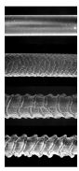
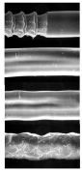
.
.
.
.
.
.
.
.
.
.

Fig. 1. The photograph of the neat Exact 4033 extrudates at various apparent shear rates.
( T=120ºC, L/D=30 mm, D=1mm, 180º entry angle )
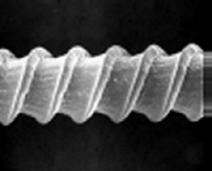
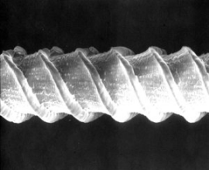
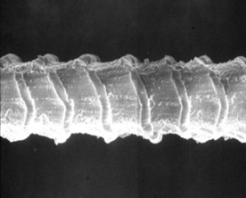
L/D = 10 L/D = 20 L/D = 30

Fig. 2. The effect of L/D on sharkskin at apparent shear rate of 29.0 s⁻¹.
(neat Exact 4033, T=120ºC, L/D=30 mm, D=1mm, 180º entry angle)
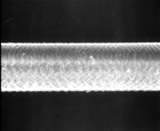
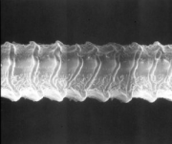
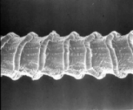
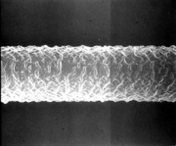
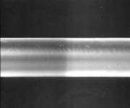
120ºC 130ºC 140ºC 150ºC 160ºC

Fig. 3. The photograph of the neat Exact 4033 extrudates for various temperatures at constant apparent shear rate of 20.0 s⁻¹.

Fig. 4 Apparent wall shear stress vs. app-
arent shear rate for Exact 4033 with and
Fig. 5. Linear viscoelastic data for Exact 4033 with and without BN at 180ºC.

without BN at 180ºC.
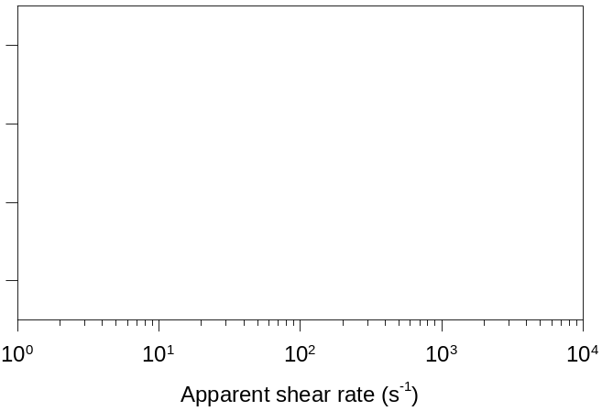
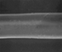
Neat Resin
Neat Resin
BN 0.5
BN 0.5
120 ºC
120 ºC
150 ºC
150 ºC
gross fracture
smooth
sharkskin
stick-slip
slip
Stick region
Slip

Fig. 6. Range of the critical apparent shear rate for the neat resin and resin containing BN
0.5 wt % at various temperatures.
Fig. 7. The relationship between the critical Fig. 8. The relationship between the critic-
apparent shear rate for the onset of melt fra- al apparent shear rate for the onset of slip
cture and the relaxation time for Exact 4033 and the relaxation time for Exact 4033 co-
containing various BN contents. ntaining various BN contents.

