전기장에서 거대결정성 콜로이드 집합체의 제조

문준혁, 이기라, 양승만
한국과학기술원 화학공학과

Macrocrystalline colloidal assemblies in an electric field

Jun Hyuk Moon, Gi-Ra Yi, and Seung-Man Yang
Department of Chemical Engineering
Korea Advanced Institute of Science and Technology, Taejon 305-701

Introduction
Macrocrystalline colloidal assemblies show great promise as building block for advanced materials. Closely packed crystals display a number of potentially applicable characteristics such as photonic crystals [1], high packing density and surface-to-volume ratio, maximal structural stability, and high catalytic/reactivity throughput. For practical application of these structures, the crystals should be mounted or shaped into usable objects. a number of methods have been exploited using colloidal crystallization in confined geometry. One of the simplest approaches involves the use of suspension droplet as confined geometry. When the suspension droplet is dried, the crystallization of submicron-sized colloidal particles occurs inside the droplet leading to highly ordered colloidal assemblies [2]. Such structured materials have an important application as chromatography and biocatalyst [3]. Complex composite assemblies can be fabricated when the original drop contains a mixture of two or more different particles. Such anisotropic particles can be manipulated by electric or magnetic fields and can find application in electronic paper [4]. In the previous works, the shapes of assemblies were controlled by means of thermodynamic properties, which led to assemblies with several symmetric shapes such as spherical and disk [3]. However, in many practical applications, asymmetric shape may be of considerable significance [4]. Therefore, we designed the shape of the drop by use of an AC electric field.

Theory
Under an ac field, a liquid drop suspended in an immiscible liquid deform and oscillate, which is due to the electric and the hydrodynamic stresses at the interface between the drop and the medium. We defined the total deformation in terms of the major and minor axis lengths of deformed drop. We wrote this as the sum of a steady component and an oscillatory component [5]:
(1)
First, the steady deformation stems from the balance of the sum of the steady electric and hydrodynamic normal stresses at the interface and the interfacial tension because of changes in surface curvature accompanying deformation of the drop.
(2)
where is the interfacial tension, is the permittivity of free space and is the ratio of the drop.
(3)
where , , is the resistivity ratio, the dielectric constant ratio and the viscosity ratio, respectively.
Second, the oscillation deformation results from the balance of the total oscillating normal stress at the drop surface and interfacial forces through oscillation.
(4)
(5)
where is the frequency.
the steady value we consider the ratio:
(6)
The dimensionless parameter k that characterize () represents the ratio of the oscillatory hydrodynamic stress () and the capillary pressure () at the drop interface. When ()and () remains fixed, and (), the drop surface being unable to respond to the oscillating stress. Therefore, we can obtain the steady deformation without electrophoresis.

Experimental
In this study, we dispersed polystyrene latex particles inside the droplets, and applied an AC electric field to the aqueous droplet floating on the partially fluorinated oil (Shin Etsu: FL-100, viscosity = 1 ). In a DC field, a liquid drop suspended in an immiscible liquid occurs the electrophoresis : the drop translated when it acquired a small net electric charge. In order to eliminate the electrophoresis during the drying of the suspension droplet, we use an AC field. During the evaporation of the drop-phase liquid, the aqueous suspension droplet containing the polystyrene particles become macrocrystalline particles with the deformation induced by the applied electric field.
Aqueous droplets of colloidal suspension were placed on the surface of the partially fluorinated oil (Fig. 1). The suspension droplets, of initial volume of 40 micro-liters, contained 10 % in volume of negatively charged polystyrene latex micro-spheres of 200-320 nm in diameter.

E
Side view
Suspension drop dropdroplet
E
Oil
Top view
Electrode

Figure 1. Schematic of the apparatus

The droplet shrank as a function of the elapsed time (Fig. 2). After 6 hours, the macrocrystalline crystalline structure was extracted from the oil and dried out. In the absence of the electric field, the assembly process yielded smooth spherical assemblies 1 to 2mm in diameter (Fig. 3A). The surface of these balls was bright and its color depended on the size of the PS latex particles. The color is from light diffraction by the colloidal arrays, indicating long-range ordering of the PS latex particles. In an electric field, we get a spheroidal shape (Fig. 3B) and the deformation of the particle increases with electric field intensity.
Figure 2. Variation of the drop size according to the evaporation

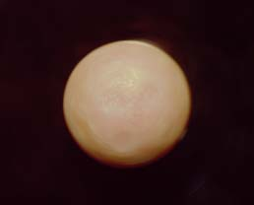
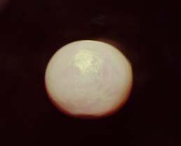
1mm
1mm
A
B

Figure 3. Macrocrystalline particle without (A), and with the action of an electric field (B).

Results
Cross-sectional images of scanning electron microscopy (Fig. 4) suggest that the interstices of colloidal assemblies were filled with silicone oil. To use this particle as structured porous materials, oil infiltration should be avoided, or even in the worst case, infiltrated oil should be removed. The infiltration is mainly due to the high viscosity of the oil (Fig. 4). We can infer that the oil diffused into the drop during the evaporation and flow out while the particle being dried

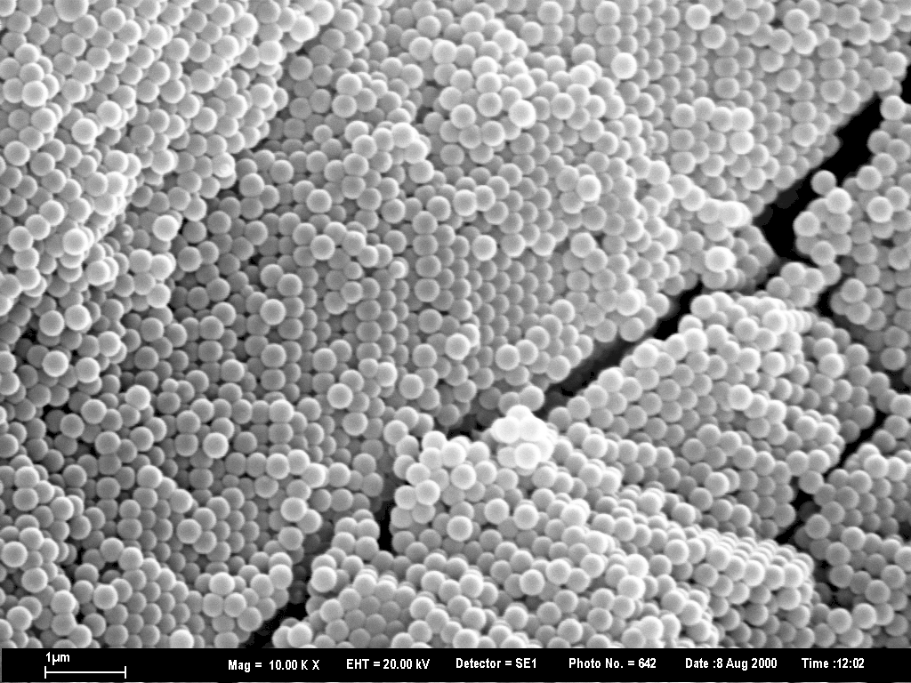
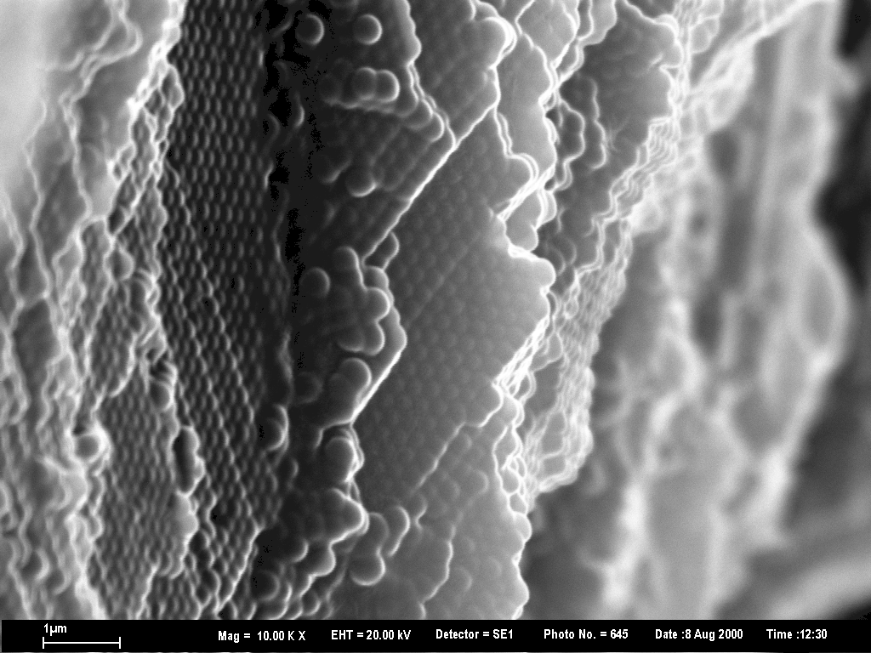
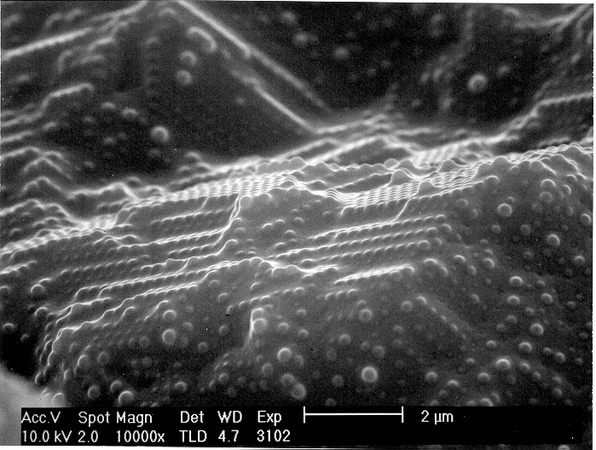
A
B
C

Figure 4. (A) The oil infiltrates and remains inside the particle. From the image of particle that has been in the silicone oil of 0.01 (B) and 1 (C), we find the higher viscosity keep the medium oil from infiltration.

We removed the infiltrated oil by solvent extraction. the partially fluorine-substituted silicone oil was able to remove by hexane or diluted HF, which did not dissolve the colloidal crystals of polystyrene (Fig. 5).
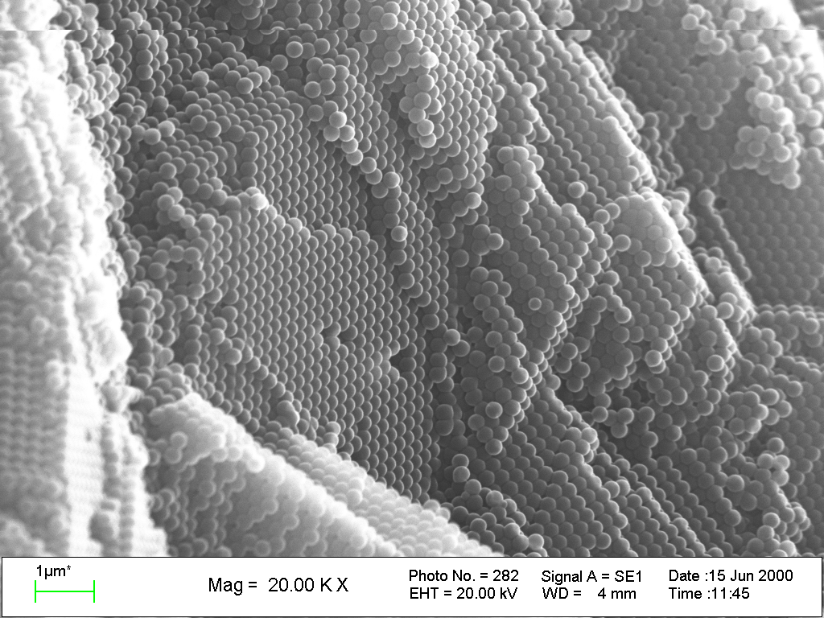

Figure 5. Image which is free from the infiltrated oil by treating with the solvent.
Figure 6. Plot of the deformation to the volume fraction of the suspension drop.
Deformation of the particle reduced during evaporation (Fig. 6). This is because electrical property, size and viscosity change as the time increasing. Therefore, for obtaining the properly deformed particle, we raised the electric field intensity during evaporation. By the equation (2) mentioned above, we could plot the deformation to . There was a large deviation from the equation, which is probably due to the assumption of the equation (Fig. 7A, 7B).
Figure 7. Plot for the volume fraction of 10% (A) and 40% (B). The deviation from theory increases as the fraction increases.

References

1. J. E. G. J. Wijnhoven and W. L. Vos, Science 281, 802 (1998)
2. O. D. Velev, A. M. Lenhoff and E. W. Kaler, Science 287, 24 (2000)
3. F. Svec and J. M. J. Frechet, Science 273, 205 (1996)
4. B. Comiskey, J. D. Albert, H. Yoshizawa, J. Jacobson, Nature 394, 253 (1998)
5. S. Torza, R. G. Cox and S. G. Mason, Proc. Roy. Soc. Lond. 269, 27 (1970)

