Di-2,4,4-trimethylpentyl phosphinic acid를 함침시킨 중금속 흡착제의
재생에 관한 연구

차순우, 배은주, 이종협
서울대학교 응용화학부

Regeneration of adsorbents impregnated with Di-2,4,4-trimethylpentyl phosphinic acid

Soonwoo Chah, Eunjoo Bae and Jongheop YI
School of Chemical Engineering, Seoul National University

Introduction
Water pollution, which results from the release of heavy metal ions from industrial wastewater causes a serious environmental problem. Waste streams from industries contain a variety of metal ions, such as copper, nickel, zinc, cobalt, chromium (+6), lead, mercury, and aluminum.¹
Solvent extraction has been widely used to remove metal ions from aqueous streams, but it is well known that this procedure is ineffective for aqueous metal concentrations below 0.01 mol/L.² So, several adsorption technologies for removing heavy metals from dilute metal waste streams, which include silica supports impregnated with ion-chelating agents have been studied.³⁻⁴
The prepared silica with chelating agents has certain advantages over other methods, such as simplicity, no swelling and sludge free operation. However, many ion-chelating agents may not contain a reactive functional group that is suitable for chemical bonding with a silanized inorganic surface, and it is not adequate to be used in the industrial process.
In this study, we focused on the regeneration of silica adsorbents to examine the possibility to apply this material to industrial processes. Di-2,4,4-trimethylpentyl phosphinic acid whose bonding force is known to be physical attraction such as Van der Waals force was used as a chelating agent. Characterization of first-prepared adsorbents was compared with that of regenerated adsorbents by several analyses.

Experiments
Preparation. Two silica supports were used to prepare adsorbents impregnating di-2,4,4-trimethylpentyl phosphinic acid; solid support and hollow sphere. Solid supports were purchased from Aldrich Co. and hollow spheres were prepared at the laboratory. The procedure of hollow spheres was explained in another paper.⁵
Dried silicas (hereafter referred as SP) of 10 g were shaken for 16 hours with dichlorodimethylsilane of 40g. The silanized silicas were dried under vacuum at 30 mmHg, 100℃, to remove unreacted silane. The dried silica was washed with deionized water to eliminate residual HCl and dried again at 30 mmHg, 100℃. The silicas which had been silaned with dichlorodimethylsilane were designated SPD respectively.
For the impregnation with CYANEX 272, 40 g of a 20 wt % CYANEX 272 solution, mixed with 80 wt% toluene, was added to each flask containing 10 g of silanized silicas (SPD). The flask was shaken gently on a rotating shaker for 2 h. The impregnated silica was separated from the solution, dried at atmosphere and successively at 110℃ to evaporate the toluene completely. The impregnated silicas were designated SPDC.
Adsorption and regeneration. The SPDC were treated with two acidic solutions (0.1 M HCl, and 1.0 M HCl), an alkaline solution (0.01 M NaOH) and deionized water at pH 4.5 for 7 days, respectively. The treated samples of 0.2g were suspended in 25ml of 5mmol/L zinc solutions for 24 h, in order to examine the change of zinc adsorption capacity. Zn²⁺ adsorbed SPDC is referred to as SPDCM.
SPDCM was regenerated with 0.1 M HCl on the basis of the stability test. Successive adsorption and elution cycles were conducted using a column reactor, in order to determine changes in the samples after regeneration. 200ml of a 0.2M Zn(NO₃)₂ solution was fed to the reactor for 2 hour, and 100 ml of 0.1 M HCl solution was then fed to the reactor in order to desorb the zinc ions from the adsorbents. The elution time was 3 h. A successive operation of adsorption and elution was repeated for 11 cycles. The SPDCM that has undergone 10 cycles of regeneration is referred to as SPDCMR. A schematic showing the preparation, adsorption and regeneration is shown in Fig. 1.
Characterization. Five characterization methods were performed for samples (SP, SPD, SPDC, SPDCM and SPDCMR) at each step. The surface change of adsorbents was examined by SEM (Jeol, JSM-840A). FT-IR (Jasco, FT/IR-200) was used to compare the components of SPDC and SPDCMR. CHNS Corder (Yanaco, MT-2) was used for elemental analysis to determine quantitatively the amount of organic molecules in each substrate. Changes in surface area, average diameter and pore volume were examined with BET (Micromeritics, ASAP 2010) data. The concentrations of metal ions adsorbed on each substrate were determined using an Atomic Absorption Spectrometer (Perkin-Elmer, Model 3110).

Fig. 1. Schematic of preparation, adsorption and regeneration.

Results and Discussion
The surface was examined with scanning electron microscopy. Fig. 2 shows the surface of SPDCM and SPDCMR.

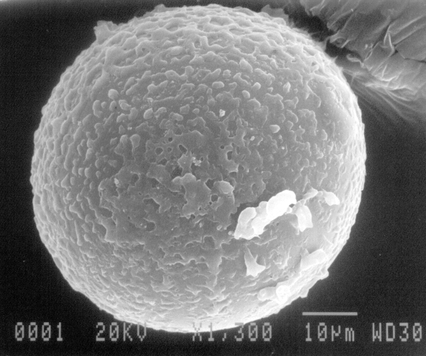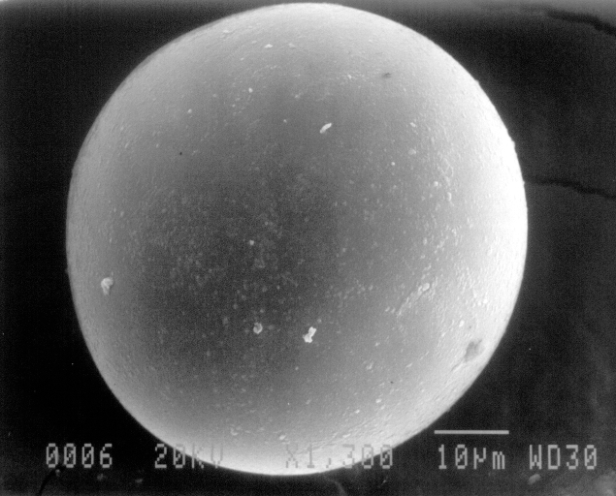
(a) (b)
Fig. 2. Scanning electron microscopy of (a) SPDCM (c) SPDCMR.
The surface on which zinc ions were adsorbed has something, maybe zinc ions, but the surface that was treated with 0.1 HCl was smooth. The surface after regeneration(SPDCMR) was the same as that of first prepared silica(SPDC).
Fig. 3 shows the FT-IR data for SPDC and SPDCMR. The peak for SPDCMR was nearly the same as that of SPDC. The C-H peak near 3000 cm⁻¹ and CH₂ peak near 1480 cm⁻¹ remained after the regeneration. This represents additional proof that the composition of SPDC is qualitatively similar to that of SPDCMR.
The result of elemental analysis with CHNS corder is shown in Fig. 4. SP contains no carbon or hydrogen, since it is composed exclusively of Si and O. The fraction of carbon and hydrogen of SPD is 6.89% and 1.89% because of the carbon and hydrogen in dichlorodimethylsilane, and a higher level of carbon and hydrogen was shown for the case of SPDC. However, SPDCMR which had been regenerated with 0.1M HCl or 1.0M HCl was not significantly different from SPDC in terms of carbon and hydrogen contents. This constitutes proof that SPDC and SPDCMR contain the same components.
Fig. 3. FT-IR data for SPDC and SPDCMR Fig 4. Carbon and hydrogen analysis of SP,
regenerated with 0.1M HCl. SPD, SPDC, SPDCMR regenerated with
0.1M HCl, and SPDCMR regenerated with
1.0M HCl.

The surface area, pore volume and isotherm data of SPDCMR were analyzed with BET, and compared with the SPDC data that was discussed above. The surface area, pore volume of SPDCMR were 56.2 m²/g, 0.28 cm³/g while those of SPDC are 53.7 m²/g, 0.27 cm³/g. N₂ adsorption-desorption isotherm of SPDC and SPDCMR at Fig. 5 showed the similar tendency, as well. Although the values were slightly different, it could be inferred that the structure of SPDC remained intact after the regeneration.
The above data proves that SPDCMR is almost similar to SPDC in terms of components and structure. However, the more important issue was whether the regenerated silica, SPDCMR actually had the same adsorption capacity for heavy metal ions as SPDC.
In order to investigate the effect of repeated use on SPDC capacity, successive adsorption and regeneration rate data for SPDC were obtained using a packed-column reactor. 0.5 g of an SPDC sample was treated with a zinc solution (200 ml, 2mmol/L, pH 4). Then, 100 ml of 0.1 M HCl solution was fed to the reactor at a rate of 5 ml/min, in order to desorb the zinc ions from the adsorbents. This operation was repeated for 11 cycles. The adsorption and desorption operation times were 2 and 3 h, respectively. The results provided data relative to the effect of recycling on adsorption capacity. Fig. 6 shows changes in zinc adsorption capacity for successive operations. The adsorption capacity increased from 0.23 mmol/g for the first operation to 0.28 mmol/g for the 11th operation. Bars above and below each point of Fig. 6 represent the maximum and minimum points of analyses. Standard deviations of each point were from 5.77e-4 to 0.00289, and error range of data was very narrow. The initial low adsorption capacity can be explained by the low adsorption rate due to surface hydrophobicity. It was found that treatment of SPDC with acidic solutions increased the adsorption rate and regeneration capability. These results indicate that SPDC is regenerable and efficient in cyclic use.
Fig. 5. Isotherm of SPDC and SPDCMR Fig. 6. Successive adsorption-regeneration of
regenerated with 0.1M HCl. SPDC. SPDC 0.5 g, zinc solution 2 mmol/L;
200 ml; pH 4, regeneration solution 0.1 M
HCl; 100 ml, adsorption operation time 2 h,
regeneration time 3 h.

Reference
- Alimarin, I., Fadeeva, V., Kudryavtsev G., and Loskutova, I.: Talanta, 34, 103 (1987)
- Deorkar, N. V., and Tavlarides, L. L.: Ind. Eng. Chem. Res, 36, 399 (1997)
- Fadeeva, V. I., Tikhomirova, T. I., Yuferova, I. B., and Kudryavtsev, G. V.: Anal. Chim. Acta, 219, 201 (1989)
- Tikhomirova, T. I., Fadeeva, V. I., Kudryavtsev, G. V., and Nesterenko, P. N.: Talanta, 38, 267 (1991)
- Bae, E. J., Chah, S. W., and Yi, J.: Journal of Colloid interface science, submitted
- Kim, J. S., and Yi, J.: Separation Science and Technology, 34(15), 1 (1999)
- Kim, J.S., and Yi, J.: J. Chemical Technology and Biotechnology, 74, 544 (1999)
- Kim, J. S., Chah, S. W., and Yi, J.: Korean Journal of Chemical Engineering, 17(1), 118 (2000)

