탄소원에 의한 Anaerobiospirillum succiniciproducens의 발효산물의 생성변화

이평천, 이우기, 이상엽, 장호남
한국과학기술원 화학공학과

Effect of carbon sources on the end-product profile of Anaerobiospirillum succiniciproducens

Pyung Cheon Lee, Woo Gi Lee, Sang Yup Lee, Ho Nam Chang

Department of Chemical Engineering, Korea Advanced Institute of Science and Technology 373-1, Kusong-dong, Yusong-gu, Taejon, Korea, 305-701

Introduction
To date, succinic acid has been produced commercially by chemical processes. Recently, however, fermentative production of succinic acid from renewable biomass by anaerobic bacteria has attracted great interest [1]. An anaerobic bacterium Anaerobiospirillum succiniciproducens has been considered as one of the best succinic acid producers because it can produce a significant amount of succinic acid from glucose and lactose [2-4].
It is well known that the presence of by-product such as acetic acid can negatively affect the purification process of succinic acid. Lee et al [2]. reported that acetic acid was also produced as a by-product with a gram ratio of succinic acid to acetic acid of 4:1 in the fermentation of A. succiniciproducens from glucose. Acetic acid formation reduces succinic acid yield and makes purification of succinic acid more difficult and costly. Therefore, fermentation process for succinic acid production with reduced acetic acid formation should be developed for better fermentation performance and economical purification of succinic acid.
Glycerol is an attractive carbon substrate for biological conversion because it is available from renewable resources in large amounts and can be utilized by a number of microorganisms [5]. Glycerol is produced as a surplus by-product in the growing oleochemical industries for the production of soaps, fatty acids, waxes and surfactants. Therefore, several environmentally friendly processes based on microbial fermentation have been proposed for glycerol utilization. To date, however, succinic acid production from glycerol has not been reported.
In this study, we report that glycerol has a significant effect on the production of succinic acid and acetic acid.

Materials and methods
Organism and growth conditions. Anaerobiospirillum succiniciproducens (ATCC 29305) was obtained from the American Type Culture Collection (Rockville, MD). Cells were grown in sealed anaerobic bottles containing 100 mL minimal salts medium1 (AnS1) containing 5 g/L glucose, 10 g/L yeast extract with CO₂ as the gas phase. The AnS1 medium contains per liter, 3 g K₂HPO₄, 1 g NaCl, 1 g (NH₄)₂SO₄, 0.2 g CaCl₂2H₂O, 0.2 g MgCl₂6H₂O, and 1 g Na₂CO₃. The medium was heat sterilized (15 min at 121ºC) in anaerobic bottle with nitrogen headspace and inoculated with 2.5 mL glycerol stock culture and incubated at 39 ºC for 15-16 h. Batch cultures were carried out at 39 ºC in a jar fermenter (2.5 L) containing 1 L of minimal salts medium2 (AnS2) containing 3.5-10 g glycerol, 5 g yeast extract. In case of cofermentation, the AnS2 medium containing glycerol, yeast extract were supplemented with glucose as indicated. The AnS2 medium contained per liter: 3 g K₂HPO₄, 2 g NaCl, 5 g (NH₄)₂SO₄, 0.2 g CaCl₂2H₂O, 0.4 g MgCl₂6H₂O, 5 mg FeSO₄7H₂O, and 3 g Na₂CO₃. The pH was controlled at 6.5 using 1.5 M Na₂CO₃. CO₂ sparging rate and agitation speed were controlled at 0.25 vvm and 200 rpm, respectively.

Preparation of cell extracts. Cells from the exponential phase of growth were harvested by centrifugation at 12,000 X g and 4 ºC for 20 min under N₂ atmosphere. After centrifugation, the supernatant was decanted while flushing with N₂, and the cell pellet was washed once with oxygen-free distilled water containing 2 mM dithiothreitol (DTT). Cell suspensions were sonicated by using ultrasonic homogenizer (Cole-Parmer international, IL, USA) in conical tubes on ice with continuous flushing of N₂. The disrupted cells were immediately centrifuged at 20,000 X g at 4 ºC for 30 min. The supernatant was stored under N₂ in rubber vials at –75 ºC until used. Total protein concentration in cell-free extracts was measured by the Bradford method [6] using bovine serum albumin as a standard.

Enzyme assays. Enzyme activities were measured spectrophotometrically under anoxic conditions. All components of the reaction mixture except for the cell extract and the substrate were added by a microliter syringe to serum vials sealed with a soft rubber stopper. The vials were made anoxic by flushing with N₂ for 5 min before use. Cell extract and anoxic substrate solutions were added to the anoxic vials and the reactions were started by the addition of the substrate at 37ºC. The enzyme activities were measured by standard spectrophotometry methods as described below and corrected for endogenous activity. Enzyme activities were determined from three separate measurements. The milimolar extinction coefficient for NADPH at 340 nm is 6.23 cm⁻¹mM⁻¹. One unit (U) of enzyme activity represents the amount of enzyme catalyzing the conversion of 1 nmol of substrate per min into specific products. Glucose: PEP phosphotransferase (EC 2. 7. 1.) activity was assayed by monitoring the reduction of NADP at 340 nm. The assay mixture contained 0.1 M Tris-HCl (pH 8.4), 10 mM MgCl₂, 10 mM PEP, 1 mM DTT, 1 mM NADP, 15 mM glucose, 3 U glucose-6-phosphate dehydrogenase and cell extract. Hexokinase (EC 2. 7. 1. 1) activity was determined by measuring the reduction of NADP at 340 nm. 0.1 M Tris-HCl (pH 7.5), 60 mM MgCl_{2 ,} 2 mM ATP, 1 mM DTT, 0.5 mM NADP, 15 mM glucose, 3 U glucose-6-phosphate dehydrogenase and cell extract.
Analytical methods. The concentrations of glucose, glycerol, succinic acid and acetic acid were measured by high-performance liquid chromatography equipped with an ion exchange column (Aminex HPX-87H) using 0.012 N H₂SO₄ as a mobile phase. Cell growth was monitored by measuring the absorbance at 660 nm (OD₆₆₀) using a spectrophotometer.

Results and discussions
When glycerol was used as a carbon source in the fermentation of A. succiniciproducens, succinic acid was produced with a high yield and the formation of by-product acetic acid was significantly suppressed, which resulted in the increased ratio of succinic acid to acetic acid. Reducing acetic acid formation during fermentation is important for the production and the purification of succinic acid because the formation of acetic acid as a by-product not only reduces succinic acid production but also increases purification cost.
The effects of glucose on the fermentation of glycerol are summarized in Table I. With the increasing ratio of glucose to glycerol, the gram ratio of succinic acid to acetic acid decreased, suggesting that glucose enhanced acetic acid formation irrespective of the presence of glycerol. Also, succinic acid yield decreased according to the increased formation of acetic acid. For many bacteria, glycerol is known to be transported by facilitated diffusion. If glycerol is also transported by facilitated diffusion in A. succiniciproducens, PEP is not consumed for the glycerol transport, and subsequently, acetic acid formation is reduced. Whereas, if A. succiniciproducens uses PEP-dependent phosphotransferase system for glucose, PEP will be converted to pyruvate, which will be further metabolized to generate acetic acid, lactic acid and ethanol depending on the culture condition. Therefore, when glucose is transported and metabolized in A. succiniciproducens, acetic acid formation will be enhanced, which results in the decrease of the ratio of succinic acid to acetic acid. To verify this assumption, both hexokinase and glucose:PEP-phosphotransferase activities were measured using cell extracts anaerobically made from exponential phase of A. succiniciproducens cells. The cells were found to possess both glucose:PEP phosphotransferase and hexokinase activities for the uptake of glucose. This seems to be why higher ratio of succinic acid to acetic acid can be obtained when glycerol is used as a carbon source as depicted in Figure. 1.
In conclusion, this study shows that when glycerol is used as a carbon source for succinic acid production by A. succiniciproducens, the formation of by-product acetic acid is suppressed and thus, a higher succinic acid yield can be obtained. The former is particularly beneficial for the purification of succinic acid.

References
(1) Landucci R, Goodman B and Wyman C. Appl Biochem Biotechnol (1994) 45-46: 678-696.
(2) Lee PC, Lee WG, Kwon S, Lee SY and Chang HN. Enzyme Microb Technol (1999) 24: 549-554.
(3) Lee PC, Lee WG, Lee SY and Chang HN. Process Biochem (1999) 35: 49-55.
(4) Lee PC, Lee WG, Kwon S, Lee SY and Chang HN. Appl Microbiol Biotechnol (2000) in press.
(5) Lin ECC. Ann Rev Microbiol (1976) 30: 535-578.
(6) Bradford MM. Anal Biochem (1976) 72: 248-254.

Acknowledgment
This work was supported by the Korean Ministry of Science and Technology
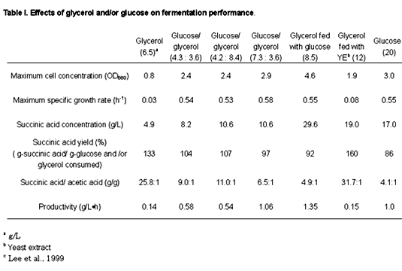

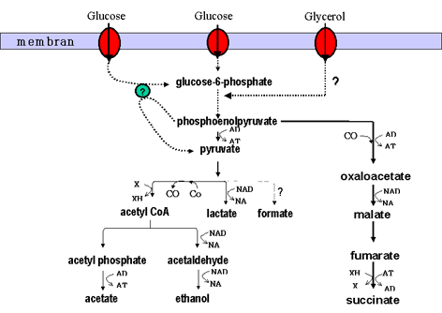
Figure. 1

