전산유체역학을 이용한 혼합 용기의 최적 노즐 구성

최준원, 이태용

대전광역시 유성구 구성동 373-1 (우) 305-701
한국과학기술원 화학공학과

Optimal nozzle configuration of mixing vessels using CFD

Junwon Choi and Tai-yong Lee

Department of Chemical Engineering
Korea Advanced Institute of Science and Technology
373-1, Kusong-dong, Yusung-gu, Taejon, Korea, 305-701

Agitator driven by external motor is one of the most widely used tools for mixing process. The mixing with mechanical agitator, however, has the unavoidable leakage problem at the trim of agitator stem under high pressure. This leakage is not desirable from the viewpoint of economics and safety. But the trim is inevitable for mechanical agitators. One of the suggestions for the problem is to eliminate mechanical assemblies from mixing vessels and to drive mixing with jet.
In most process vessels without agitator, feed flow plays the primary role of mixing the vessel content. Hence the product quality is closely related to the configuration of injection and product nozzles. The configuration concerns the location of nozzles and the direction of injection nozzles.
The flow field of a mixing vessel has the characteristic of turbulent flow that can be described by k-ε turbulent model. This work tried to show mixing tendency with the relative configuration of each nozzle and to find the configuration of the best mixing performance.

Introduction

One can expect that the configuration of feeding and product nozzles affects the flow field in a vessel, hence affects the mixing performance. The object of this work is to investigate the optimal nozzle configuration. Before the calculation for complex geometry, it is efficient to perform the simulation in simpler one in order to find out rough tendency of fluid field with different nozzle configurations. First, 2D rectangular plane was introduced with two inlet nozzles and one outlet nozzle. The system of simulation has the same length of x and y direction, and the mesh with 70 by 70 grid points ( Figure 1.).
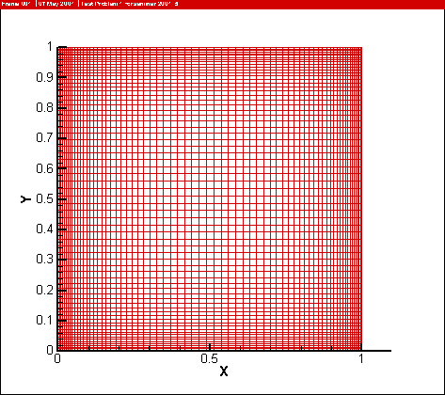
Figure 1 Grid system

Mathematical model

To describe turbulent characteristics of the flow field, it is practical to use turbulent models. Among many models, k-ε model and its modified versions are examined in many practical areas[1] [2]. The standard k-ε model[3] is introduced. The model can be generally written in following form.
$$\frac{∂}{∂x_{j}}(ρU_{j}φ)=\frac{∂}{∂x_{j}}(D_{φ}\frac{∂φ}{∂x_{j}})+S_{φ}$$
φ$μ_{t}=C_{μ}ρ{k^{2}}/ε$ is the dependent variables such as velocity, turbulent kinetic and dissipation energy, and species concentration. $D_{ϕ}$ is the diffusion coefficient. The detailed form is summarized in Table 1.

Table 1 The detailed k- model
φ | Dφ | Sφ
1 | 0 | 0
Ui (i=1,2,3) | μt | -∂P/∂xi+∂[μt(∂Uj/∂xi)]/∂xj
S | μt/Sc | 0
K | μt /σk | G-ρε
ε | μt /σε | (ε/k)(c1G-c2ρε)

S: a scalar
Cμ=0.09, c1 =1.44, c2= 1.92, σk =1.0, σε=1.3
G: Production rate of turbulent kinetic energy. $=μ_{t}\frac{∂U_{i}}{∂x_{j}}(\frac{∂U_{i}}{∂x_{j}}+\frac{∂U_{j}}{∂x_{i}})$

Conclusion

2D simulation of jet-driven mixing vessel showed significant difference with the change of nozzle configurations. It means that it is also possible to find optimal configuration in 3D simulation, or further in more complex geometry.

Acknowledgement
This work was also partially supported by Brain Korea 21 Project.

[1] J.J. Costa, L.A. Oliveira, D. Blay, Test of several versions for the k-ε type turbulence modeling of internal mixed convection flow, International Journal of Heat and Mass Transfer 42 (1999) 4391-4409
[2] Guang He, Yanhu Guo, Andrew T. Hsu, The effect of Schmidt number on turbulent sclar mixing in a jet-in-cross flow, International Journal of Heat and Mass Transfer 42 (1999) 3727-3738
[3] B.E. Launder and D.B. Spalding, The numerical computation of turbulent flow, Computer Methods in Applied Mechanics and Engineering 3 (1974) 269-289

