하이브리드 모델을 이용한 스티렌 모노머 반응기 모사기 개발

임희진, 강민구, 장민호, 이정석*, 박선원
한국과학기술원, 화학공학과
*LG화학 SR연구소

Development of a PC Based Simulator for a Styrene Monomer Reactor Using a Neural Network Hybrid Model

Heejin Lim, Mingu Kang, Minho Chang, Jeongseok Lee*, Sunwon Park
Dept. of Chem. Eng., KAIST
*SR Research Institute, LG Chem.

Introduction
Even though the adiabatic reactor needs more expensive equipment cost and operating cost, it has been used in many companies because of their high conversion of ethylbenzene and the small usage of catalyst pellets [1].
The optimization of a styrene monomer(SM) reactor is highly valuable because it can be used in optimizing the current operation, which has high cost due to the large amount of expensive high-pressure steam. But, only a few researchers had studied about industrial SM reactors because they have difficult geometries and unknown reaction mechanisms [2]. There had been many efforts to improve the productivity of styrene monomer production plants. But most of them had been focused on improvement of the recovery section or the other equipments except the reactor and development of new dehydrogenation catalyst. Reaction models had been formulated by Clough and Ramirez [3], Scheel and Crowe [4] and Hirano [5]. Crowe and Abdalla [6] studied about the characteristics of the SM plug-flow reactor. Only Savoretti [7] proposed the non-adiabatic radial-flow reactor model.
In this study, a PC based simulator for a styrene monomer reactor has been introduced. The mathematical kinetic model for an adiabatic radial-flow styrene monomer reactor has been used as a first principle model. A neural network model has been developed for the catalyst deactivation model because the exact parameters for the deactivation could not be measured and the deactivation was observed by the plant data only. Finally, some examples have been tested with this simulator and the potential usages of this program have been investigated.

System Description – Characteristics of Reactor
The conversion of ethylbenzene and the selectivity of ethylbenzene to styrene are affected by reactor operating pressure, temperature, steam-to-hydrocarbon (oil) ratio (S/O ratio), and reactor load ([current ethylbenzene flow rate] / [design ethylbenzene flow rate]). The effects of each operating variable are shown in Table 1 [8].

Table 1. Effects of operating variables
Variables | Characteristics | Increasing effects
Variables | Characteristics | Conversion | Selectivity
Operating pressure | • Constant in the current plant | ↓ | ↑
S/O (Steam to Oil) ratio | • Feed = EB + steam  • Role of steam  – A heating medium  – A diluent  – A coke suppresser | ↑ | ↓
Temperature | • Endothermic reaction of EB dehydrogenation to SM | ↑ | ↓
Load | • Effect on residence time | ↓ | ↑

Model Description
The hybrid styrene reactor model consists the following of two parts.
First principle model
First principle model includes the reaction kinetics and the reactor geometry. The brief descriptions are shown in Table 2 [9].
Table 2. First principle model
Reaction mechanism | Governing Equations
$$C_{6}H_{5}{\text{CH}}_{2}{\text{CH}}_{3}↔C_{6}H_{5}{\text{CHCH}}_{2}+H_{2}$$  $$C_{6}H_{5}{\text{CH}}_{2}{\text{CH}}_{3}→C_{6}H_{6}+C_{2}H_{4}$$  $$C_{6}H_{5}{\text{CH}}_{2}{\text{CH}}_{3}+H_{2}→C_{6}H_{5}{\text{CH}}_{3}+{\text{CH}}_{4}$$  $$H_{2}O+\frac{1}{2}C_{2}H_{4}→\text{CO}+2H_{2}$$  $$H_{2}O+{\text{CH}}_{4}→\text{CO}+3H_{2}$$  $$H_{2}O+\text{CO}→{\text{CO}}_{2}+H_{2}$$ | $\frac{{\text{dg}}_{i}}{\text{dr}}=\frac{1}{F}\left(2π\text{rL}\sum_{j=1}^{m}{f_{\text{ij}}{\text{MW}}_{i}}\right)$, $\sum_{i=1}^{\text{NC}}{g_{i}}=1$  $$\frac{\text{dT}}{\text{dr}}=\frac{2π\text{rL}\sum_{j=1}^{m}{\left(−{ΔH}_{j}\right)f_{j}}}{{\text{FC}}_{p}}$$  $$\frac{\text{dP}}{\text{dr}}=\frac{P_{\text{out}}−P_{\text{in}}}{R_{\text{out}}−R_{\text{in}}}$$

Neural network model for catalyst deactivation
The neural network model consists of a set of processing units called neurons, connected to one another. The neural network in this study is a feed-forward network with one hidden layer, seven input variables (temperature, feed rate, partial pressure of ethylbenzene, styrene monomer, hydrogen, steam in feed, and DOS (Days On Stream)) and one output variable, deactivation factor. By adjusting parameters in the coupling, between neurons, the network is capable of learning from a set of numerical data corresponding to the input and desired output. [10]

Simulator Description
The program has three modules: parameter update, sensitivity analysis, and optimization module.
Parameter update module
When the simulator is started, the parameter update module is activated. At this time, the simulator is connected with the plant PIS (Plant Integration System) database, and the parameters for the catalyst deactivation are automatically updated. After this is executed, the user can use other modules and the updated catalyst parameters are used for the calculation in the other modules.
Sensitivity analysis module
Figure 1 shows the sensitivity analysis module input screen and the excel results. In this module, the reactor conditions can be simulated and analyzed with a selected process variable, such as load, S/O ratio, inlet temperatures or outlet pressure. The calculation results are shown as an excel sheet and saved as text files.

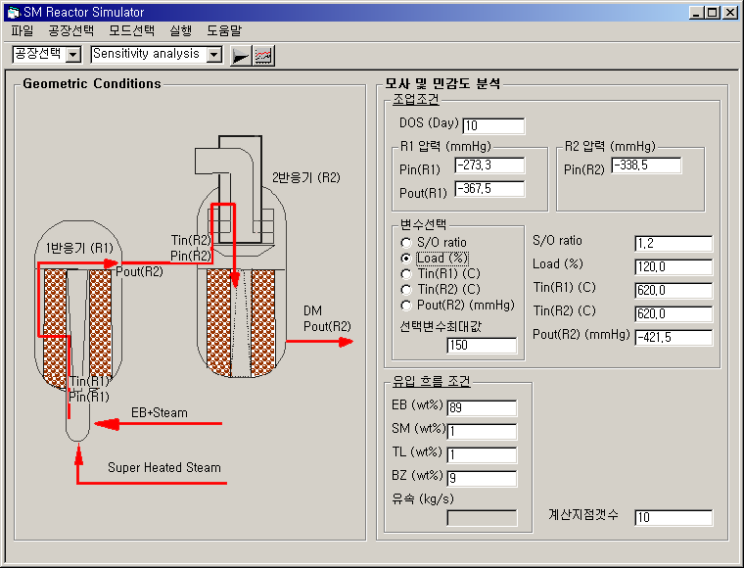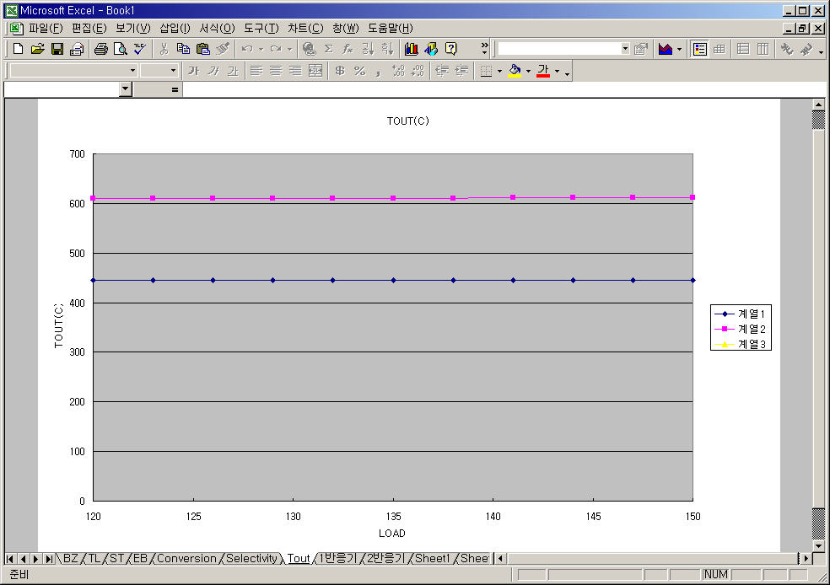
Figure 1. User interface screenshots and excel results for sensitivity analysis module

Optimization module
In this module, the optimal profit and optimal operating conditions are calculated using given operating condition boundaries and price conditions. Figure 2 shows the user input interface and the results window.

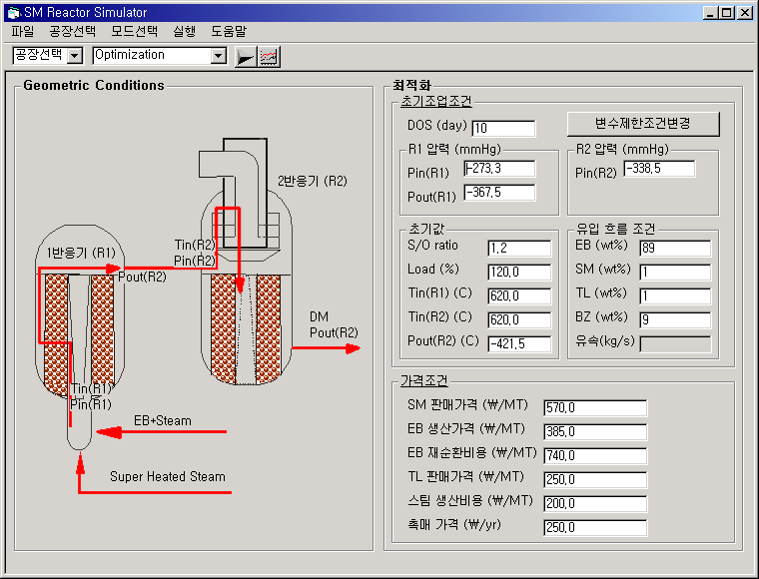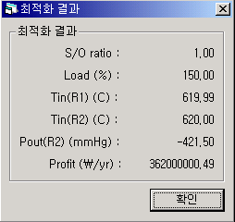
Figure 2. User interface screenshots and results window for optimization module

Examples
Example 1: sensitivity analysis for S/O ratio change
Figure 3. Conversion for S/O ratio change
To see the simulation of the styrene monomer reactor, one of the operating variables is simulated. The input conditions are based on industrial data. Figure 3 shows the simulation results with changing S/O ratio and DOS (days on stream). According to the figure, the conversion of early DOS is similar. But, increasing DOS, higher S/O ratio condition shows higher conversion of styrene monomer from ethylbenzene and lower catalyst deactivation effect.

Example 2: optimization for operating conditions
The operating conditions are optimized using given boundaries. The given conditions and the results are shown in Table 3.

Conclusions
A PC based styrene monomer reactor simulator has been developed using the neural network hybrid catalyst deactivation model with rigorous reaction and reactor models as a first principle model. Also the performances of the developed simulator have been presented.
Using this simulator, determining optimal operating conditions and testing new operating conditions are performed easily. On the situation of changing catalyst, this simulator shows good performance because the catalyst parameters are updated using current process data.

Acknowledgment
This work was partially supported by the Brain Korea 21 project. Funding and all plant information were provided by LG Chemicals co.

Table 3. Calculated and specified values for constraints and objective function
Constraint | Specified | Calculated
Constraint | Specified | Starting | Optimum
S/O ratio  Load (%)  Reactor 1 inlet temperature (℃)  Reactor 2 inlet temperature (℃)  Reactor 2 outlet pressure (mmHg)  Profit | 1.5  120.0  620.4  620.2  -400.0  54.0 | 1.5  100.0  630.0  630.0  -421.5  38.8 | 2.0  150.0  620.0  620.0  -400.0  79.3
Objective function:

F = SMSALE – EBVALUE – CATVALUE + TLSALE – STEAMVALUE

SMSALE [$/day]=(SM price [$/ton])*(outlet SM flowrate [ton/day])
EBVALUE [$/day]=(EB price [$/ton])*((total EB inlet flow rate [ton/day])-(recycled EB flowrate [ton/day]))+(EB recycle price [$/ton])*(recycled EB flowrate [ton/day])
CATVALUE=(catalyst price [$/day])*W₁
TLSALE=(TL price [$/ton])*(outlet TL flowrate [ton/day])
STEAMVALUE=(steam price [$/day])*W₂

(W₁ & W₂: scalar weight)

References
[1] H. Lim, E. Joo, J. Lee, M. Chang, S. Park, “New Operation Strategy Development for A Styrene Monomer Reactor”, KIChE Spring Meeting, 7(1), 465-468 (2001)
[2] K. M. Sundaram, H. Sardian, J. M. Fernandez-Baujin, and J. M. Hildreth, “Styrene plant simulation and optimization,” Hydrocarbon Processing, January, 93~97(1991)
[3] D. E. Clough, and W. F. Ramirez, Mathematical Modeling and Optimization of the Dehydrogenation of ethylbenzene to Form Styrene, AIChE Journal, 22, 6, 1097~1105(1976)
[4] J. G. P. Scheel, and C. M. Crowe, Simulation and optimization of an existing ethylbenzene dehydrogenation reactor, The Canadian Journal of Chemical Engineering, 47 183~187(1969)
[5] T. Hirano, Roles of potassium in potassium-promoted iron oxide catalyst for dehydrogenation of ethylbenzene, Applied Catalysis, 26, 65~79(1986)
[6] B. K. Abdalla, S. S. E. H Elnashaie, S. Alkhowaiter, S. S. Elshishini, Intrinsic kinetics and industrial reactors modeling for the dehydrogenation of ethylbenzene to styrene on promoted iron oxide catalysts, Applied Catalysis, 113, 89~102(1994)
[7] A. A. Savoretti, D. O. Borio, V. Bucala, and J. A. Porras, Non-adiabatic radial-flow reactor for styrene production, Chemical Engineering Science, 52, 205~213(1999)
[8] H. Lim, E. Joo, M. Chang, S. Park, “Mathematical modeling and simulation of styrene monomer reactor”, KIChE Fall Meeting, 6(2), 2897-2900 (2000)
[9] H. Lim, “Modeling and Operation Strategy Development for A Styrene Monomer Reactor”, M.S. Thesis, KAIST (2001)
[10] C. A. O. Nascimento, R. Giudici, N. Scherbakoff, “Modeling of Industrial Nylon-6, 6 Polymerization Process in a Twin-Screw Extruder Reactor”, Neural Networks and Hybrid, Journal of Applied Polymer Science, 72, 905-912 (1999)

