생물정보학: DNA microarray 에 관한 개선된 Data 분석
최 호석, 이 동권, 박 진현*, 이 인범
포항공과대학교 화학공학과
Bioinformatics: An advanced analysis of DNA microarray
Ho-Suk Choi and In-Beum Lee
Department of Chemical Engineering
*P & I Consulting Co., Ltd.

Introduction
Classification of patient samples is an extremely important for cancer diagnosis and treatment. Current classification methods depend on the cancer’s tissue of origin and on the microscopic appearance and location of cancerous cells. However, these classifications were made only by hindsight of doctors. The diagnosis of patients could be difficult. Especially, in Acute Leukemia, distinctions between acute lymphoblastic leukemia (ALL) and acute myeoloid leukemia (AML) are very important for leukemia cancer treatment. In the mean time, DNA microarray analysis which is related with gene expressions should help the separation of several cancer cases. The last leukemia study provides measurements for 7,070 probes in 72 human leukemia samples, 47 ALL and 25 AML (total 72), 10 peripheral blood (PB) and 62 bone marrow (BM) (total 72), 9 T cell and 38 B cell (total 47), and 26 male and 23 female (total 49). By using those data, we applied several methods, naive Bayes models, Support vector machines (SVMs) and naïve Bayes global relevance (NBGR), Principal component analysis (PCA). Also, we applied self-organizing maps (SOMs), neighborhood analysis, and weighed voting and gene/class correlation to seventy-two 7,070 feature experiment profile vectors derived from BM and PB. In the end, through these many experiments we should help the diagnosis of doctors and many biological meanings could be deduced from those things.

Theoretical Backgrounds

Principal Component Analysis
$X=\text{TP}'(+E)$
$$\begin{aligned}T:{\text{score}}_{\text{vector}} \\ P:{\text{loading}}_{\text{vector}} \\ E:\text{residual}\end{aligned}$$
Support Vector Machine
$W^{T}X_{i}+b≥1$ for $d_{i}\text{=+}1$
$W^{T}X_{i}+b≤−1$ for $d_{i}=−1$
The issue at hand is to find the parameters W and b for the optimal hyperplane, given the training set $τ=\left\{\left(x_{i},d_{i}\right)\right\}$ with above constraints. So, we can obtain margins as$ρ=\frac{2}{\left\|w\right\|}$. $d_{i}(W^{T}X_{i}+b)≥1$ for $i=1,2,\text{.}\text{.}\text{.},N$and the weight vector W minimizes the cost function: $Φ(W)=\frac{1}{2}W^{T}W$
We may solve the constrained optimization problem using the method of Lagrange multipliers.
Mean aggregate relevance
MAR(F_{l}) = $\frac{μ_{i,l}−μ_{j,l}}{σ_{i,l}+σ_{j,l}}$
where $\left[μ_{i,l},σ_{i,l}\right],\left[μ_{j,l},σ_{j,l}\right]$are the mean and standard deviation of the log of the expression level of gene $F_{l}$in classes $i$and $j$.
Median vote relevance
MVR(F_{l}) =$\sum_{n=1}^{N}{V(n,l)=}$$\begin{aligned}1 \\ 0\end{aligned}$ $\begin{aligned}\text{if}\left|v_{i}(F_{l})−x_{l}^{n}\right|<\left|v_{j}(F_{l})−x_{l}^{n}\right| \\ \text{Otherwise}\end{aligned}$
MVR is the sum over all N samples. The larger the score, the better the gene distinguishes classes (two or more genes can have the same value). Although leukemia tests require labeled a training example, the MVR is less sensitive to outliers than the mean-based MAR, because the median is a more robust estimate of the center of a population sample.
Naïve Bayes global relevance
NBGR(F_{l}) = $\frac{1}{K}\sum_{i=1}^{K}{\sum_{j=1}^{K}{\text{log}\left[\frac{4}{N}\sum_{n=1}^{N}{\frac{P(x_{l}^{n}|c_{i,l})P(x_{l}^{n}|c_{j,l})}{[P(x_{l}^{n}|c_{i,l})+P(x_{l}^{n}|c_{j,l})]^{2}}}\right]}}$
$P(x_{l}^{n}|c_{k,l})=[2{\text{πσ}}^{2_{k,l}}]^{{−1}/2}\text{exp}\left[{−1}/2{\left\{(x_{l}^{n}−μ_{k,l})/{σ_{k,l}}\right\}}^{2}\right]$
where $\left[μ_{k,l},σ_{k,l}\right]$ is the [mean, standardization]
$P(x_{l}^{n}|c_{k,l})$ is the probability of the expression level given class k. The greater the absolute magnitude, the better the gene distinguishes all K classes.

Conclusion

Classification of features may be easy, but many efforts needed for better classification. Data of microarray is so numerous that, in advance, we should have a feature selection. That means we had to find the meaningful genes out of 7,070 genes. In Golub et al. (1999), they selected 50 genes out of 7,070 genes and the number of genes could be very profitable to classifying observations. Of course, 300 genes which are correlated with distinction of ALL and AML led to same results by test. By using fisher’s linear discrimination and correlation coefficient about classifying two leukemia subsets, we could find 50 genes out of 7,070 genes. And then T square chart of PCA methods are very helpful to the visualizing of classifying leukemia subsets. We also can classify ALL cases into T-cell lineage ALL and B-cell lineage ALL. Only one error was found in testing data sets with PCA methods as figure 1 and 2. Of course, both one error were found with SVMs methods as figure 3 and 4. A few miss-classified data could result from errors of devices or patient’s characteristics. Further study could solve those things. It is very important that both of them show better results than pre-studying projects. Unlike supervised SOMS, by using NBGR unsupervised methods the number of classes could be determined through data. Therefore, the choice of classes should be accurate.

Acknowledgement
This work was supported by Brain Korea 21 (BK21) with Pohang University of Science and Technology.
Literature Cited
- T. R. Golub, D. K. Slonim, P. Tamayo, C. Huard, M. Gassenbeek, J. P. Mesirov, H. Coller, M. L. Loh, J. R. Downing, M. A. Caligiuri, C. D. Bloomfield, E. S. Lander ;“Science”, in press (1999)
Figures
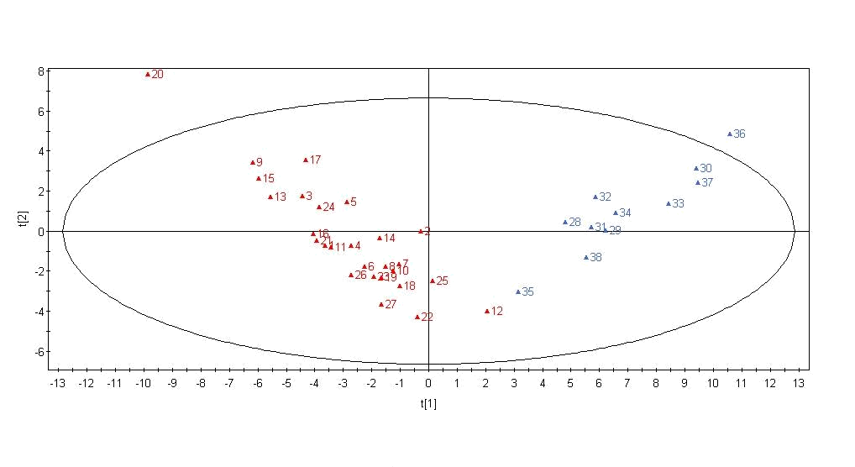
Figure 1. Learning Data Sets: 38 persons (ALL & AML)

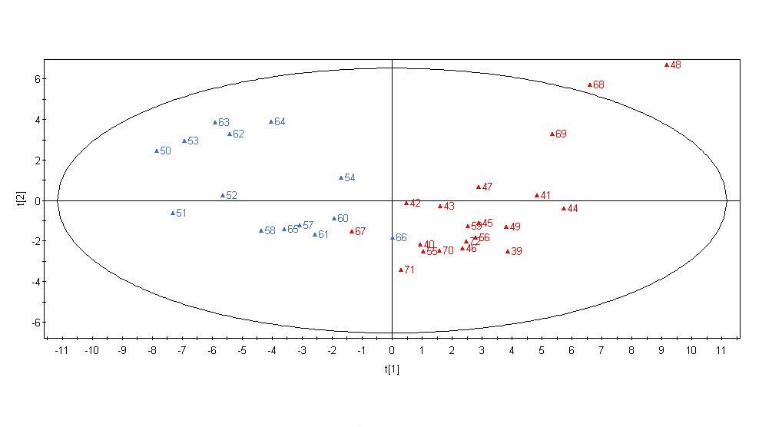
Figure 2. Testing Data Sets: 34 persons (ALL & AML)
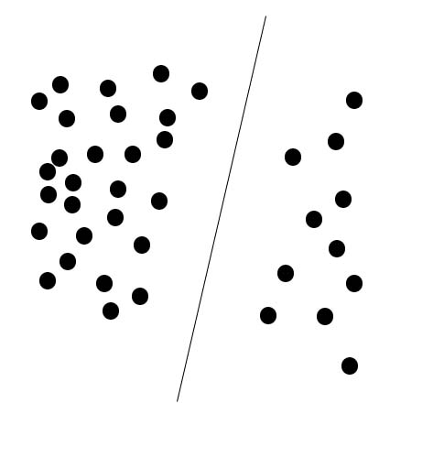
Figure 3. Learning Data Sets: 38 persons (ALL & AML)
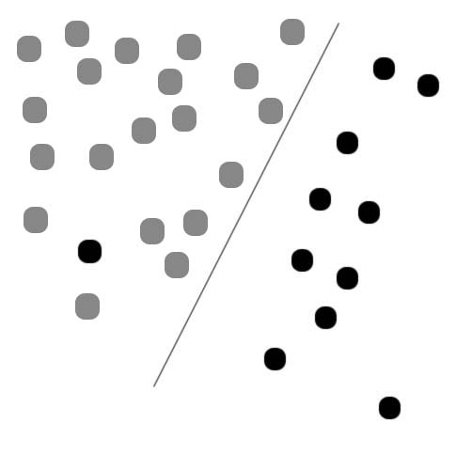
Figure 4. Testing Data Sets: 34 persons (ALL & AML)

