amine 추출제가 포함된
Colloidal Liquid Aphrons (CLAs)의 안전성
함형철, 이동우*, 홍원희, 이철호**
한국과학기술원 화학공학과, LG-EDS Systems*,
공주대학교 화학공학과**

The stability of Colloidal Liquid Aphrons (CLAs)
containing amine extractants

Hyung Chul Hahm, Dong Woo Lee*, Won Hi Hong and Choul Ho Lee**
Department of Chemical Engineering
Korea Advanced Institute of Science and Technology
LG – EDS Systems*
Department of Chemical Engineering, Kongju National University**

Introduction
An Aphron is defined as a distinct unit of fluid, encapsulated by a thin soapy film of another fluid. This soapy film enables polyaphrons containing amine extractants to be dispersed in the pregnant phase without mechanical mixing. Therefore, a conventional mixer-settler stage can be eliminated and energy saving can be accomplished by comminuting only one phase instead of both copper-bearing solutions and organic phase containing amine extractants. In addition, mass transfer enhancement can be achieved due to this micro-sized polyaphrons by increasing interfacial area [1,2]. The stability of Colloidal Liquid Aprhons (CLAs) in the continuous phase is related with removal of Cu(II) in Predispersed Solvent Extraction (PDSE). In this study, PDSE of Cu(II) according to the concentration of SDBS was performed. The amine extractants used were trioctylamine(TOA) and trioctylmetylammonium chloride(Aliquat 336). The stability of CLAs was also investigated.

Experimental
The preparation of polyaphrons
The tertiary TOA, the quaternary ammonium salt Aliquat 336, kerosene, CuSO4, EDTA(Ethylenediaminetetraacteic acid), Tergitol 15-S-3, Sodium Dodecyl Benzene Sulfonate (SDBS) were obtained from Aldrich. Polyahprons are prepared by gradually introducing organic phase which contain amine extractant diluted with kerosene and oil-soluble surfactant Tergitol 15-S-3 (0.01% v/v) into the aqueous phase with water-soluble surfactant SDBS. Stable polyaphrons show white creamy appearance and do not cause phase separation for the long time. These polyaphrons are characterized into phase volume ratio (PVR).
$\text{PVR}=\frac{\text{Dispersed} \text{solvent} \text{phase} \text{volume}}{\text{Continuous} \text{phase} \text{volume}}$ (1)
Experimental procedures in PDSE
In PDSE experiments, 10ml of polyaphrons prepared was added to 10ml of ${\text{CuSO}}_{4}$solution in vial. The mixture was stirred in constant bath during 30min. After the phase separation in centrifuge, the copper solution in the pregnant phase was analyzed with Atomic Absorption Spectrometer of HP(perkin-Elmer 3300).

Stability measurement of CLAs
A method to measure emulsion stability was used for the measurement of the stability of Colloidal liquid Aphrons (CLAs). Prepared CLAs were transferred to 50 ml measuring cylinder. And then the continuous phase was added. The stability of CLAs in the continuous phase arises from the formation of a film at the extractant–continuous phase interface. Volume of amine extractant released to surface was recorded against time.

Results and discussion
Table. 1 shows maximum PVR. The sequence of maximum PVR of polyaphrons made is Kerosene > TOA/kerosene > Aliquat 336/kerosene. The distinction between unstable polyaphrons and stable polyaphrons was observed by visual inspection. Fig. 1 represents broken polyaphrons and Fig. 2 give stable polyaphrons.
Removal(%) is defined as follows
Removal(%) = $\frac{C_{\text{aq}}^{b}−C_{\text{aq}}^{a}}{C_{\text{aq}}^{b}}×\text{100}$ (2)
where, $C_{\text{aq}}^{b}$ is the concentration of Cu(II) in the pregnant phase before PDSE or Conventional solvent extraction (CSE), $C_{\text{aq}}^{a}$ is the concentration of Cu(II) in the pregnant phase after PDSE or CSE. The effect of the concentration of SDBS on Removal(%) is shown in Fig.1. In PDSE using Aliquat336/kerosene, Removal(%) do not change with rising the concentration of SDBS under the condition of constant concentration of Aliquat 336. Therefore, the effect of SDBS in PDSE using Aliquat 336 is negligible. Removal(%) increases with increasing the concentration of SDBS in PDSE of TOA/kerosene under the condition of constant concentration of TOA. This increase is due to the increase of stability of TOA/kerosene CLAs.
The research on the stability of CLAs has been reported by Lye et. al.[3]. He connected the stability of CLAs in the continuous phase when changing ionic strength with the dimension of the first order half-life. The stability of TOA/octanol have been estimated in terms of the psudo first half-life by Lee[4]. In this study, the stability of CLAs in the continuous phase was estimated by the measurement of the organic(extractant) phase volume released due to CLAs break-up. The organic phase volume released against time can be expressed as follows.
$Y=K(1−e^{{−t}/τ})$ (3)
Y means the normalized organic phase volume released, $τ$ is process time constant and K is process gain.$τ$ represents the time that Y becomes (1-1/e). The stability of CLAs in the continuous phase is expressed as $τ$. The large $τ$ means slow response, namely, high stability of CLAs and the small $τ$ means fast response, or rapid break-up of CLAs.$τ$is shown in Table 2. The continuous phase was ${\text{CuSO}}_{4}$ aqueous phase. Its measurement condition was that temperature was room, pH=5.4, the ratio of pregnant phase volume to TOA/kerosene CLAs was 40 ml/5 ml, the concentration of ${\text{CuSO}}_{4}$ was 120 mg/L. Since $τ$ increase when the concentration of SDBS increases, the stability of TOA/kerosene CLAs increases. This increase of stability means the increase of Removal(%) in PDSE using TOA CLAs. For the experiment of the measurement of the stability of Aliqut336/kerosene, NaCl 0.1M as the continuous phase was prepared. The result is also shown in Table 2. Process time constant slightly decrease with increasing the concentration of SDBS. That fact Removal(%) in PDSE using Aliquat336/kerosene CLAs slightly decreases according to the concentration of SDBS can partly explained by this result on the stability of Aliquat336/kerosene.

Acknowledgements
This work was partly supported by the RRC/NMR program of KOSEF in Kongju National University and the BK21 Program of the Korean Ministry of Education.

References
1. Sebba. F, Separation Science and Technology, 20, 331 (1985).
2. Lee D.W, W.H. Hong and K.Y. Hwang, Separation Science and Technology, 35(12), 1951-1962 (2000)
3. Lye.G.J et. al. Colloids Surfaces A: Physicochem Eng. Aspects, 131,119-136, (1998)
4. Lee D.W and W.H Hong, Separation Science and Technology, Submitted for publication, 2001

Table 1. Maximum Phase Volume Ratio
 | Kerosene | Aliquat 336/kerosene  ; 0.50 mol/kg | TOA/Kerosene  ; 0.50 mol/kg
SDBS 4g/L | 32 | 6 | 20

Fig. 1 The effect of concentration of SDBS under constant concentration of extractant

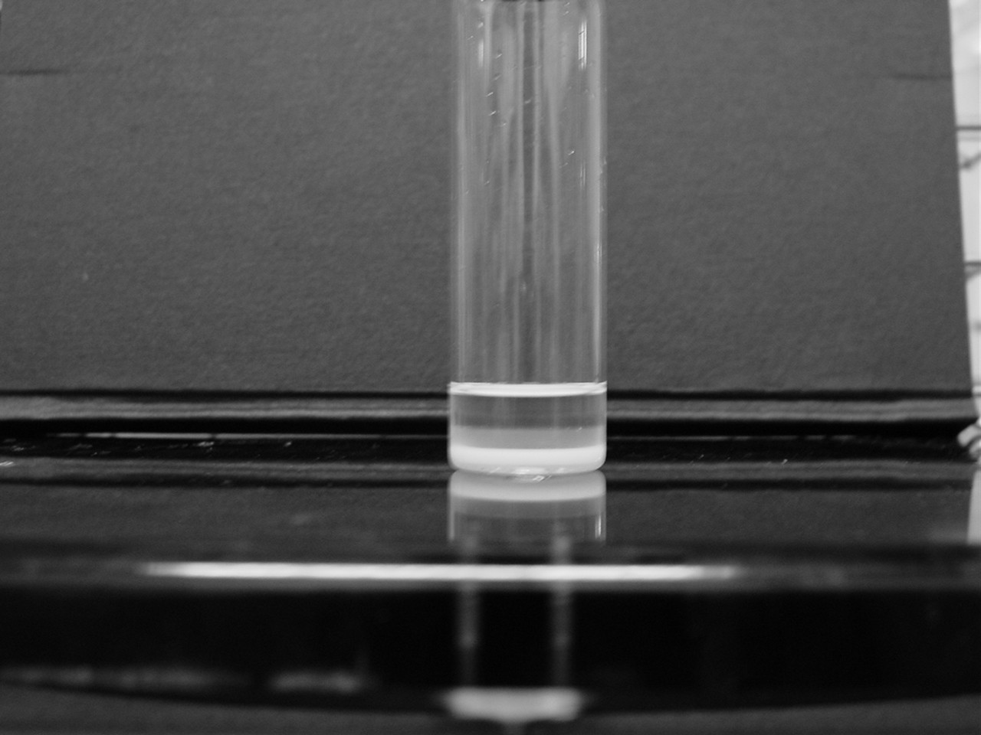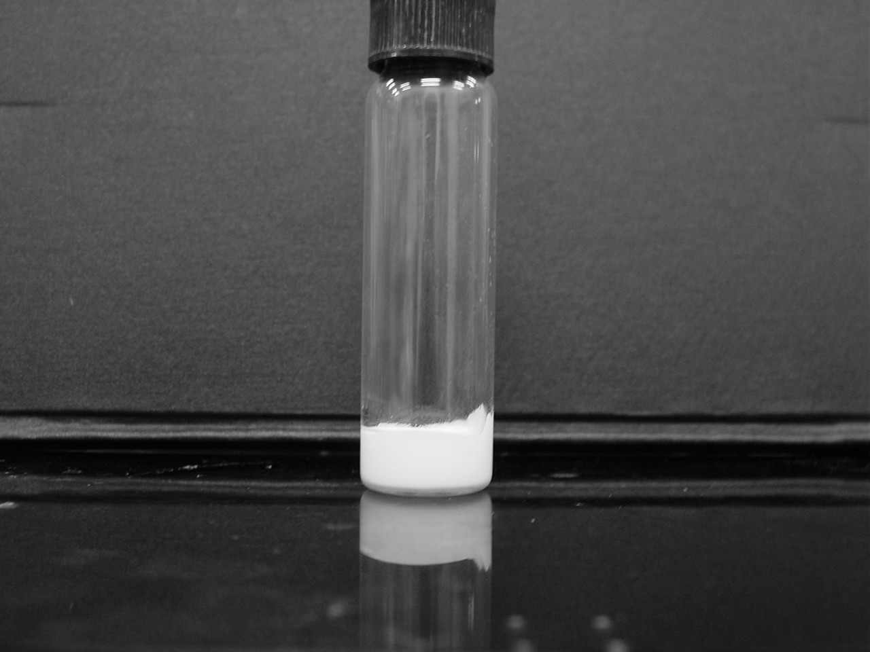

Fig. 2 Broken polyaphrons; phase separation is occurred | Fig. 3 Stable polyaphrons; white creamy appearance

Table 2 Influence of continuous phase on stability of CLAs
Process time Constant;
$τ$[min]
5 ml of 0.50 mol/kg TOA/kerosene CLAs; 40 ml of 120 mg/L${\text{CuSO}}_{4}$; SDBS 4 g/L | 2.0
5 ml of 0.50 mol/kg TOA/kerosene CLAs; 40 ml of 120 mg/L${\text{CuSO}}_{4}$; SDBS 2 g/L | 1.6
5 ml of 0.50 mol/kg TOA/kerosene CLAs; 40 ml of 120 mg/L${\text{CuSO}}_{4}$; SDBS 1g/L | 1.0
5 ml of 0.50 mol/kg Aliquat 336/kerosene CLAs; 40 ml of 120 mg/L${\text{CuSO}}_{4}$; SDBS 4 g/L | Very large
5 ml of 0.50 mol/kg Aliquat 336/kerosene CLAs; 40 ml of 120 mg/L${\text{CuSO}}_{4}$; SDBS 2 g/L | Very large
5 ml of 0.50 mol/kg Aliquat 336/kerosene CLAs; 40 ml of 120 mg/L${\text{CuSO}}_{4}$; SDBS 1 g/L | Very large
5 ml of 0.50 mol/kg Aliquat 336/kerosene CLAs; 40 ml of NaCl 0.1 M; SDBS 4 g/L | 0.9
5 ml of 0.50 mol/kg Aliquat 336/kerosene CLAs; 40 ml of NaCl 0.1 M; SDBS 2 g/L | 1.0
5 ml of 0.50 mol/kg Aliquat 336/kerosene CLAs; 40 ml of NaCl 0.1 M; SDBS 1 g/L | 1.0

