경구 및 코점막을 통한 약물전달을 위한
생체접착성을 가지는 폴리사카라이드 마이크로 입자의 개발

김병윤, 유정아, 김종득
KAIST 화학공학과

Bioadhesive polysaccharide microparticles as oral and nasal drug delivery systems

Byoung-Yun Kim, Jung-A Ryu, and Jong-Duk Kim
Department of Chemical Engineering, KAIST

INTRODUCTION

Systemically acting peptides and proteins are normally administered by parenteral injection. There are several drawbacks to this route of administration. Firstly, injection must be given by trained staff; secondly, there is a risk of infection; and thirdly, patients may express a phobia for needles and syringes. Extensive research has been devoted to finding alternative routes, including oral, nasal, pulmonal, buceal, rectal, vaginal, and transdermal routes. Among them, the oral and nasal route has attracted the most attention (Chen 1995).
The oral route is the preferred route for drug delivery. However, numerous drugs remain poorly available when administered by this route. Currently, it is believed that less than one percent of the particles can be absorbed after oral administration and much research are required. There have been considerable attempts to lower the particle fraction undergoing directly faecal elimination either by increasing the bioadhesive interactions of the particles at the surface of the intestinal membrane or their absorption through the membrane itself (Ponchel 1998).
The nose is well suited to the absorption of drugs since it has a large epithelial surface area due to the presence of numerous microvilli. Furthermore, the subepithelial layer is highly vascularized and the venous blood from the nose passes directly into the systemic circulation bypassing the liver.
Many researches were performed to enhance the adsorption of protein drugs through the mucus surface of nose. The polysaccharide delivery systems are effective in enhancing the absorption of protein drugs. There are two possible explanations for this. Firstly, the microspheres used in the above studies are muco-adhesive and this property is expected to decrease the rate of mucociliary clearance from the nasal cavity. The longer contact time between the drug and the absorbing membrane surface should result in enhanced bioavailability. Secondly, the polysaccharide delivery systems may cause a transient widening the tight junctions between the cells of the nasal epithelia. This is due to the swelling of the dry microspheres and viscous polysaccharides which results in dehydration of the mucosa with a consequent reversible widening of the tight junction between the cells (Chen 1995, Pereswetoff-Morath 1998).
Bioadhesion can be obtained by the building of either non-specific interactions with the mucosal surface, which are driven by the physicochemical properties of the particles and the surfaces, or specific interactions when a ligand attached to the particle is used for the recognition and attachment to a specific site at the mucosal surface (Ponchel 1998).
In this work, bioadhesive polysaccharide microspheres were prepared. Starch was used as the material of polysaccharide microspheres and the representative bioadhesive polymer acrylic acid was grafted on starch to give bioadhesive property. In addition to this non-specific bioadhesive systems, specific bioadhesive microspheres will be studied in near future by conjugation of lectin which has specific binding property with the glycoprotein of human mucus layer.

EXPERIMENTAL

Synthesis of Starch-g-PAA
Synthesis scheme is according to that of Athawale (1998). 2g of starch was dispersed in 40ml of water and stirred magnetically under nitrogen atmosphere. To facilitate the free radical formation on starch this solution was treated with ceric ammonium nitrate (CAN) for 10 min. After this, acrylic acid(AA) was added and polymerization was carried out at 35℃ for 4h. The reaction mixture was allowed to stand up to about 10min. The supernatant solution was replaced by fresh distilled water and was stirred again for 15min. This procedure was repeated twice to extract the PAA homopolymer certaninly. The solution was centrifuged at 900rpm for 2h to separate the graft product and vacuum dried. The graft products were characterized by the following parameters:
$\text{Grafting yield \% }(\text{GY\%})=\frac{\text{A-B}}{B}×\text{ 100}$
Where A, B are the weights of graft product and ethylcellulose, respectively.

Infra-red spectral analysis
The composition of the graft products were examined by Fourier Transform Infra Red Spectroscopy (MB 154-BOMEM, Bomem Inc., Canada). They were run in the form of KBr pellets. The resolution was 4 cm⁻¹ and the scanning was established for 400 times.

DSC measurements
The differential scanning calorimetry (Thermal analyst 2000, Du Pont Instruments, USA) studies were carried out to determine the glass transition temperature, melting temperature of the graft products and appropriateness of graft products in our purposing temperature range.
Samples were loaded in sealed aluminum pans and sample weights were 5.3 mg. Measurements were scanned twice over a temperature range of –20℃ to 250℃ at a heating rate of 10℃/min under nitrogen atmosphere. The glass transition temperature of the sample was taken at the inflection point and melting temperature was given as the peak temperature of the melting endotherm.

Preparation of microparticles
The procedure is similar to that of Brook (1998). An aqueous solution of a protein, bovine serium albumin (BSA) was mixed with a DMSO solution of starch. Although it was necessary to heat the starch to ∼100℃ to form a homogeneous solution, this was cooled to 37℃ prior to addition of the protein solution to minimize protein denaturation. The aqueous/DMSO solution was converted to a water-in-oil emulsion by adding the starch/protein/DMSO/water solution to corn oil with sonication and/or rapid stirring (30000rpm) in the absence of any added surfactant. The addition of the W/O emulsion to acetone led to agglomerated solid starch/protein particles: acetone acts as a desiccant. Microparticles formed if a surfactant(Tween 80) was added to the acetone. The microparticle size could be controlled by modifting the type of agitation.

RESULTS AND DISCUSSION

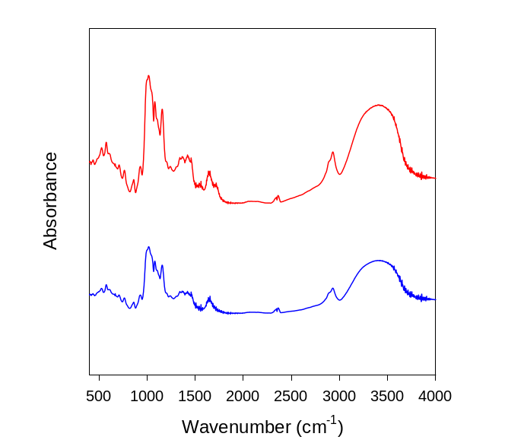
Figure 1 shows the FTIR spectra of starch and starch-g-PAA.
Starch-g-AA
Starch

Figure1. FTIR spectra of starch and graft copolymer

The IR spectra of pure and grafted starch both show a broad absorption band characteristic of glucosidic ring of starch between 3650 and 3100cm⁻¹. Moreover, there is an increment in the intensity of this band in case of grafted sample, owing to the unutilized hydroxyl groups of the grafted acrylic acid. On the contrary, the additional band owing to the carbonyl group of PAA was not so obvious, it should be further studied or new synthesis method for the acquirement of AA-grafted starch should be considered.
Figure 2 shows the SEM photograph of starch-g-AA microparticles. They were spherical and had the size of 40~100㎛. They had rugged and clean surface as confirmed by figure 3.

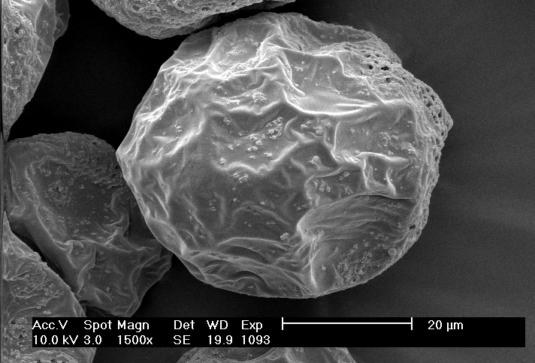
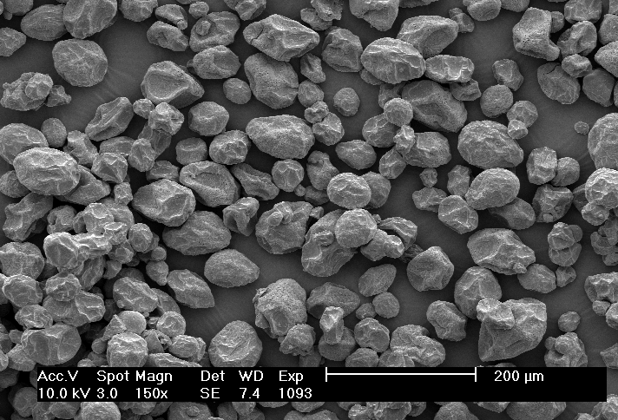
Figure 2. The SEM photograph of starch-g-AA microparticles.

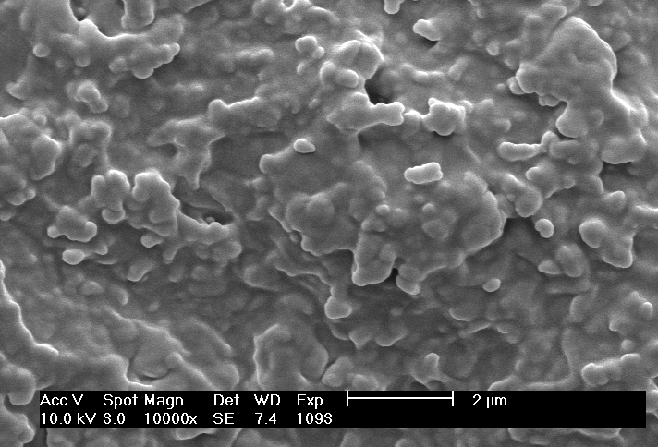

Figure 3. The SEM photograph of the surface of starch-g-AA microparticles.

The thermal analysis and X-ray diffraction patterns of graft polymer will be further studied. Measurement of dissolution degree, adhesive force of microparticles, release of model drug from the microparticles and the possibility of conjugation on the particle surface will be studied. In addition to this non-specific bioadhesive systems, specific bioadhesive microspheres will be studied in near future by conjugation of lectin which has specific binding property with the glycoprotein of human mucus layer.
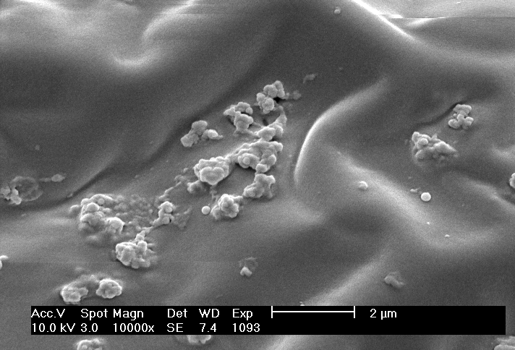

REFERENCES

Athawale, V. D., and Lele, V., Carbohydrate Polymers, 1998, 35, 21-27.
Brook, M. A., et al., Langmuir, 1997, 13, 6279-6286.
Chen, J., Jo, S., and Park, K., Carbohydrate Polymers, 1995, 28, 69-76.
Pereswetoff-Morath, L., Advanced Drug Delivery Reviews, 1998, 29, 185-194.
Ponchel, G., and Irache, J., Advanced Drug Delivery Reviews, 1998, 34, 191-219.

ACKNOWLEDGEMENT

This work was supported by the Brain Korea 21 Project.

