이소부탄의 산화적 탈수소화 반응을 위한 바나듐 담지 촉매에 안티몬 첨가 효과
V.P.비스로프스키ª, V.Yu.브치코프^{b}, 장종산ª, 박민석ª, 박상언ª
ª한국화학연구소 분자활성공학실, ^{b} Institute of Chemical Physics, Russian Academy of Sciences

Promotion Effect and Role of Antimony in Oxidative Dehydrogenation of iso-Butane over Supported V-Sb Oxide Catalysts*

V.P.Vislovskiyª, V.Yu.Bychkov^{b}, J.-S.Changª, M.-S.Parkª, S.-E.Parkª
ª Catalysis Center for Molecular Engineering, KRICT, Taejon 305-600, Korea
^{b} Institute of Chemical Physics, Russian Academy of Sciences, 4 Kosygin str., 117334 Moscow, Russia
* This paper is based on work presented at 6th European Workshop on Selective Oxidation
(Rimini, Italy, 1999)

INTRODUCTION
In the recent years, extensive studies of the oxidative dehydrogenation (ODH) of saturated light hydrocarbons have been carried out [1-5]. Compared to the ODH of other light paraffins, the ODH of isobutane has received much less attention although currently isobutene is produced industrially by the endothermic dehydrogenation of isobutane at very high temperatures (about 900 K [6]), and large amount of heat is required for this process. ODH of isobutane is potentially much more economical since this reaction is exothermic. However, over known catalysts the olefin selectivity, especially at high isobutane conversions, is relatively low because of the formation of carbon oxides, and the challenge is to improve catalyst selectivity and isobutene yield as well as stability of catalytic performance.
Most catalysts described in the literature for the ODH of light paraffins (ethane, propane, n-butane) are based on the vanadium oxide [1-5, 7-10]. In our recent paper [11] it was shown that vanadium oxide supported on alumina demonstrates high catalytic activity and selectivity also in the ODH of isobutane; this activity, however, is reduced by long-lived operation of the catalyst. The alumina supported V-Sb oxides display enhanced catalytic stability [11].
Few studies [12-14] have been presented in literature to explain the role of antimony as co-component of the catalysts for the ODH of light paraffins or related compounds. These explanations are, however, contradictory and do not provide us reliable idea for the improvement of the vanadia-based catalyst. This paper describes our results of optimization of the V/Sb ratio in the binary supported catalysts and our attempts to clarify in details the reasons and the nature of the antimony doping effect on the catalyst behavior in the ODH of isobutane.

EXPERIMENTAL
Catalysts were prepared by impregnation of the amorphous γ-alumina (S=85 m²/g, grain size 0.3-0.8 mm) supplied by the Katalizator Company (Novosibirsk, Russia) with mixed aqueous solutions of NH₄VO₃ and SbCl₃ with further evaporation and calcinations at 600ºC. Total amount of the supported component(s) was fixed (17.7 wt.%). ODH of isobutane was studied in a fixed-bed quartz reactor at 550ºC; initial gas feed had i-C₄H₁₀:O₂:N₂=20:10:70 and HGSV=900 h^{-1.}. Catalysts were characterized by BET, XRD and XPS techniques [11]. Here in situ DRIFTS spectra were recorded by an IFS 88 Bruker Fourier Transform spectrophotometer in flows of i-C₄H₁₀, O₂, or i-C₄H₁₀/O₂ mixtures in dry He in a 20-550ºC range. Heats of reduction and reoxidation were measured using a Setaram DSC-111 differential scanning calorimeter with on-line GC analysis. In order to simplify the analysis of carbon-containing products and to increase the accuracy of thermo-chemical calculations, we used C₂H₆ as reducing agent instead of isobutane. Oxygen TPD studies were performed in the same DSC set-up. More details about these procedures are given elsewhere [11,15].

RESULTS AND DISCUSSION
Alumina supported V-only catalyst demonstrates a good initial ODH activity (iso-butane conversion after 1 h time-on-stream was 39.5%) which declines after 2.5 h on stream to 29.5 %. Initial isobutene selectivity (~64%) remains almost the same.
Varying the relative antimony content Sb/V+Sb in the binary V-Sb oxide system (including the individual supported Sb and V oxides) was carried out. SbO_{x}/Al₂O₃ and Sb-rich catalysts are not effective for olefin formation. The same observation for SbO_{x} have been made in [12] concerning to Pt/SbO_{x} catalyst for the oxidation of isobutane to methacrolein. Both isobutane conversion and olefin selectivity increase linearly and stabilize in the region of high vanadia concentrations (till 93-95 at.%). The best binary catalyst with V/Sb=8.8 (89.8 at.%V+10.2at.%Sb)/Al₂O₃ exhibits isobutane conversion 39.6% and olefin selectivity 68%. This sample provides the initial yield of i-C₄H₈ (~27%) close to observed over V₂O₅/Al₂O₃, but this value for binary catalyst remains almost unchanged (~26%) after 4 h. It is important to notice that almost all studied Sb-containing samples (except the catalyst with low – 0.73 wt.% SbO_{x} content) demonstrate stable activity and selectivity. So, the addition of 10 at.% of antimony changes a little the initial ODH activity of the V-only catalyst, but increments its stability. It indicates that catalytic properties mostly determined by vanadium oxide are stabilized by antimony in a binary supported system.
The main reason why V₂O₅/Al₂O₃ catalyst activity decreases is coke formation. It was proved by intense CO_{x} evolution during the treatment (reoxidation) of this used catalyst by air pulses at 550ºC. Reoxidation of the used Sb-doped vanadium oxide catalyst also was accompanied by an CO_{x} evolution, but in very small amounts.
In [11] we showed that V and Sb are represented in amorphous VSbO layer on alumina surface in the ratio, which corresponds to the chemical composition of supported component. V₂O₅ is the main catalytic component, and reaction mixture causes its significant reduction. Taking into account the principal role of active oxygen species in the efficiency of the catalyst, we focused our attention on their characterization using oxygen TPD, in situ DSC and in situ DRIFTS. The latter technique could also provide us an information about carbon-containing species on working catalyst.
V-only catalyst releases only 0.9 μmol O₂/g while heating to 670ºC. Oxygen desorption from Sb-only system starts at 580ºC (28 μmol O₂/g). During O₂ TPD from V-Sb catalyst, which starts at 510ºC, 52 μmol O₂/g were detected. This clearly shows a synergy between components and suggests the formation of new active oxygen species in V-Sb system which are not present in individual supported oxides. In Sb-doped system, despite of the higher energy of the lattice oxygen bond, the amount and reactivity of active oxygen participating in redox processes substantially increase. In the case of binary catalyst the curve “olefin selectivity vs. reduction degree” in the pulse experiments with reductant (alkane) almost coincide with the same for the reaction mixture (alkane+O₂). It means that both olefin and CO_{x} are produced by the reaction of hydrocarbon with catalyst lattice oxygen (reduction stage), and gaseous oxygen takes part only in the reoxidation of reduced catalyst (redox mechanism). This is not the case for the non-selective Sb-only catalyst when the formation of at least part of the products is affected by adsorbed oxygen species existing in equilibrium with gaseous O₂ (associative mechanism).
In DRIFTS spectra of V-containing samples we used 2000 cm⁻¹ V=O band to estimate the reduction degree of vanadium component. This band disappeared when vanadium ions are reduced approximately to V³⁺ state. Both in isobutane and isobutane+O₂ mixture, vanadium undergoes a reduction at 450ºC. It is seen also (Fig.1) that Sb-doped catalyst demonstrates higher rates of vanadium reduction and reoxidation than V-only sample.
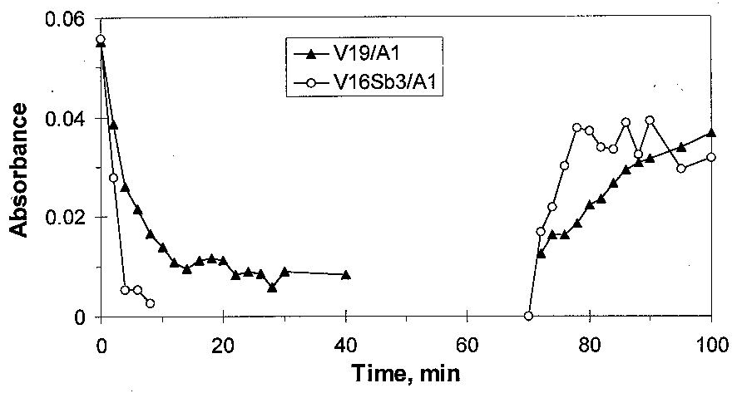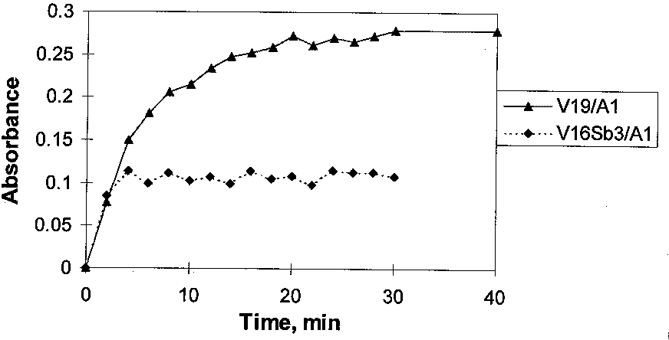

Fig.1. Intensity of 2000 cm⁻¹ V=O band at 450^{O}C on VO_{x}/Al₂O₃ and VSbO/Al₂O₃ catalyst during interaction with isobutane (0~40min), He (40~70 min), air (70~100 min) flows
Fig.2. Intensity of 1560 cm⁻¹ band at 450^{O}C on VO_{x}/Al₂O₃ and VSbO/Al₂O₃ catalyst during interaction with isobutane flow

Interaction of isobutane flow with binary catalyst at 20ºC leads to a formation of some adsorbed species.
The appearance of the bands ν(O-H) (3500-3600 cm^{–1}), δ(O-H) (1630 cm^{–1}), ν(C-H) (2955-2875 cm^{–1}), δ(C-H) (1475,1370 cm⁻¹), ν(C=O) (1577 cm⁻¹) is observed with simultaneous decrease of the 2000 cm⁻¹ band intensity. TPD of the products of isobutane low temperature adsorption on a fully oxidized or on a partially reduced catalyst surface shows that only carbon oxides were detected. No traces of iso-butene were observed. Apparently, such products of isobutane adsorption can be intermediates only in the total oxidation of paraffin and/or in coke formation, but not in oxidative dehydrogenation. After interaction of isobutane with the catalysts at 250-450ºC no ν (C-H) bands were detected, but 1560, 1460 cm⁻¹ bands were observed by DRIFTS. Similar spectra are usually attributed to “carboxylates” which are intermediates in the formation of coke or some part of it. So, data of Fig.2 show, that Sb addition decreases the formation of coke precursors.

CONCLUSION
Addition of 10 at.% of antimony to vanadia creates on VSbO/Al₂O₃ catalyst new form of reactive oxygen with higher binding energy, increases rate of active phase redox transformations, decreases the amount of carboxylates on catalyst surface and thus prevents the coke formation and catalyst deactivation.

REFERENCES
- H.Kung. Adv. Catal. 40 (1994) 1
- E.A.Mamedov, V.Cortes Corberan. Appl.Catal. A: 127 (1995) 1
- S.Albonetti, F.Cavani, F.Trifiro. Catal.Rev.-Sci.Eng. 38 (1996) 413.
- B.Grzybowska-Swierkosz, F.Trifiro, J.C.Vedrine (Eds.). Appl.Catal. A: 157 (1997).
- F.Cavani, F.Trifiro. Catal.Today. 36 (1997) 431.
- T.Matsuda, I.Koike, N.Kubo, E.Kukuchi. Appl.Catal. 96 (1993) 3.
- J.Le Bars, A.Auroux, M.Forrissier, J.C.Vedrine J.Catal. 162 (1996) 250.
- T.Blasco, A.Galli, J.M.Lopez-Nieto, F.Trifiro. J.Catal. 169 (1997) 203.
- A.A.Lemonidou, L.Nalbandian, I.A.Vasalos. Catal.Today 61 (2000) 333.
- J.M.Lopez-Nieto, P.Concepcion, A.Dejoz, F.Melo, H.Knozinger, M.I.Vasquez. Catal.Today 61 (2000) 361.
- V.P.Vislovskiy, V.Yu.Bychkov, M.Yu.Sinev, N.T.Shamilov, P.Ruiz, Z.Schay. Catal.Today 61 (2000) 325.
- T.Inoue, K.Asakita, Y.Iwasawa. J.Catal. 171 (1997) 457.
- F.Cavani, M.Koutyrev, F.Trifiro. Catal.Today 24 (1995) 315.
- F.Cavani, A.Tanguy, F.Trifiro, M.Koutyrev. J.Catal. 174 (1998) 231.
- V.Yu.Bychkov, M.Yu.Sinev, V.N.Korchak, E.L.Aptekar’, O.V.Krylov. Kinetika I Kataliz (Russ.) 30 (1989) 1137.

Acknowledgements: This study was funded by the European Commission under the INCO-Copernicus Programme (contract ERBIC15-CT-96-0725). We also acknowledge a helpful contribution of Drs. M.Sinev, and P.Ruiz

