아임계와 초임계수에서 p-Xylene의 부분 산화Mechanism과
Kinetic model
Mechanism and Kinetic model of p-Xylene Partial Oxidation
in Sub- and Supercritical Water

김영래, 임종성, 이윤우, 김재덕, 이성철*
Young-Lae Kim, Jong Sung Lim, Youn-Woo Lee, Jae-Duck Kim, Sung-Chul Yi*

한국과학기술연구원 환경복원연구센터, 한양대학교 화학공학과*
Environment Remediation Research Center, KIST
Department of Chemical Engineering, Hanyang University*

Introduction
In the recent, some reactions in sub- and supercritical water are of technical interest, such an oxidation of organic material, condensation reactions. Supercritical water is a reaction medium with extraordinary properties, mainly because its density can be varied continuously from gas-like to liquid-like values. Also, Most polar organic become completely miscible, while many non-polar compounds dissolve sufficiently. This property suggests that sub- or supercritical water may be used as a possible replacement for environmentally unacceptable solvents for a number of organic reactions. A recent review such reactions illustrates the usefulness of metal catalyst in the oxidation of organic compounds in sub- and supercritical water.
In this research, to demonstrate that sub- and supercritical water can be a viable replacement for such environmentally undesirable solvent. Particularly, This reaction has important practical implications since it constitutes the first step of the industrial process for the production of product such a terephthalic acid. Also, a lumped kinetic scheme is developed which accounts for the most important intermediates and final products of process. Thereby we are to find optimized p-Xylene partial oxidation reaction mechanism and are to model these in sub- and supercritical water, lumped reaction pathway are used with appropriate paths to formation of desired products.

Reaction pathway and kinetic model
Deduced a reaction pathway of figure 1 is qualitatively consistent with the experimental observations and the literature. This reaction pathway would incorporate the effect of process variables to the maximum formation of the desired products. And, this experimental results and used apparatus reported in previous work. (Y. L. Kim et. al) The presents of our experimental data do not yet admit the development of such a complete reaction pathway and model. Nevertheless, we have developed a quantitative reaction model based on these pathways.

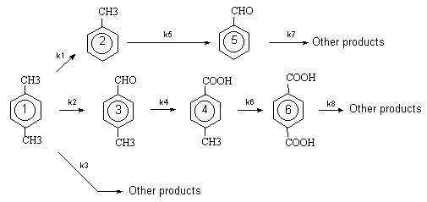
Figure 1. Proposed mechanism of p-Xylene with SCWO in this work

For reaction conducted with a negligible change in specific volume in an isothermal, isobaric, mixed batch reactor, the mole balance can be written as
$\frac{{\text{dC}}_{i}}{\text{dt}}=r_{i}$ (1)

Where C_{i} is the concentration of species i in the reaction, t is reaction time, and r_{i} is the rate of formation of species i. Thus, the differential equations that describe the concentrations of multi products as functions of time and assuming pseudo-first-order kinetics for all of the reactions Figure 1, are
$\frac{{\text{dC}}_{p−\text{Xylene}}}{\text{dt}}=−k_{A}C_{p−\text{Xylene}}$ (2)

$k_{A}=k_{1}+k_{2}+k_{3}$Where,
$\frac{{\text{dC}}_{2}}{\text{dt}}=k_{1}C_{p−\text{Xylene}}−k_{5}C_{2}$ (3)

$\frac{{\text{dC}}_{3}}{\text{dt}}=k_{2}C_{p−\text{Xylene}}−k_{4}C_{3}$ (4)

$\frac{{\text{dC}}_{4}}{\text{dt}}=k_{4}C_{3}−k_{6}C_{4}$ (5)
$\frac{{\text{dC}}_{5}}{\text{dt}}=k_{5}C_{2}−k_{7}C_{5}$ (6)
$\frac{{\text{dC}}_{6}}{\text{dt}}=k_{6}C_{4}−k_{8}C_{6}$
(7)

Equations (2)-(7) can be solved simultaneously with the initial condition C_{p-Xylene} =C_{(p-Xylene)o} and all other C_{i}=0 at t=0 to obtain analytical expressions for the concentration of p-Xylene and each of reaction products. The resulting equations are

$C_{p−\text{Xylene}}=C_{(p−\text{Xylene})o}\text{exp}(−k_{A}t)$ (8)
$C_{2}=\frac{k_{1}C_{(p−\text{Xylene})o}}{k_{5}−k_{A}}\left[\text{exp}(−k_{A}t)−\text{exp}(−k_{5}t)\right]$
(9)
$C_{3}=\frac{k_{2}C_{(p−\text{Xylene})o}}{k_{4}−k_{A}}\left[\text{exp}(−k_{A}t)−\text{exp}(−k_{4}t)\right]$
(10)

$C_{4}=\frac{k_{2}k_{4}C_{(p−\text{Xylene})o}}{k_{4}−k_{A}}\left[\frac{\text{exp}(−k_{4}−k_{6})t−\text{exp}(−k_{6}t)}{k_{4}}−\frac{\text{exp}(−k_{A}−k_{6})t−\text{exp}(−k_{6}t)}{k_{A}}\right]$
(11)

$C_{5}=\frac{k_{1}k_{5}C_{(p−\text{Xylene})o}}{k_{5}−k_{A}}\left[\frac{\text{exp}(−k_{5}−k_{7})t−\text{exp}(−k_{7}t)}{k_{5}}−\frac{\text{exp}(−k_{A}−k_{7})t−\text{exp}(−k_{7}t)}{k_{A}}\right]$
(12)

$C_{6}=\frac{k_{2}k_{4}C_{(p−\text{Xylene})o}}{k_{A}−k_{4}}\begin{aligned}\left[\left(\frac{\text{exp}(−k_{A}−k_{6}−k_{8})t−\text{exp}(−k_{\text{10}}t)}{k_{A}^{2}}−\frac{\text{exp}(−k_{4}−k_{6}−k_{8})t−\text{exp}(−k_{8}t)}{k_{4}^{2}}\right) | \right]\left[+ | \right] \\ \end{aligned}$

(13)

These equations can be used with different sets of experimental data to determine optimized values of the reaction rate constants. Also, the values of the rate constants provided insight into the relative significance of the different steps in the reaction pathway. At the following Figures, the solid curves represent the concentrations calculated using equation (8)-(13) and the discrete points represent the experimental data. Clearly, the model calculations and experimental data display the same trends.

Acknowledgment
This experimental work carried out by foundation of the National Research Laboratory (supercritical fluid).

References
1. Antonello Viola and Giacomo Cao, Journal of Chromatographic Science, 34, 27-33, January 1996
2. Giacomo.Cao, Massimo Pisu and Massimo Morbidelli, Chemical Engineering Science, 49, 5775-5788(1994)
3. Milan Hronec, Zuzana Cvengrosova and Jan Ilavsky, Ind. Eng. Chem. Prod. Res. Develop., 24, 787-794, 1985
4. Young-Lae Kim, Jae-Duck Kim et. al, Theories and Applications of Chem. Eng., Vol. 6, No. 2, 3981-3984, 2000
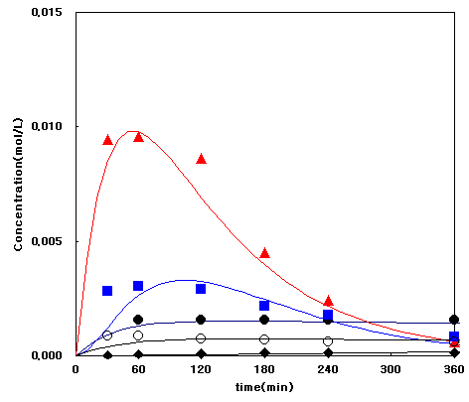
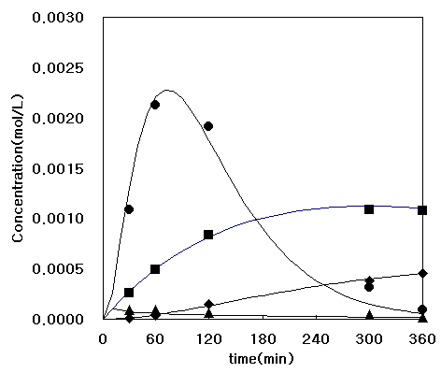
:p-Terephthalaldehyde,  : p-Toluic acid : p-Terephthalaldehyde, : p-Toluic acid
 : Toluene, :Benzaldehyde,  : Toluene, :Benzaldehyde,
 :Tereththalic acid,  Calculated  Calculated
Figure 2. Products concentration from p-Xylene Figure 3. Products concentration from
Oxidation in SCW (reaction conditions: 300ºC, p-Xylene oxidation in SCW (reaction
260bar, H₂O₂: 50%(stoichiometric amount)) conditions: 450 ºC, 260bar, H₂O₂: 50%
(stoichiometric amount))

