화학적인 방법을 이용한 자기 나노입자의 제조

현택환, 이수성, 박상재, 박종남, 정윤희
서울대학교 응용화학부

Chemical Synthesis of Magnetic Nanoparticles

Taeghwan Hyeon, Soosung Lee, Sang Jae Park, Jong Nam Park, and Yoon Hee Chung
School of Chemical Engineering, Seoul National University

Introduction
The development of uniform nanometer size particles has been intensively pursued for their technological and fundamental scientific interests [1, 2]. These nanostructured materials often exhibit very interesting electronic, optical and magnetic properties, different from their bulk counterparts [3, 4]. For the synthesis of uniform spherical nanoparticles, burst of nucleation induced by injecting precursors into hot surfactant solutions, followed by growth of particles, was most frequently applied [5]. These uniform spherical nanoparticles can self-assemble to get three-dimensional superlattice structures. TEM images of uniform CdSe semiconductor nanoparticles produced from these colloidal methods are shown in Figure 1.
Recently, the development of uniform magnetic nanoparticles of ~ 10 nm became a very important issue in their application to ultra-high-density magnetic storage devices [6]. Several synthetic approaches including thermal [7] and sonochemical decomposition [8] of organometallic precursors, and reduction inside reverse micelles [9] have been applied to fabricate magnetic nanoparticles. Among them, thermal decomposition of organometallic compounds in the presence of suitable stabilizers become preferred method because the possibility of contamination from other elements (e.g. boron and oxygen) can be excluded. Many studies on nanoparticles have focused on the synthesis of uniform spherical forms and the control of their particle sizes. Recently, the shape control of nanoparticles was recognized as a very important issue in the nanoparticle synthesis, which turned out to be a challenging problem [10]. In particular, anisotropic magnetic nanoparticles are expected to offer many advantages because the shape anisotropy would exert a tremendous influence on their magnetic properties. Only a few anisotropic magnetic nanoparticles have been developed so far, nonetheless the particle dimensions are too big to exhibit any nanosize (quantum) effect and they are often extensively agglomerated. In this presentation, we would like to present the fabrication of nearly uniform rod-shape iron nanoparticles produced from the controlled growth of monodisperse spherical nanoparticles. We also compared the magnetic properties of the spherical and the rod-shape iron nanoparticles.

Results and Discussion
The spherical iron nanoparticles were prepared by the modified procedure of the previously reported method [5]. The synthesized powder form of spherical nanoparticles can be easily re-dispersed in pyridine to yield a clear homogeneous solution. The transmission electron micrograph (TEM) revealed that uniform 2 nm particles were well dispersed in the solution, and for many parts of the image three-dimensional close-packing of the particles were clearly observed (Figure 2). Electron diffraction pattern showed that these iron nanoparticles are amorphous.
The following procedure was applied to synthesize rod-shape nanoparticles. At first, spherical 2 nm sized nanoparticles were prepared by injecting 0.2 mL of Fe(CO)₅ into 5.0 g of TOPO at 340 ºC followed by aging for 30 min at 320ºC, as described above. To the resulting spherical nanoparticles in TOPO, 5 mL of 2.6 mM Fe(CO)₅ in trioctylphosphine (TOP) was added at 320 ºC, and the resulting black solution was aged for 30min at 320ºC. This step was repeated once more and the resulting reaction mixture was cooled down to room temperature to get a black solid. Butanol was added to solubilize the reaction mixture and the resulting butanol solution was added into excess acetone, resulting in a black precipitate. The precipitate was collected by centrifugation, and was washed several times with acetone to remove excess surfactant. The precipitate was dissolved in 19 mL of pyridine containing 0.5 g of didodecyldimethylammonium bromide (DDAB), and the resulting solution was refluxed for 12 hours. The precipitate formed during the reflux was removed by centrifugation and the supernatant was vacuum-dried to yield a black powder. The dry powder was soluble in pyridine and the solution was kept stable for a week without precipitation under an ambient condition. The TEM image of the sample (Figure 3) revealed nearly monodisperse rod-shape particles with dimensions of 15 nm (length) × 2 nm (thickness). Electron diffraction pattern of the material exhibited a body center cubic (bcc) structure of α-Fe. When the DDAB concentration in pyridine was varied, rod-shaped particles with higher aspect ratios were obtained along with uniform 2 nm sized spherical nanoparticles. The thickness of these nanorods (2 nm) was kept unchanged, only the length was increased to 20 nm and 30 nm. For the nanorods of 2 nm (thickness) × 30 nm (length), TEM images revealed that most of these nanorods were closely stacked, probably resulting from the high magnetic interaction between the particles.
Magnetic studies were conducted on the spherical 2 nm iron nanoparticles and 2 nm × 15 nm nanorods using a superconducting quantum interference device (SQUID). The temperature dependence of magnetization was measured in an applied magnetic field of 100 Oe between 5K and 300K using zero-field-cooling (ZFC) and field-cooling (FC) procedures. These nanoparticles are so small that they show superparamagnetism at high temperatures, because the thermal energy overcomes the magnetic anisotropy energy of the particles. If the temperature is lowered below the blocking temperature (T_{B}), the relaxation time of particles is longer than measurement time, so the particles exhibit ferromagnetism. The blocking temperature of 2 nm × 15 nm rod-shaped nanoparticles (110K) was found out to be much higher than that of 2 nm spherical nanoparticles (12 K).
In conclusion, we have fabricated new uniform magnetic iron nanorods from the controlled growth of uniform 2 nm sized spherical nanoparticles. These nanorods with a dimension of 2 nm (thickness) × 15 nm (length) exhibited a much higher blocking temperature of 110 K compared to that of the spherical nanoparticles with a diameter of 2 nm (12 K). This is the first report on the fabrication of uniform spherical iron nanoparticles of 2~3 nm and anisotropic magnetic nanorods with dimensions of 10 ~ 30 nm.

References
- Schmid, G., Ed. Clusters and Colloids; VCH Press: New York, 1994.
- Weller, H. Angew. Chem. Int. Ed. Engl. 1993, 32, 41.
- Alivisatos, A. P. Science 1996, 271, 933.
- Shi, J.; Gider, S.; Babcock, K.; Awschalom, D. D. Science 1996, 271, 937.
- Murray, C. B.; Norris, D. J.; Bawendi, M. G. J. Am. Chem. Soc. 1993, 115, 8706.
- Sun, S.; Murray, C. B.; Weller, D.; Folks, L.; Moser, A. Science 2000, 287, 1989.
- Sun, S.; Murray, C. B. J. Appl. Phys. 1999, 85, 4325.
- Suslick, K. S.; Fang, M.; Hyeon, T. J. Am. Chem. Soc. 1996, 118, 11960.
- Petit, C.; Taleb, A.; Pileni, M. P. J. Phys. Chem. B 1999, 103, 1805.
Peng, X.; Manna, L.; Yang, W.; Wickham, J.; Scher, E.; Kadavanich, A.; Alivisatos, A. P. Nature 2000, 404, 59.
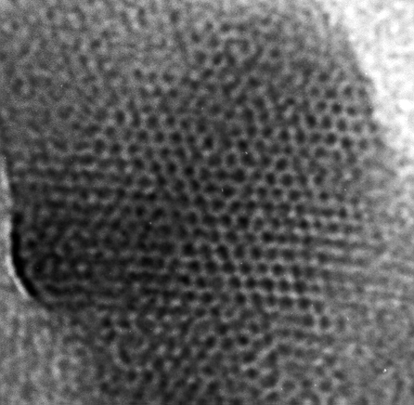
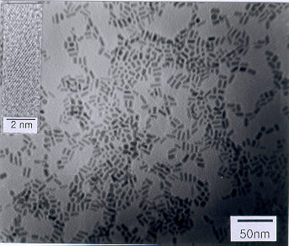
Figure 1

Figure 2
Figure 3

