, 스타이렌 모노머 반응기의 혼합 모델 제안 및 조업조건 최적화

강민구, 임희진, 이정석*, 박선원
한국과학기술원, 화학공학과
*LG화학 SR연구소

Development of Hybrid Model and Optimization of Operating Conditions for a Styrene Monomer Reactor

Min-gu Kang, Heejin Lim, Jeongseok Lee*, Sunwon Park
Dept. of Chem. Eng., KAIST
*SR Research Institute, LG Chem.

Introduction
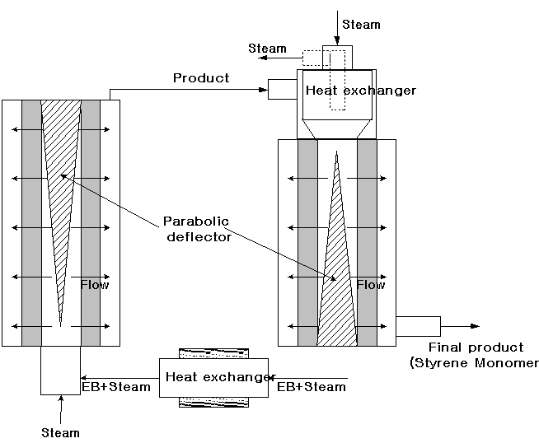
Most of the industrial styrene monomer plants carry out the adiabatic dehydrogenation reaction in the multiple reactors in series. Because of high operation cost, the rigorous styrene monomer(SM) reactor model is highly valuable. Therefore Clough and Ramirez [1], Scheel and Crowe [2] and Hirano [3] formulated reaction models. Crowe and Abdalla [4] had studied about the characteristics of a SM plug-flow reactor. Lim et al. [5] had developed the first principle model for an adiabatic radial-flow SM reactor based on the chemical kinetics.
Fig 1. Current adiabatic radial flow reactor
Although the first principle model of the radial flow reactor gave a reasonable prediction from the industrial point of view [5], the nature of the process presented some difficulties in the prediction of catalyst activity. The lack of internal or intermediate measurements of the reactor represented a limitation for the detailed model validation. In addition, the lack of experiments of catalyst activity represented the uncertainty of parameters in mathematical equations. Thus the first principle model was not enough to represent changes of catalyst activities.
In light of these difficulties for developing the first principle model, we propose alternative models of the styrene monomer reactor, using a hybrid model in which the first principle model is combined with neural networks.

System Description
In the SM reactor, three major competing reactions((1)~(3)) and three side reactions((4)~(6)) are known.
$C_{6}H_{5}{\text{CH}}_{2}{\text{CH}}_{3}↔C_{6}H_{5}{\text{CHCH}}_{2}+H_{2}$ (1)
$C_{6}H_{5}{\text{CH}}_{2}{\text{CH}}_{3}→C_{6}H_{6}+C_{2}H_{4}$ (2)
$C_{6}H_{5}{\text{CH}}_{2}{\text{CH}}_{3}+H_{2}→C_{6}H_{5}{\text{CH}}_{3}+{\text{CH}}_{4}$ (3)
$H_{2}O+\frac{1}{2}C_{2}H_{4}→\text{CO}+2H_{2}$ (4)
$H_{2}O+{\text{CH}}_{4}→\text{CO}+3H_{2}$ (5)
$H_{2}O+\text{CO}→{\text{CO}}_{2}+H_{2}$ (6)
And Fig 1 shows the adiabatic radial flow reactor which is the target process in this study.

Hybrid modeling of SM reactor

a) First principle model
Mass balance $\frac{{\text{dg}}_{i}}{\text{dr}}=\frac{1}{F}\left(2π\text{rL}\sum_{j=1}^{m}{f_{\text{ij}}{\text{MW}}_{i}}\right)$, $\sum_{i=1}^{\text{NC}}{g_{i}}=1$ (15)
Energy balance $\frac{\text{dT}}{\text{dr}}=\frac{2π\text{rL}\sum_{j=1}^{m}{\left(−{ΔH}_{j}\right)f_{j}}}{{\text{FC}}_{p}}$ (16)
Pressure drop $\frac{\text{dP}}{\text{dr}}=\frac{P_{\text{out}}−P_{\text{in}}}{R_{\text{out}}−R_{\text{in}}}$ (17)

b) Neural Network model
The neural network model consists of a set of processing units called neurons, connected to one another. The neural network in this study is a feed-forward network with one hidden layer, seven input variables and one output variable. By adjusting parameters in the coupling, between neurons, the network is capable of learning from a set of numerical data corresponding to the input and desired output.[6] Because of the time-varying characteristics of catalyst activity, the recurrent neural network is used in this hybrid model
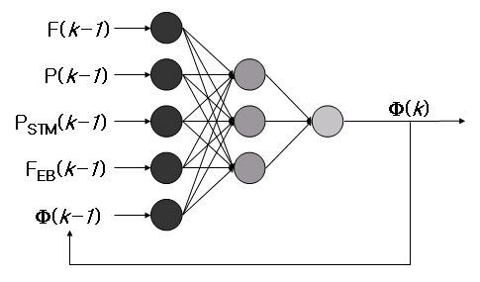
Fig 2. Recurrent neural network model

As the input variables
- Temperature (T (k-1));
- Feed rate (F (k-1));
- Partial pressure of steam in feed (P_{STM} (k-1));
- Feed flowrate of EB in feed (F_{EB} (k-1));
- Deactivation factor at time point k-1 (Φ(k-1))

As the output variable
(1) Deactivation factor at time point k (Φ(k))

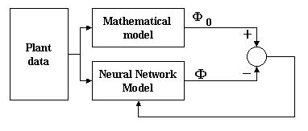
Neural Network Training
Fig 3. Schematic diagram of learning method
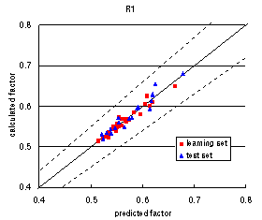
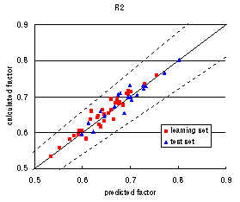
A set of 22 data obtained from the industrial plant was used to train the neural network (15 data) and another set to check the trained neural network (7 data). As shown in Fig 3, using the difference of two values, calculated real factor (Φ₀) and predicted factor (Φ), neural network model can be trained. Figs 4 & 5 show the calculated (Φ₀) versus predicted deactivation factor (Φ) for the learning and test set. The achieved agreement is within the error.
Fig 4. Calculated vs. Predicted of Reactor 1
Fig 5. Calculated vs. Predicted of Reactor 2

c) Hybrid model
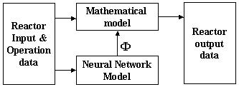
After training, the proposed neural network model supplies the catalyst deactivation factor (Φ) at any operating conditions. Mass balance, energy balance and pressure drop equations can be solved using given plant data. From these equations, we can obtain reactor output data, such as temperatures and composition of the product from each reactor.
Fig 6. Schematic diagram of hybrid model
The structure of the hybrid model, in which the first principle model and the neural network model are coupled, is presented in Fig 6.

Simulation Results

The proposed hybrid model is well fitted with the real plant data. Fig 7 compare a real plant data with simulation results using predicted catalyst deactivation factor (Φ). These figures show the performance of styrene monomer and ethylbenzene that are the main materials of this process. The simulation results show good performance within error. The simulation results show good performance of 0.4% relative error, compare with 1.7% relative error of first principle model [7].

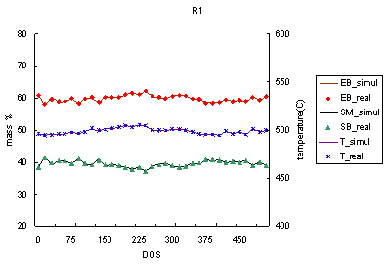
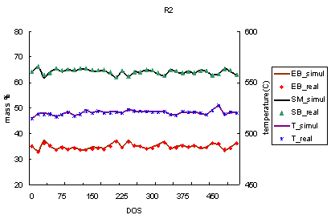
a) Reactor 1
b) Reactor 2

Fig 7. Comparison of simulation data and real data of reactors

Optimization of operating condition

a) Problem formulation
The objective function for optimization is the profit of the styrene monomer process. The objective function and constrains are formulated as shown in Table 1. TinR1 and TinR2 are inlet temperatures of reactor 1 and 2.

Table 1. Objective function and constraints for optimization
Objective function $\text{Maximize Profit}={\text{Pr}}_{1}{\text{Fg}}_{1}+{\text{Pr}}_{3}{\text{Fg}}_{3}−{\text{Pr}}_{\text{Raw}}F−\frac{{\text{Pr}}_{\text{NTH}}}{C_{1}}\left\{F(T_{\text{INR}2}−T_{\text{OUTR}1})\sum_{i}^{\text{NC}}{({\text{Cp}}_{i}g_{i})}+{\text{Cp}}_{\text{10}}{\text{Fg}}_{\text{10}}(T_{\text{INR}1}−C_{2})\right\}−C_{3}$
Equality constraints  $\frac{{\text{dg}}_{i}}{\text{dr}}=\frac{1}{F}\left(2π\text{rL}\sum_{j=1}^{m}{f_{\text{ij}}{\text{MW}}_{i}}\right)$, $\frac{\text{dT}}{\text{dr}}=2π\text{rL}\sum_{j=1}^{m}{\left(−{ΔH}_{j}\right){f_{j}}/{\left({\text{FC}}_{p}\right)}}$,  $\frac{\text{dP}}{\text{dr}}=\frac{P_{\text{out}}−P_{\text{in}}}{R_{\text{out}}−R_{\text{in}}}$, $\sum_{i=1}^{\text{NC}}{g_{i}}=1$ , $Φ=Φ(t,F,X_{\text{10}},X_{1},P)$ | Inequality constraints  $\text{600}≤T_{\text{INR}2}≤\text{650}$ , $\text{600}≤T_{\text{INR}1}≤\text{650}$  $0\text{.}5≤g_{\text{10}}≤0\text{.}\text{63}$ ,  $$0≤g_{i}≤1 (i=1,2,⋯,9)$$

b) Optimization for single operating variable
First we will show how to determine the optimum trajectory of each operating variable while the other variables are remaining constant during the whole operating horizon. Fig 8 shows optimization results for single operating variable.
a) S/O ratio
b) TinR1
c) TinR2

Fig 8 Optimization results for single operating variable

c) Profile fitting
y | S/O ratio | TinR1 | TinR2
a₁ | -0.4618 | 239.7 | 40.8274
a₂ | -6.126E-8 | 3.64E-4 | 3.67E-5
a₃ | 1.307E-4 | -0.5152 | -0.7316
a₄ | 3.2464 | 147.4537 | 560.245
a₅ | 1.0072E-2 | 3.8E-5 | 1.4141
C₁ | 6.0E+3 | 65.0 | 0.01
C₂ | 10.0 | 1.0E-5 | 0.01
error | 0.077% | 0.016% | 0.017%
Table 2. Profile fitting results
Using the results from the previous section, mathematical equation form, (18) was selected.
$y=a_{1}\text{Log}(t+C_{1})+a_{2}t^{2}+a_{3}t+a_{4}+\frac{a_{5}}{t+C_{2}}$ (18)
In this equation, y is operating variable and t is DOS. And a₁~a₅ are variables and C₁ and C₂ are constants. As shown in Table 2, this equation fits profiles of Fig 8 well.

d) Profile optimization
Fig 9 shows optimization results. As shown in Fig 9, S/O ratio should be increased slowly and inlet temperature of each reactor should be increased. Optimum profit is 65.2x10⁸ won/yr. The current operating conditions are 130% load and 89 wt% EB/1 wt% SM/ 1wt% TL/ 9 wt% ET feed composition.
a) S/O ratio
b) TinR1 and TinR2

Fig 9 Profile optimization results

Conclusion
The hybrid model combining the first principle model with neural networks has been developed for an adiabatic radial-flow dehydrogenation reactor in the styrene monomer production process. The neural network model has predicted the catalyst deactivation factors and the first principle model calculates the reactor outlet data.
From simulation data, the maximum profit of this process has been calculated using real prices. Optimum trajectories of all operating variables have been proposed.

Acknowledgment
This work was partially supported by the Brain Korea 21 project. Funding and all plant information were provided by LG Chemicals co.

References
[1] D. E. Clough, and W. F. Ramirez, Mathematical Modeling and Optimization of the Dehydrogenation of ethylbenzene to Form Styrene, AIChE Journal, 22, 6, 1097~1105(1976)
[2] J. G. P. Scheel, and C. M. Crowe, Simulation and optimization of an existing ethylbenzene dehydrogenation reactor, The Canadian Journal of Chemical Engineering, 47 183~187(1969)
[3] T. Hirano, Roles of potassium in potassium-promoted iron oxide catalyst for dehydrogenation of ethylbenzene, Applied Catalysis, 26, 65~79(1986)
[4] B. K. Abdalla, S. S. E. H Elnashaie, S. Alkhowaiter, S. S. Elshishini, Intrinsic kinetics and industrial reactors modeling for the dehydrogenation of ethylbenzene to styrene on promoted iron oxide catalysts, Applied Catalysis, 113, 89~102(1994)
[5] Heejin Lim, Eunjung Joo, Jeongseok Lee, Minho Chang, Sunwon Park, Mathmatical Modeling and Simulation of Styrene Monomer Reactor, KIChE Fall Meeting, 6, 2897~2900 (2000)
[6] C. A. O. Nascimento, R. Giudici, N. Scherbakoff, Modeling of Industrial Nylon-6,6 Polymerization Process in a Twin-Screw Extruder Reactor. Neural Networks and Hybrid, Journal of Applied Polymer Science, 72, 905-912 (1999)
[7] Lim, H. (2001a) Modeling and Operation Strategy Development for A Styrene Monomer Reactor, M.S. Thesis, KAIST, Teajon, Korea

