SMB 프로세스에 대한 식별
송인협, 이현구

서울대학교 응용화학부, 화학공정신기술연구소

Identification of a simulated moving bed process
In-Hyoup Song and Hyun-Ku Rhee
School of Chemical Engineering and Institute of Chemical Processes
Seoul National University

Introduction
This work is concerned with the model identification for a simulated moving bed (SMB) process.
Currently, the main applications to continuous chromatographic separation can be divided in two groups: first, the large-scale industrial production of relatively cheap speciality products and second the separation for high value products in small amounts, which very often exhibit separation factors near unity or which are thermally unstable. The separation costs in both cases are very high compare to the process costs. An optimal design and operation might therefore be the only possibility to exploit the economic potential of the process and to make its application feasible. A few rigorous design and optimisation procedures for SMB reactors based on dynamic process models are described in the literature but some drawbacks of the design methods for SMB separation process such as high computational load and difficulty in controller design make it necessary to introduce a more simple identified model.
It is difficult to characterize the dynamic behaviour of an SMB process because the process is a hybrid one consisting of continuous and discrete components. Hence, the optimization of SMB processes is confined to finding the optimal steady state operating conditions using several guide rules such as the triangle theory but the operation of SMB process based on the guide rules is not sufficient to deal with various control problems such as disturbance rejection or setpoint tracking.
In this study we identify an SMB process using the subspace identification method. The internal flow rate ratios are chosen as input variables and the averaged concentrations of rich components in raffinate and extrat are selected as output variables.

SMB Process Description
The SMB chromatographic process is the technical realization of a countercurrent adsorption process, approximating the countercurrent flow by a cyclic port switching. It consists of a certain number of chromatographic columns in series as depicted in Fig. 1 while the countercurrent movement is achieved by sequentially switching the inlet and outlet ports. In this study, the process is divided into four sections, of which each one consists of 2 columns of chromatography playing a specific role in the separation. A feed mixture containing a proper inert solvent and the two components to be separated are considered. The separation is carried out in the two central sections, in which component A ( the more adsorbable component) is conveyed downwards to the extract outlet and component B upwards to the raffinate outlet, respectively.
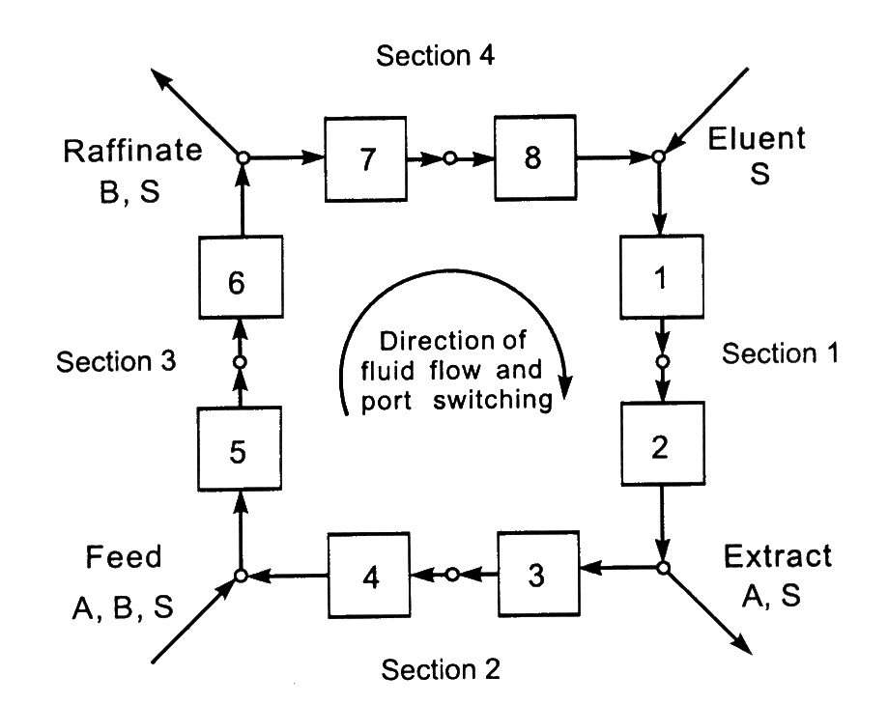
Figure. 1 A four-section SMB unit.
The principle of operation can be best described with reference to the equivalent true counter-current true countercurrently moving bed (TCC) configuration. Since the two configurations are equivalent, i.e., they achieve the same separation performance provided geometric and kinematic conversion rules are fulfilled, the simpler model of the equivalent TCC unit can be used to predict the steady state separation performances of SMB units, in particular for design purposes. The first principles model of an SMB unit is constructed based on the previous works [2, 3]. Axial mixing and mass transfer resistances are neglected and adsorption equilibrium is assumed to be established everywhere in the column. With reference to a binary separation [1], the material balance equations are given by the following set of first-order partial differential equations:

$$\frac{∂}{∂τ}\left[ε^{}c_{i}^{j}+(1−ε^{})n_{i}^{j}\right]+(1−ε^{p})\frac{∂}{∂ξ}\left[m_{j}c_{i}^{j}−n_{i}^{j}\right]=0 , (i=A, B)$$

where τ and ξ are the dimensionless time and space coordinates. $ε^{}=ε+ε^{p}(1−ε)$ represent the overall void fraction of the bed, while $ε^{p}$ is the intraparticle porosity. In these equations, the composition of the adsorbed phase, $n_{i}^{j}$, is calculated according to the bi-Langmuir isotherm. The parameters m_{j} are the so-called flow rate ratios and are defined as the ratio of the net fluid flow rate over the solid phase flow rate in each section of the unit:

$$m_{j}=\frac{\text{net} \text{fluid} \text{flow} \text{rate}}{\text{adsorbed} \text{phase} \text{flow} \text{rate}}=\frac{Q_{j}^{\text{SMB}}t^{}−{Vε}^{}}{V(1−ε^{})}$$

where Q_{j} , t* and V denote the internal flow rate, the switching time and the volume of one column in the SMB unit, respectively. In the framework of equilibrium theory the design problem for SMB units reduces to developing criteria for the selection of the values of m_{j.} These values are considered as the input variables.

Identification of SMB Process
The averaged concentrations of rich component in raffinate and extrat are selected as output variables. Since these variables are directly correlated with the product purities, the control of product purities is also accomplished.
To find out the correlation between the inputs and outputs, the subspace identification method is adopted. First, on the basis of the triangle theory, the optimal feed flow rate ratios at steady state are calculated. Then, pseudo random binary input signal is generated on the basis of this optimal value. The optimal conditions for complete separation are given by the following inequalities:

$$\begin{aligned}[γ_{A}−ω_{G}(1+K_{A}c_{A}^{F})]m_{2}+K_{A}c_{A}^{F}ω_{G}m_{3}<ω_{G}(γ_{A}−ω_{G}) \\ [γ_{A}−γ_{B}(1+K_{A}c_{A}^{F})]m_{2}+K_{A}c_{A}^{F}γ_{B}m_{3}<γ_{B}(γ_{A}−γ_{B}) \\ m_{2}<m_{3}\end{aligned}$$

where $γ_{A}$ and $ω_{G}$denote the intersection points in the complete separation zone. For the detail one may refer to the Mazzotti and his coworkers’ article [1]. Above inequalities are also considered as input constraints when the controller is designed.
Figure. 2 shows the identification result. We obtain the 10th order state space model using the subspace identification method [5, 6]. The model includes the state space matrices and optimal Kalman filter gain matrix. Akaike's final prediction error (FPE) criteria for concentrations in extract and raffinate are 6.775e-005 and 4.382e-004, respectively.
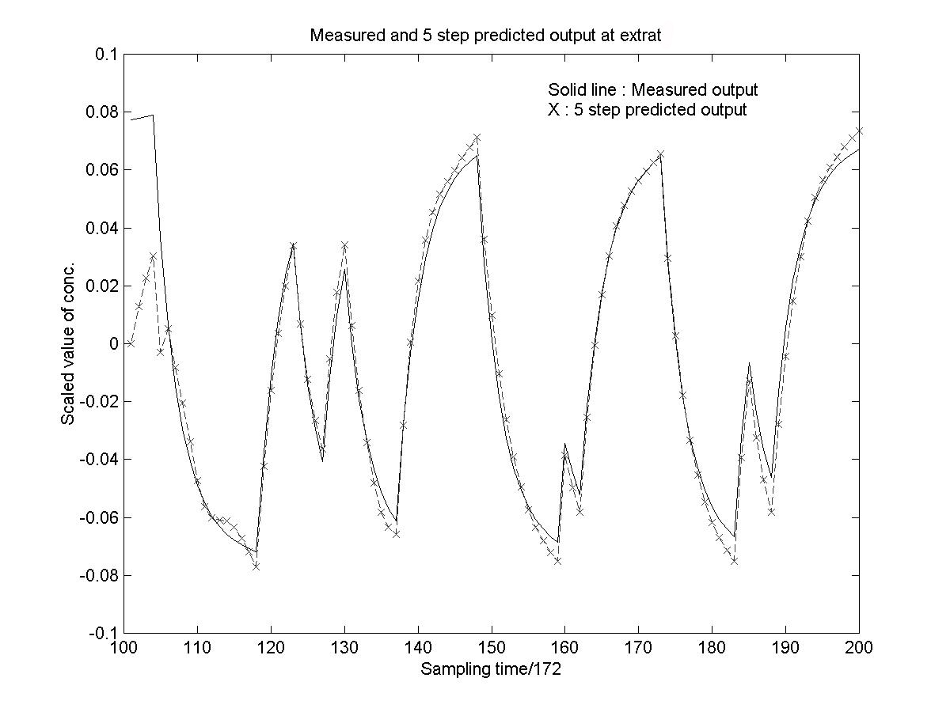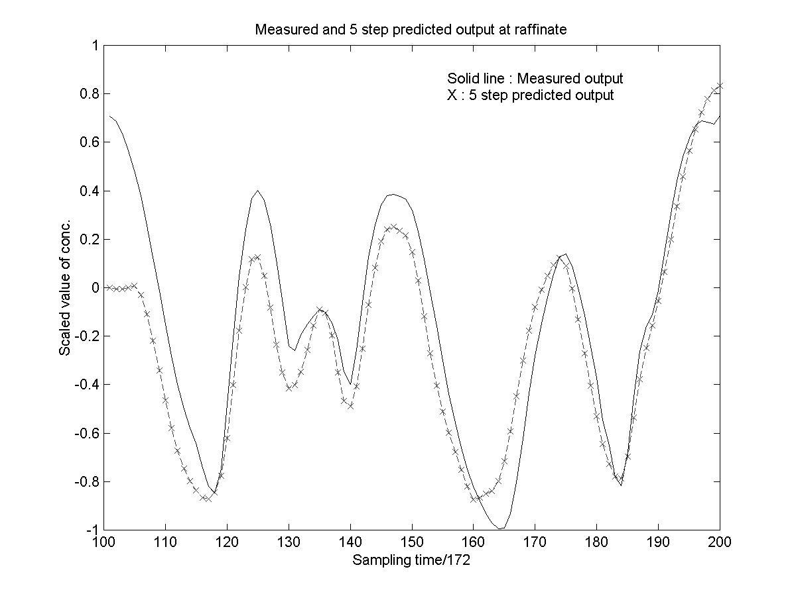
Figure 2. Validation of identified model
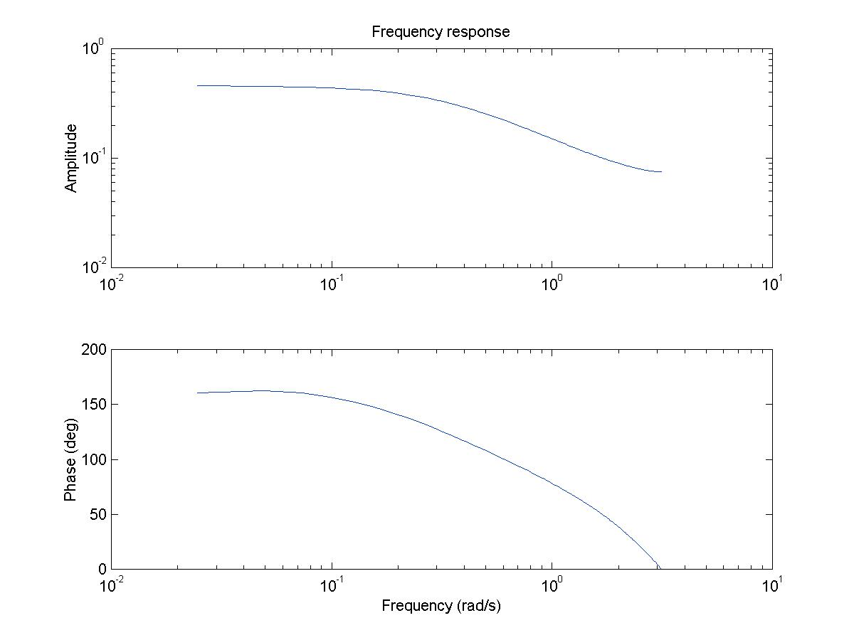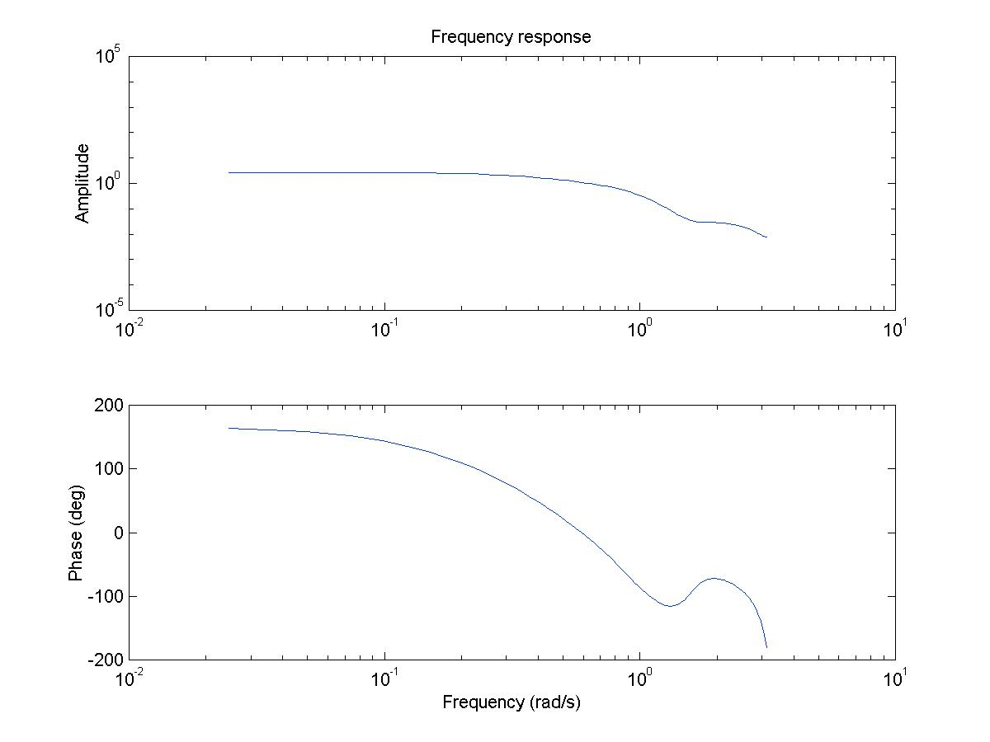
(a) u₁ → y₁ (b) u₁ → y₂

Figure 3. Frequency response of the identified model.
Figure 3 shows the frequency response of the identified model. In an actual SMB separation unit, it is hard to obtain the frequency responses due to the lack of robustness of process. From the frequency response of the identified model one can choose the first approximation of phase margin and gain margin and guarantee the stable operation to some extent.
It should be possible to design an advanced controller based on the identified model such as model predictive controller or linear quadratic gaussian controller. For this, however, one needs a state estimator because the state estimation must precede the calculation of control input. Unknown a priori information of the initial state and covariance matrices makes the design of advanced controllers difficult.

Conclusion
The 10th order state space model is identified for an SMB unit by using the subspace identification method. Due to the heavy computational load and the complexity of the first principles model it is necessary to have an identified model for the design of an advanced controller. Using the identified model, we obtain the frequency response. On the basis of the frequency response, one can calculate the phase margin and gain margin of the SMB unit. Also, the analysis of stability can be performed by using the identified model. A simple controller such as state feedback controller may be designed using simple pole-zero cancellation technique but it is a challenging task to design an advanced controller. The hybrid characteristics and the periodicity of the SMB unit make it difficult to implement the advanced controller. Design of an optimal controller based on the identified model is in progress.

Acknowledgment
The financial aid from the Brain Korea 21 Program supported by the Ministry of Education is greatly appreciated.

References
- Migliorini, G., Mazzotti, M. and Morbidelli, M., “Continuous chromatographic separation through simulated moving beds under linear and nonlinear conditions,” Journal of Chromatography, A, 827, 161-173, (1998).
- Dunnebier, G., Fricke, J., and Klatt, Karsten-Ulrich, “Optimal Design and Operation of Simulated Moving Bed Chromatographic Reactors,” Ind. Eng. Chem. Res., 39, 2290-2304, (2000).
- Kloppenburg, E. and Gills, E.D., “Automatic control of the simulated moving bed process for C8 aromatics separation using asymptotically exact input/output-linearization,” Journal of Process Control, 9, 41-50, (1999).
- Verhaegen, M. and Dewilde, P., “Subspace model identification: Part 1. The output-error state-space model identification class of algorithms,” Int. J. Control, 5, 1187-1210 (1992).
- Viberg, M., “Subspace-based Methods for the Identification of Linear Time-invariant Systems,” Automatica, 31(12), 1835-1851 (1995).

