바이오 칩 제작을 위한 표면위 일정한 메조간격 형성

박 준 원, 오순진, 최영서, 홍봉진
포항공과대학교 화학과, 분자생명학부, 바이오나노텍센터

REGULAR MESOSPACING ON THE SURFACE FOR THE BIOCHIPS

Joon Won Park, Soon Jin Oh, Young Seo Choi, Bong Jin Hong
Bionanotechnology Center, Department of Chemistry, Division of Molecular and Life Sciences, Pohang University of Science and Technology,
Pohang 790-784, KOREA

Dendrimers are highly branched polymers with uniform size and molecular weight as well as well-defined structure. Because it is possible to control their size and structure and at the same time to introduce a variable kind of functional groups into their end groups or core, they are frequently used to make thin film with a various functional group on the top surface of substrate. In addition, because the size of dendrimers can be tailored by choosing the number of repeating units, it is possible to select the number of interacting functional group of the molecule with the surface and control the space between functional groups on surface. Therefore dendrimers are good candidates that provide surface area enough to accommodate large molecules such as supramolecules and biomolecules.
The procedure for the self-assembly with the nonacarboxylic acid is schematically presented in Figure 1. Oxide surface of fused silica or Si wafer was transformed into the aminosilylated one by immersion of the substrates in a toluene solution of (3-aminopropyl)diethoxymethylsilane (APDES) for 3 h. After being washed and dried under vacuum, the substrates was dipped in a solution dissolving the nonacarboxylic acid for the self-assembly. The modified substrates were washed and dried under vacuum for the further application and the characterization. Efficiency of the last spontaneous process varied with the choice of solvent, the reaction time, and the concentration of the nonacarboxylic acid.

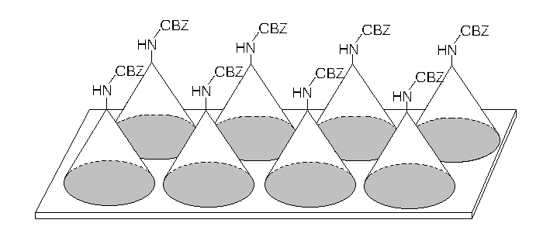
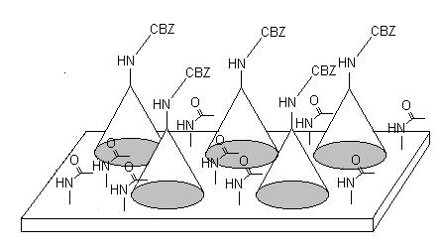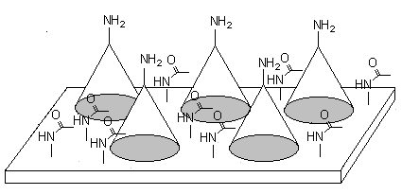
Aminosilylation with
(3-aminopropyl)-
diethoxymethylsilane
Quenching of residual amines by acetic anhydride
Deprotection of cbz group by trifluoroacetic acid
Figure 1. Schematic presentation of the procedure for the self-assembly with the hyperbranched dendrimer on the aminosilylated surface, quenching of residual amines by acetic anhydride and deprotection of cbz group by trifluoroacetic acid.
Fused silica or Si wafer
Self-assembly of nonacarboxylic acid

AFM image (Figure 2A) analysis showed that the nonacarboxylic acid molecules formed aggregates in 10 mM concentration. Figure 2A shows that the number of the aggregates is 80-100/ 25 µm² and these aggregates are 2-10 nm in height and 10-100 nm in lateral size. Meanwhile, Figure 2C and 2D indicate that the well-defined monolayers are formed in 1.0 mM and 0.10 mM concentration in which the aggregates (5-10/ 25 µm²) are scarce. The aggregates are also smaller both in height and lateral size than those in 10 mM concentration. In the latter case roughness of the films in 10 µm² was less than 2 Å, which is calculated by the software supplied by D.I instrument.
After the self-assembly the substrate was treated with acetic anhydride to cap the free amine groups which were left behind without interacting with the carboxylic acid. Figure 2B is the one obtained after being treated with acetic anhydride. AFM images show that over 90% of the aggregates are removed after being treated with acetic anhydride. Therefore, the surface analysis confirms that the treatment of acetic anhydride remove the aggregates adsorbed physically. However, no change of the surface morphology was observed for the film obtained at 1.0 mM and 0.10 mM concentration after the treatment.
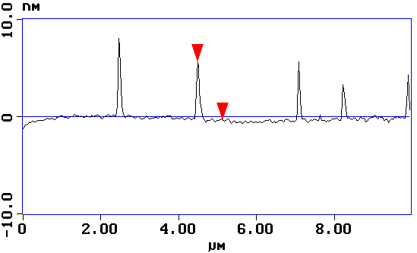
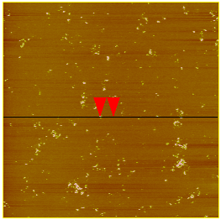
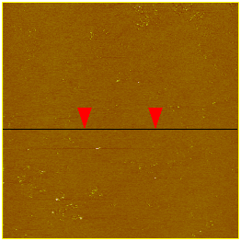
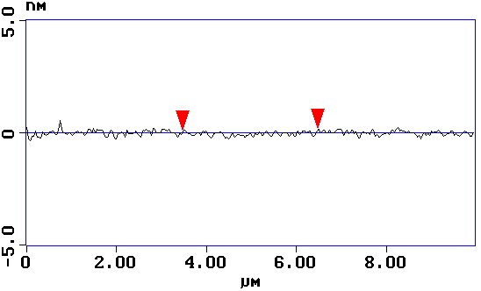
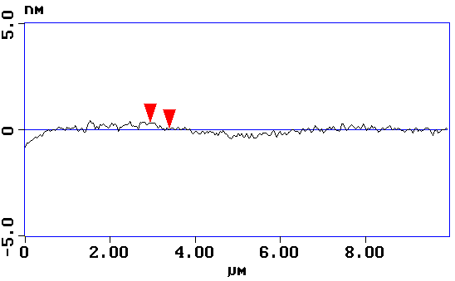
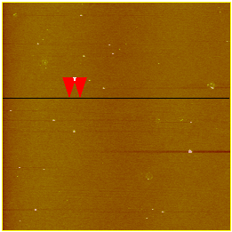
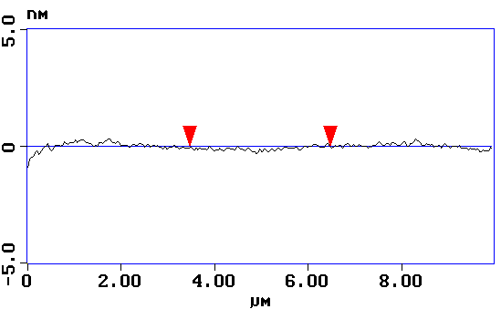
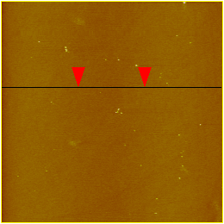
(B)
(A)
(C)
(D)

Figure 2. AFM images of the self-assembled layer formed in 12 h ((A) and (B) at 10 mM concentration, (C) at 1.0 mM concentration, and (D) 0.10 mM concentration.) (B) is the image obtained after the treatment with acetic anhydride
In the mean time, four kinds of aminosilane layers on glass slides or silicon wafers were prepared. The amine density of the layers prepared with aminopropyldiethoxymethylsilane (APDES), aminopropylmonoethoxydimethylsilane (APMES), a mixture of aminopropyltriethoxysilane (APTES) and n-buthyltrimethoxysilane (n-BTMS) (v/v = 1:10) are 4.0(±0.8) amines/nm², 1.0(±0.2) amine/nm², and 0.30(±0.6) amine/nm², respectively. A substrate with much higher amine density, i.e. 40(±8) amines/nm² was also prepared by allowing aziridine to polymerize on the APDES-treated substrate. AFM revealed that APDES, APMES, and APTES:n-BTMS-treated surfaces were relatively flat, on the other hand, aziridine-treated surface showed embossed morphology. The amine substrates were allowed to react with a heterobifunctional linker succinimidyl 4-maleimido butyrate (SMB), and subsequently pentadecadeoxynucleotides were microarrayed on the SMB-treated substrates. Characteristics of the DNA microarrays including the dynamic range and the mismatch discrimination efficiency, etc were examined. Noteworthily, DNA microarrays on the aziridine-polymerized substrate showed much higher fluorescence intensity. At the same time, DNA microarrays from these four substrates were able to discriminate internal- and terminal-mismatched pairs, but the fluorescence ratio was far from the one that thermodynamics implies.
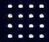
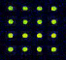
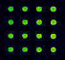
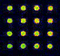
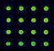
a b c d e

Figure 3. Fluorescence images after hybridization of the probe oligodeoxynucleotides microarrayed on the linker-modified aziridine surface with a target oligonucleotide labeled with Cy3 (c = 10 nM). Microarrayed oligodeoxynucleotides were (a) 3´-SH-spacer-ACCTGTGAGCCTTAX-5´; X = C; matched, (b) X = G; terminal-mismatched, (c) X = A; terminal-mismatched, (d) X = T; terminal-mismatched, (e) 3´-SH-spacer-ACCTGTGXGCCTTAC-5´; X = T; internal-mismatched. Target oligodeoxynucleotide is 3´-GTAAGGCTCACAGGT-Cy3-5´.

