물리적 구속에 의한 고분자 박리 제어

박준형,서갑양,이홍희
서울대학교 대학원 응용화학부

Controlled Polymer Dewetting by Physical Confinement

Joonhyung Park, Kahp Y. Suh and Hong H. Lee
School of Chemical Engineering, Seoul National University

Introduction
Much effort has been devoted to the dewetting behavior of thin polymer films in two-dimensional systems [1,2]. The polymer films in such systems undergo dewetting above the glass transition temperature (T_{g}) through the generation of spherical drops with a finite contact angle given by Young’s equation. The drops, in turn, contact one another, resulting in the well-known cellular structure [2]. The usefulness of the structure is restricted in that it lacks long-range order even on a several-micron scale.
Much work in the direction of getting order into dewetting phenomenon has been carried out [3,4]. Meyer and Braun [3] generated ordered polymer drops on chemically modified surface by microcontact printing. It was reported that the holes are formed exclusively on the hydrophilic microprinted areas due to poor wettability with the polymer film. Kargupta and Sharma [4] subsequently developed a theoretical explanation for the controlled dewetting process on chemically heterogeneous striped pattern. They found that the film breakup is suppressed on some potentially destabilizing nonwettable sites when the pattern spacing is below a certain characteristic length. However, less is known about the dewetting dynamics when the polymer film is physically confined. In this paper, we report on polymer dewetting for physically confined systems.
Micro- or nanostructures of polymer can be fabricated by placing a polydimethylsiloxane (PDMS) mold with channel patterns on a spin-coated polymer surface and then raising the temperature above T_{g}, as shown in Fig. 1 [5]. During the annealing process, the polymer flows into the channel of the mold and forms the replica after mold removal. If one hopes to obtain the exact replica of the mold, a high molecular weight polymer should be used as the dewetting of the polymer is quite suppressed throughout the annealing process due to its high viscosity. On the other hand, if one hopes to utilize the dewetting phenomenon of the polymer film, a low molecular weight polymer should be used for the purpose [6]. This latter case is investigated.

Experimental Method
We fabricated PDMS (Sylgard 184, Dow Corning) mold that has a planar surface with protruding (positive) or recessed (negative) patterns by casting PDMS against a complementary relief structure prepared by photolithographic method. For the polymer, we used a standard polystyrene (PS) (M_{w}=3900, M_{w}/M_{n}<1.02, and T_{g}=98°C). The low molecular weight used in our experiment facilitates the dewetting process due to its low viscosity. Silicon wafer was cleaned by ultrasonic treatment in trichloroethylene and methanol for 5 minutes each and dried in nitrogen. Native oxide was not removed of the surface and thus would exist on the surface. Thin films were prepared by spin coating a toluene solution of the polymer onto a silicon substrate. The film thickness ranges from 23nm to 75nm, which was determined by elipsometry with an accuracy of 0.5~1nm. The mold with the pattern is placed on the surface of a polymer layer that has been spin-coated onto a substrate and then heated above the glass transition temperature (typically 150°C) of the polymer. In the dewetting, the PDMS walls act as a boundary, thereby generating a three-dimensionally confined system. A schematic diagram of our experimental setup is shown in Fig. 1.

Results and Discussion
To investigate the transients of the regular drop formation, we carried out dewetting experiments with 23nm PS films using a positive mold for various annealing times (20, 40, 60, and 80 min) at 130°C, the results of which are shown in Fig. 2. Both the box size and the space between two adjacent boxes in the figure are 10μm. After 20 minutes [Fig. 2(a)], the mass climbs up the walls due to capillarity, leading to the thin square lines defining the boxes. Hole formation, which is frequently observed in the conventional dewetting experiments [2], was not detected in this initial stage. Instead, the polymer recedes from the confining walls both inside and outside the box such that outside the box a large circular rim surrounding the box is observed but a flat and circular drop forms inside the box. Note in this regard that the box in contact with the polymer acts as a defect-like site from which the mass is driven away. The circular rim outside the box is formed by the mass accumulation from the walls, which has the same origin as in the hill formation around the holes in the conventional dewetting. In this initial stage, no distinct ordering is observed. Then, the polymer merges into the thick, square ribbon outside the box. Spherical drops form at four corners due to mass accumulation [Fig. 2(b)]. The drops continuously grow in size at the expense of the ribbons and finally the ribbons break up after about 60 minutes [Fig. 2(c)]. When the annealing time exceeded 60 minutes, the drops further merged into larger ones that are located at four corners and four center lines around a box [Fig. 2(d)], which resembles the two-dimensional projection of face-centered cubic (FCC) structure.
We found in our experiment that polymer drops cease to form as the film thickness increases and the pattern size decreases. To investigate the effect of the film thickness and the pattern size on the ordering behavior, we consider propagation of the wave as determined by the balance between surface energy and intermolecular forces. In our experiment, the mold walls act as a physical barrier. Therefore, a wave could not be sustained due to the barrier if the wavelength is larger than the pattern size. This supposition is similar to the conclusion reached by Kargupta and Sharma [4]. Through simulation of dewetting on chemically heterogeneous stripes, they concluded that the film breakup is suppressed when the pattern spacing is below a certain critical length. The wavelength of the capillary wave can be determined from the capillary wave theory [1], the cut-off wave vector q_{c} being given by
$q_{c}={\left[\frac{A_{\text{eff}}}{2\text{πγ} h_{r^{4}}}\right]}^{1/2}$ (1)
where A_{eff} is the effective Hamaker constant for the van der Waals interaction of the film with the surrounding media, γ is the surface tension of the film, and h_{r} is the thickness of the film remaining after the capillary rise.
The supposition here is that no polymer drops form when the wavelength as determined by the cut-off wave vector is larger than the pattern size, which in the experiment is the pattern width. Otherwise, ordered drops do form. To test the supposition, we carried out experiments in which the pattern size and the film thickness were varied. Shown in Fig. 3 is the comparison between theory and experiment. Given the pattern size, the residual film thickness is a function of the initial film thickness, which ranges from 23 to 75nm in our experiment. For 2μm pattern in Fig. 3, for instance, the initial film thickness was varied for three different residual film thicknesses. The demarcation line in the figure is given by the capillary wave theory [Eq. (1)]. As shown in the figure, h_{r} (nm) = 7.51×λ^{1/2} (μm) such that the residual film thickness is equivalent to the wavelength λ. When the pattern size is smaller than the wavelength (upper region), the capillary wave is blocked, resulting in no drop formation and thus no ordering. On the other hand, ordering can be observed when the pattern size is larger than the wavelength (lower region). It is seen that the theoretical prediction is in satisfactory agreement with the experimental data.

Summary
It has been shown that PS films of low molecular weight form ordered drops when annealed above the glass transition temperature under the physical confinement of PDMS mold. It is found that the dewetting is observed only when the wavelength of capillary wave for the residual film is smaller than the pattern size, which indicates that the mold walls block the propagation of the capillary wave. A theoretical model has been found to adequately describe the ordering. Since the findings should be equally applicable to a number of polymers, the results reported here could provide a convenient way of studying dewetting behavior of thin polymer films under confined geometry and also of fabricating ordered polymer microstructures.

References
[1] Brochard-Wyart and J. Daillant, Can. J. Phys. 68, 1084 (1990).
[2] G. Reiter, Phys. Rev. Lett. 68, 75 (1992).
[3] E. Meyer and H.-G. Braun, Macromol. Mater. Eng. 276/277, 44 (2000).
[4] K. Kargupta and A. Sharma, Phys. Rev. Lett. 86, 4536 (2001).
[5] K. Y. Suh and H. H. Lee, J. Chem. Phys. 115, 8204 (2001).
[6] K. Y. Suh, Y. S. Kim, and H. H. Lee, Adv. Mater. 13, 1386 (2001).

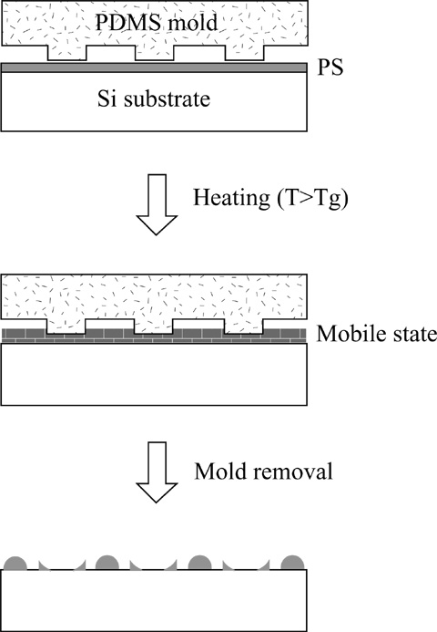
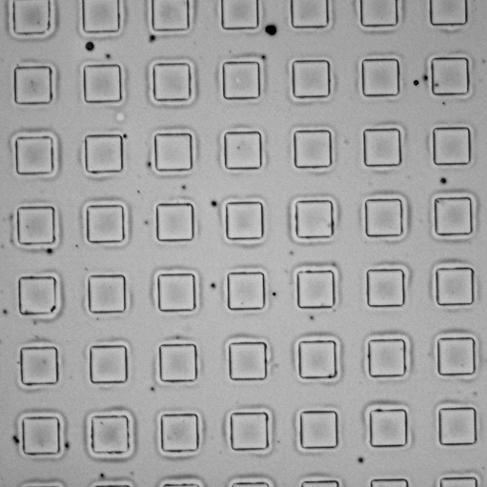
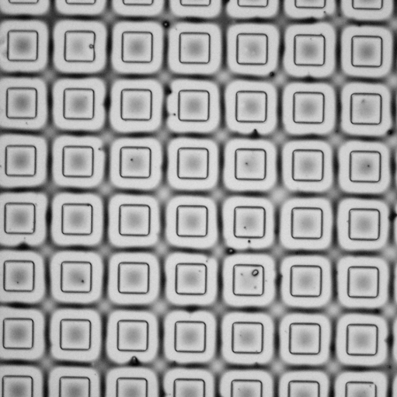
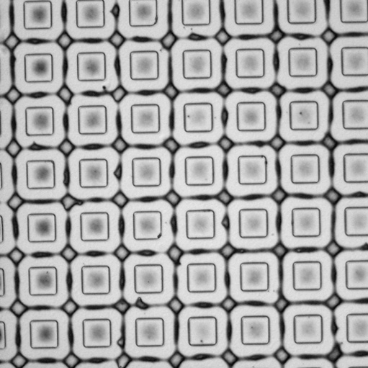
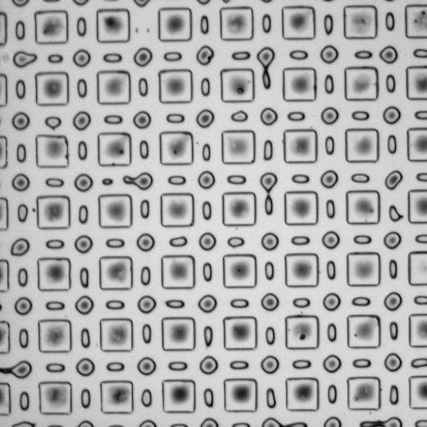
(a)
(b)
(c)
(d)
10 μm

<Fig. 1> Illustration of our experimental procedure. <Fig. 2> Optical micrographs of the transient morphologies
of polymer drops for a 10μm×10μm positive box pattern.

<Fig. 3> Comparison of the calculated wavelength of the capillary wave with
the pattern size as a function of the thickness of residual film.

