용융삽입법에 의한 폴리에틸렌/실리케이트 나노복합체의 특성연구

왕기현, 허명철, 정 인 재
한국과학기술원 화학공학과

Morphology and physical properties of polyethylene/silicate nanocomposite prepared by melt intercalation

Ki Hyun Wang, Mingzhe Xu, In Jae Chung
Department of Chemical Engineering, Korea Advanced Institute of Science and
Technology, 373-1 Kusong, Yusong, Taejon, 305-701, South Korea

Abstract
Maleated polyethylene/silicate nanocomposite with different aspect ratio of silicate and maleated polyethylene/SiO₂ composite were prepared by melt intercalation. The nanocomposite with high aspect ratio silicate (montmorillonite) showed the faster decrease in terminal slope of storage modulus and the steeper increase in complex viscosity than those with low aspect ratio silicate (laponite) and SiO₂. Addition of montmorillonite increases the crystallization temperature of PEMA but again decreases above 3 volume% of silicate content because of the increased viscosity.
Keywords: polyethylene, nanocomposite, melt intercalation,

Introduction
Layered-silicate based polymer nanocomposites have attracted considerable technological and scientific interest in recent years.¹⁻⁴ The technological interest has stemmed from the dramatic enhancements in physical, thermal and mechanical properties of polymer-based materials with minimal increase in density due to the low inorganic loading.⁴
Initial attempts to create the nonpolar polymer/silicate nanocomposites by melt intercalation were based on the introduction of a modified oligomer to mediate the polarity between the silicate surface and polymer. One of the typical examples is polypropylene/silicate nanocomposite system by Toyota.
In this study, we use two kinds of silicates with high and low aspect ratios and one conventional filler SiO₂. The aim of this work is to investigate the role of silicates with different aspect ratios and conventional filler in crystallization behavior and rheological properties of the polyethylene composites.

Experimental

Materials
Organically modified montmorillonite (Closite 20A) and modified laponite (SCPX2231) were obtained from Southern Clay Products as nano-sized fillers and maleic anhydride modified polyethylene (PEMA) purchased from Aldrich was used as a matrix resin. The montmorillonite (20A) had high aspect ratio (100-200) and the laponite (Lapo) had low aspect ratio (20-30). The organic modifier for both organo silicates was dimethyl dihydrogenated tallow ammonium ions. The PEMA was the linear low density polyethylene grafted with 0.85wt% maleic anhydride (density = 0.930g/cc). The conventional filler, SiO₂ (average particle diameter: 1.8μ) was purchased from Fuji Sylysia.

Preparation of composites
The composites were prepared through melt intercalation at 140℃, using a brabender mixer with the chamber size of 50cc. Screw speed was 60rpm and the mixing time was 20 min for all the cases.

Measurements
Transmission electron microscope (TEM) and X-ray diffraction (XRD) were used to observe the dispersability of the silicate in composites. Differential scanning calorimetry (DSC) was used to obtain the crystallization and melting transition. Measurements were performed on Du Pont model 910 thermal analyzer under nitrogen atmosphere. Rheological properties of composites were measured by using ARES (Advanced Rheometric Expansion System) in oscillatory mode with cone and plate geometry under nitrogen atmosphere.

Results and Discussion

Preparation of nanocomposites with different aspect ratio silicate
The X-ray diffraction (XRD) profiles of the two kinds of silicates with different aspect ratios are shown in Fig.1. The (001) plane peak of 20A is shown around 2θ= 3.6˚and the broad peak of Lapo around 2θ= 4.3˚. These peaks disappear when the silicates (3volume%) are melt intercalated with PEMA. This clearly indicates the exfoliation capabilities of silicate in the PEMA in both cases.
We employed the transmission electron microscopy in order to confirm the dispersion of 3 vol% of silicates in PEMA. Fig.2 (a) show that each layer of silicate is well dispersed and exfoliated in the PEMA. Fig.2(c) shows TEM image of PEMA/SiO₂ composite prepared as mentioned above. Irregular sizes of SiO₂ particles are detected, indicating the aggregation and poor dispersion of SiO₂ particles relatively.
Fig.1. X-ray diffraction patterns of PEMA/silicate(3vol%) anocomposite with 20A and Lapo.a:PEMA/20A, b:PEMA/Lapo, the patterns of 20A and Lapo are shown.

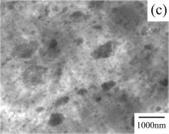
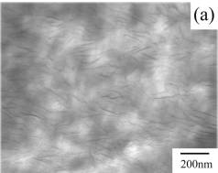

Fig.2. TEM of composites with 3vol% filler.
a:PEMA/20A, c: PEMA/SiO₂

Rheological properties of composites
Fig.3 show storage moduli of composites and PEMA measured at 210 ℃. The storage moduli of all the composites show a monotonic increase at all frequency ranges with increasing filler contents in Fig.3.
The terminal slope decreases as the silicate loading increases. The slope for PEMA/20A decreases faster than that of PEMA/Lapo, and changes abruptly between 1 and 3 vol %. This abrupt decrease may be due to the pseudo-solid like property. The nanocomposite of PEMA with 20A(high aspect ratio) shows the highest non-terminal yield at 3 vol% of silicate in Fig.3. The terminal slopes of PEMA/SiO₂ macrocomposites show the least sensitiveness with SiO₂ loading in Fig.3(c).

(a)

Fig.3. Storage moduli of composites measured in cone and plate geometry at 210℃.
(a):PEMA/20A, (b):PEMA/Lapo, (c): PEMA/SiO₂

(c)
(b)

In Fig.4, relative complex viscosity (η*_{re}) is plotted to investigate the effect of aspect ratio of a filler. The η*_{re} increases more steeply for PEMA/20A with high aspect ratio of 20A. But PEMA/Lapo and PEMA/SiO₂ show a little increase with filler loading. Especially, PEMA/20A shows the abrupt increase of η*_{re} at the silicate concentration above 1vol%. This corresponds to the result that the storage moduli of PEMA/20A show the abrupt increase between 1 and 3vol% of filler content. The nanocomposite with high aspect ratio of a filler shows the steeper increase in relative viscosity with the filler loading than that with low aspect ratio filler.

Thermal behavior of composites
Fig.4. Relative complex viscosity(η*_{re}) of composites at frequency of 0.01s⁻¹ .
a:PEMA/20A, b:PEMA/Lapo, c: PEMA/SiO₂

Fig.5(a), (b) and (c) show the crystallization temperature of composites with 20A, Lapo and SiO₂ , respectively. The last number of the sample name in the caption indicates the volume fraction of a filler, for example, 0.5v is 0.5vol%. The presence of 20A in the composites produces the increase of the PEMA crystallization temperature around 103℃. But when the content is more than 3vol%, the crystallization temperature slightly decreases again. Lapo with low aspect ratio silicate also increases the crystallization temperature of composite at a low content but it does not change further as its content increases. It is understood that the silicate plays a nucleating role to some extent and the crystallization temperature may be related to the viscosity of nanocomposite.
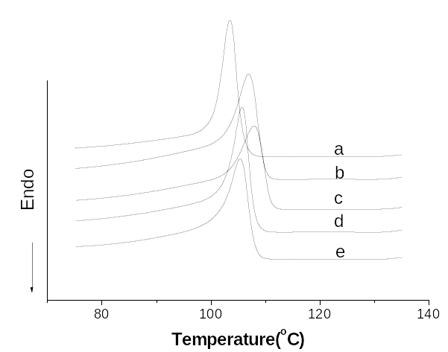
(a)
(a)

Fig. 6. (a) Crystallization behavior of composites with 20A.
a: PEMA b: 20A-0.5v c: 20A-1v
d: 20A-3v e:20A-5v
Fig.6.(b) Crystallization behavior of composites with Lapo.
a: PEMA b: Lapo-0.5v c: Lapo-1v
d: Lapo-3v e: Lapo-5v
Fig.6. (c) Crystallization behavior of composites with SiO2.
a: PEMA b: Si-0.5v c: Si-1v
d: Si-3v e: Si-5v

(b)
(c)
(c)

For the PEMA/20A, the silicate with a high aspect ratio does not disturb the crystallization under 3vol% silicate contents. But the crystallization is impeded due to the decrease in diffusion rate of PEMA chain caused by the increase of viscosity of composites over 3 vol%, at which the high value of η*_{re} is shown in Fig.4. For the PEMA/Lapo, there is almost no change in crystallization temperature like the small change of the η*_{re} shown in Fig.4.
In Fig. 5(c), PEMA/SiO₂ composites show the bimodal crystallization behaviors at the content of SiO₂ above 3vol%. It is understood as follows. As seen Fig. 2 (c), SiO₂ is not dispersed at a molecular level in matrix. The well-dispersed part of SiO₂ in the matrix may play a role of nucleating agent like 20A or Lapo. But some aggregated SiO₂ particles locally increase the viscosity of the composite and some molecules near the aggregated SiO₂ crystallize slowly.

Conclusions
PEMA/20A and PEMA/Lapo nanocomposites show the exfoliated state. The PEMA/20A with the high aspect ratio shows the sharp decrease in terminal slope of storage modulus and the sharp increase in the relative viscosity with content. The crystallization of composites are strongly related with the viscosity resulted from fillers and its dispersion state. The crystallization temperature of PEMA/20A are lowered above 3 vol% of 20A because of the high viscosity..

References
- Giannelis, E. P. Adv Mater 1996, 8, 29.
- Giannelis, E. P.; Krishnamoorti, R.; Manias, E. Adv Polym Sci 1995, 33, 1047.
- Krishnamoorti, R.; Vaia, R. A.; Giannelis, E. P. Chem Mater 1996, 8, 1718.
- Kojima, Y.; Usuki, A.; Kawasumi, M.; Okada, A.; Fukushima, Y.; Kurauchi, T.; Kamigaito, O. J Mater Res 1993, 8, 1185.

