폴리아크릴로나이트릴/몬모릴로나이트 나노복합체 제조

최용석, 함형택, 정인재
한국과학기술원 생명화학공학과

In-situ Polymerization of Polyacrylonitrile/Na-MMT Nanocomposites

Yeong Suk Choi, Hyeong Taek Ham, In Jae Chung
Department of Chemical and Biomolecular Engineering, Korea Advanced Institute of Science and
Technology, 373-1 Kusong, Yusong, Taejon, 305-701, South Korea

Abstract
Polyacrylonitrile/Na-MMT nanocomposites were synthesized through an emulsion polymerization of acrylonitrile (AN) using 2–acrylamido-2-methyl-1-propanesulfonic acid (AMPS). The nanocomposites were exfoliated during polymerization. The nanocomposites were exfoliated up to the 20 wt % content of pristine Na-MMT relative to the amount of AN. The nanocomposites exhibited the enhanced storage modulus, E´, when compared with pure PAN. Delaminated morphology of nanocomposite was confirmed by TEM.
Keywords: polyacrylonitrile, nanocomposite, silicate, exfoliation, polymerization

Introduction

Organic/inorganic hybrids have mechanical properties of organic and inorganic materials showing a huge potential application in electronics, adhesives and automotive fields. So, engineers and researchers are focusing on polymer/silicate nanocomposites, with high stiffness,¹⁻² strength, flame-retardation³⁻⁵ and gas barrier property with a small amount of silicate loading. The nanocomposites are applicable to materials for lightweight and high performances. The advantages of polymer/silicate nanocomposites result from high degree of dispersion of silicates in polymers: Intercalation of polymers in silicate layers or delamination of silicates after polymer insertion into silicate layers by the polymerization.
We pointed out some advantages of emulsion polymerizations on synthesis of polymer/silicate nanocomposites and produced exfoliated PMMA/Na-MMT nanocomposites: Water made the basal space of silicate layers widen without any chemical treatment, and 2–acrylamido-2-methyl-1-propanesulfonic acid (AMPS),⁶⁻⁸ a reactive surfactant containing an amido moiety in its molecule, made the polymer end-tethered on silicate layers. We will extend this method to PAN, and describe a simple and convenient way to obtain the exfoliated PAN/clay nanocomposites through an in-situ polymerization with AMPS. We will investigate their morphologies and mechanical properties.

Experimental

Materials
Acrylonitrile and 2–acrylamido-2-methyl-1-propanesulfonic acid (AMPS) purchased from Aldrich were used as received. Na-MMT (Kunipia-F) with 119 mequiv/100 g silicate of cation exchange capacity was obtained from Kunimine Co., and dispersed in deionized water for 12 hours at ambient temperature, before polymerization. Potassium persulfate (KPS) of Junsei, an initiator, was recrystallized using deionized water. N, N-dimethylforamide (DMF) of HPLC solvent grade was used as received from Aldrich for polymer recovery in reverse ion exchange. Methyl alcohol (MeOH) of Fluka, a nonsolvent for PAN, was distilled at a normal pressure. Lithium chloride (Junsei) was recrystallized with THF.

Synthesis of composites
Polymerizations were carried out in the following way, with various amounts of Na-MMT. For an example, Na-MMT dispersed in a deionized water, and the solution containing AN, AMPS and deionized water with the ratio of 5 g/0.3 g/126 g(AN/AMPS/water) were charged into a 1000 ml four-neck reactor equipped with a baffle stirrer, a reflux condenser, a nitrogen inlet, and a rubber septum. The mixture was stirred at 200 rpm for 30 minutes under a N₂ gas at an ambient temperature. The temperature of the reactor was raised up to 65 ºC.

Measurements
X-ray diffraction patterns were obtained by using Rigaku X-ray generator (CuKα with λ=0.15406) at a room temperature with scanning rate of 2°/min in a 2θ range of 1.5-10°. X-ray patterns were obtained from discs of dried sample. Number average molecular weights were determined by using GPC. GPC analysis were performed at a flow rate of DMSO 2.0 mL/min at 80 ºC using a Waters GPC system equipped with four styragel HR columns (two 500, two 10³, 10⁴ and 10⁵) and a Water 410 RID detector after calibration with 5 polystyrene standards obtained from Polymer Laboratories. Tanδand storage modulus (E´) were obtained by a Rheometric Scientific DMTA4 with a dual cantilever from 30 to 180 ºC with a heating rate of 5 ºC/min under 0.07% of deformation at 1 Hz of frequency. Samples were molded in 12×28×2mm size at 140 ºC for 2 minutes under 3000 psi of pressure. Glass transition temperatures, T_{g}, were determined from the maximum in tanδversus temperature scan. Morphology of nanocomposites was examined by a Philips CM-20 transmission electron microscope on 100 nm thick section of nanocomposites coated with carbon. Accelerating voltage of TEM was 160kV.

Results and Discussion
In the name of sample, N denotes the monomer, acrylonitrile (AN), A stands for AMPS, and T for pristine Na-MMT, and the numbers following A and N indicate the weight of components. The number next to T indicates the relative weight percentage of pristine Na-MMT to the weight of AN. For example A0.3N20T10% nanocomposite includes AMPS of 0.3 g, AN of 20 g, and 10wt% Na-MMT relative to 20 g of AN.
Figure 1 shows the X-ray diffraction patterns of nanocomposites after THF extraction for 12 hours. The pristine Na-MMT has a diffraction peak of (001) plane at 7.7º in a 2θ value and its basal spacing of 1.14 nm. For PAN/silicate nanocomposites, no peak is observed. It means the delamination of silicates in PAN matrix or a gap size between layers above 5.89 nm. In this experiment, the nanocomposite shows the exfoliation of silicate up to 20 wt % of Na-MMT.
Molecular weights of PAN in nanocomposites are listed in Table 1. The number-average molecular weight (Mn) decreases as the amount of silicate increases. AMPS is crowded around the silicates particles and their local concentrations are high. Therefore, the emulsion particles containing some monomers are formed faster than when no silicate is available according to the observation during experiments. When the concentration of AN is fixed, the amount of AN on unit weight of Na-MMT decreases as the content of charged silicate increases, so number average molecular weight of PAN becomes smaller with the content of Na-MMT. Interestingly, polydisperisity index (PDI=M_{w}/M_{n}) of PAN shows a somewhat narrow distribution. In emulsion polymerization, usually PDI has a higher value than 2, which is caused by various possibilities of chain terminations, including the radical coupling with a re-entering radical, the chain transfer by monomers, and the disproportionation.
Storage modulus, E´, of nanocomposite increases with the amount of silicate as shown in Figure 2. At 40 ºC, storage modulus has 2.0×10¹⁰ Pa for pure PAN, 3.1×10¹⁰ Pa for A0.3N20T5%, 4.0×10¹⁰ Pa for A0.3N20T10%, and 5.0×10¹⁰ Pa for A0.3N20T20%. The values of storage moduli of PAN/Na-MMT nanocomposites enhance 55% for A0.3N20T5%, 100% for A0.3N20T10%, and 250% for A0.3N20T20% compared to pure PAN.
Glass transition temperature (T_{g}) of each sample is obtained from the maximum temperature of tan δ in Figure 3. The values are about 140ºC for pure PAN and A0.3N20T5%. The composites containing 10 and 20 wt % of Na-MMT do not show the maximum in tan δ and hence have lost the mobility like solids. When the molecules with a low molecular weight exist between the layers of silicate, the T_{g} becomes lower with the increase in silicate content. So the loss in mobility of molecules can be interpreted in either of two ways; the existence of large molecules between silicate layers or the molecules end-tethered on silicate surfaces.
TEM is used to confirm the morphology of nanocomposites in Figure 4, in which pristine Na-MMT layers look like dark strips, and PAN appears as white domains. Layers of Na-MMT in A0.3N20T10% are well distributed and delaminated, so the exfoliated morphology of Na-MMT is confirmed.

Conclusions
With a reactive surfactant, AMPS, containing amido portion and sulfonic acid, the exfoliated PAN/pristine Na-MMT nanocomposites were synthesized via an emulsion polymerization. The composites showed the exfoliated morphology up to 20 wt % of Na-MMT and the exfoliation was confirmed by TEM. They were exfoliated within 30 minutes after polymerization was initiated. With TGA analysis of nanocomposites, considerable amounts of residue were observed. Glass transition temperature of the nanocomposites was undetectable for A0.3N20T10% and for A0.3N20T20%. Storage moduli of PAN/Na-MMT nanocomposites enhanced 55% for A0.3N20T5%, 100% for A0.3N20T10%, and 250% for A0.3N20T20% compared to pure PAN.

Acknowledgement: Authors would like to express the sincere thanks to KOSEF (Korea Science and Engineering Foundation) and CAFPoly (Center for Advanced Functional Polymers) for their financial support.

References
- Usuki, A.; Kojima, Y.; Kawasumi, M.; Okada, A.; Fukushima, Y.; Kurauchi, T.; Kamigaito, O. J. Mater. Res. 1993, 8, 1179.
- Kojima, Y.; Usuki, A.; Kawasumi, M.; Okada, A.; Fukushima, Y.; Kurauchi, T.; Kamigaito, O. J. Mater. Res. 1993, 8, 1185.
- Gilman, J. W.; Jackson, C. L.; Morgan, A. B.; Harris, Jr. R.; Manias, E.; Giannelis, E. P.; Wuthenow, M.; Hilton, D.; Philips, S. H. Chem. Mater. 2000, 12, 1866.
- Gilman, J. W. Appl. Clay Sci. 1999, 15, 31.
- Hsiue, G. H.; Liu, Y. L.; Liao, H. H. J. Polym. Sci., Part A Polym. Chem. 2001, 39, 986.
- Seki, M.; Morishima, Y.; Kamachi, M. Macromolecules 1992, 25, 6540.
- Morishima, Y.; Nomura, S.; Ikeda, T.; Seki,M.; Kamachi, M. Macromolecules 1995, 28, 2874.
- Aota, H.; Akaki, S. I.; Morishima, Y.; Kamachi, M. Macromolecules 1997, 30, 4090.

Figure 1. X-ray Diffraction patterns of PAN/Na-MMT nanocomposites of (a) A0.3N20T5%, (b) A0.3N20T10%, and (c) A0.3N20T20%, extracted from THF for 12 hours with a Soxhlet extraction apparatus. (d) The pattern of a pristine Na-MMT, a reference and its pattern is measured by the powder method.

Figure 2. Dependence of storage modulus of (a) A0.3N20T0%, (b) A0.3N20T5%, (c) A0.3N20T10%, and (d) A0.3N20T20% on temperature. Storage modulus was measured by using DMA.

Figure 3. Tan δ of (a) A0.3N20T0%, (b) A0.3N20T5%, (c) A0.3N20T10%, and (d) A0.3N20T20% obtained by using DMA.

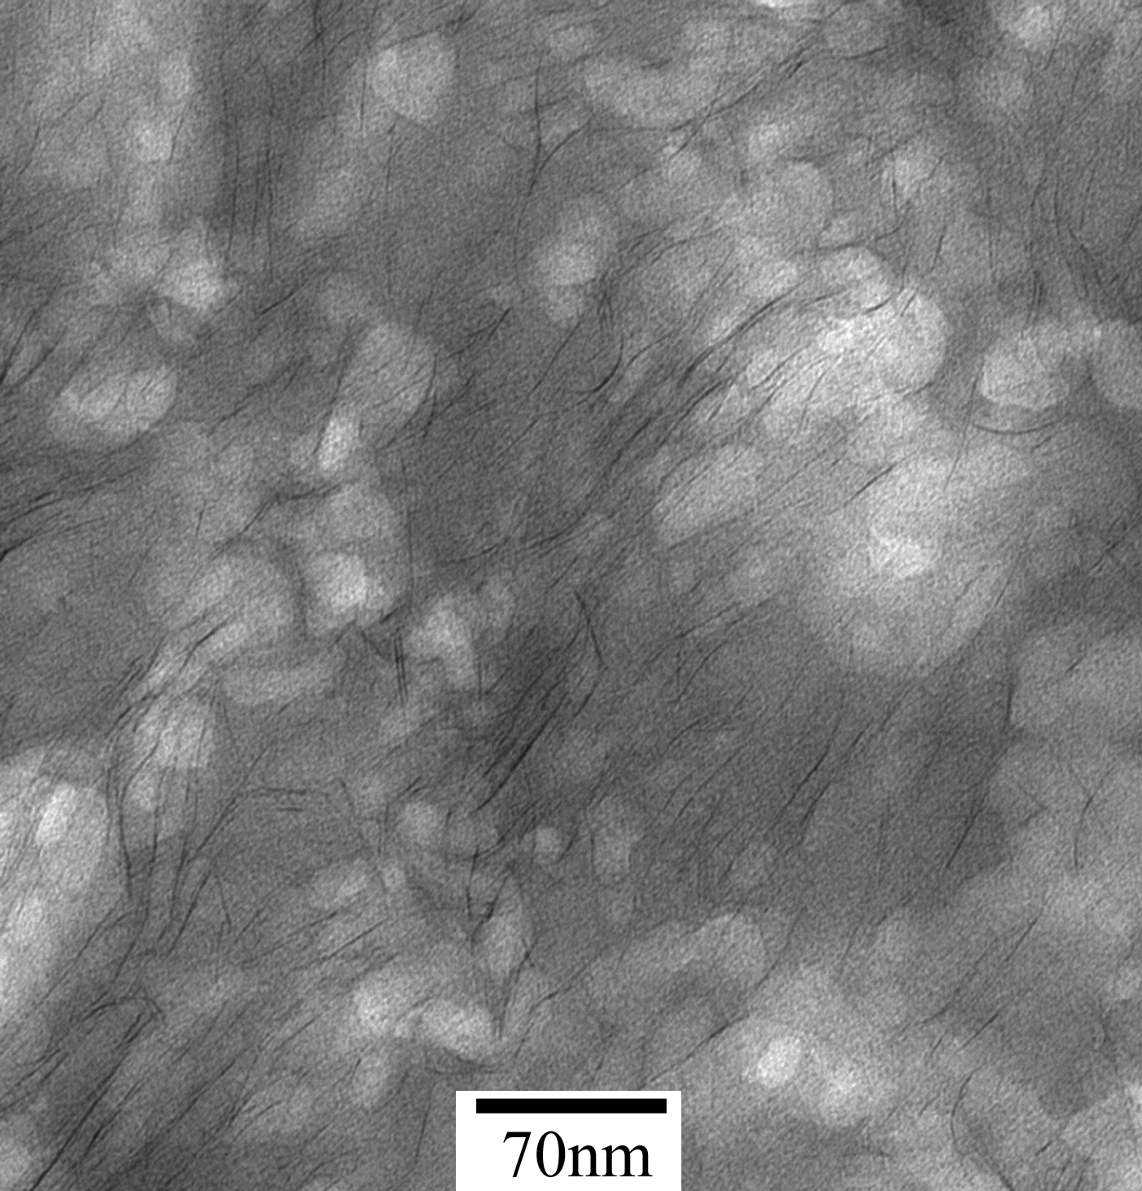

Figure 4. TEM micrograph of A0.3N20T10%.

Table 1. Molecular Weights of Polyacrylonitrile recovered from Nanocomposites

PAN from each  Nanocompostes | M_{n} | M_{w} | PDI  (M_{w} /M_{n})
A0.3N20T0% | 264196 | 528038 | 2.00
A0.3N20T5% | 183068 | 298448 | 1.63
A0.3N20T10% | 132654 | 209663 | 1.58
A0.3N20T20% | 80108 | 129856 | 1.62

