곤충 세포와 포유동물 세포 에이파토시스의 누에체액에 의한 저해 및 메커니즘

이원종, 박태현
서울대학교 공과대학 응용화학부

Inhibition of Apoptosis by Silkworm Hemolymph
and Its Mechanism in Insect and Mammalian Cells

Rhee, W. J. and Park, T. H.
School of Chemical Engineering, Seoul National University
서론
Apoptosis is a genetically programmed type of cell death mechanism and there exist some common pathways in apoptosis despite a wide range of inducing signals. Members of the caspase (cysteine aspartate proteases) family are involved in most types of this cell death mechanism. The caspases are synthesized as inactive proenzymes, and these enzymes are activated and processed into two subunits by self-proteolysis and cleavage by another caspases. These activated caspases finally degrade key structural and nuclear proteins, e.g., PARP (poly (ADP ribose) polymerase). Sf-caspase-1, which plays a principal role in apoptotic machinery of Sf9 cells, was identified in an insect cell system. This caspase belongs to group II-like effector caspase and is homologous with mammalian caspases such as caspase-7 and caspase-3. We have previously shown that silkworm hemolymph inhibits baculovirus-induced insect cell apoptosis (1-3) and has anti-apoptotic proteins such as 30K protein (4). To investigate the effects of silkworm hemolymph on apoptosis in insect and mammalian cells, various chemicals, such as actinomycin D, camptothecin, and staurosporine, were used in this study. Here we report that silkworm hemolymph is a potent inhibitor of apoptosis in these systems and works in a further upstream step than caspase-3 or –9 activation step.

본론
Effect of silkworm hemolymph on insect cell apoptosis
To investigate whether silkworm hemolymph has apoptosis-inhibiting components in itself or inhibits the apoptosis indirectly by increasing the expression level of anti-apoptotic viral genes such as p35, various chemical inducers were used for the induction of Sf9 cell apoptosis. The second possibility was suggested since the expression of some viral proteins, which were not detected before infection, were enhanced by the addition of silkworm hemolymph to the culture medium. If silkworm hemolymph inhibits the Sf9 cell apoptosis induced by chemical inducers as well as baculovirus, the second possibility will be eliminated. Three chemical inducers, such as actinomycin D, camptothecin, and staurosporine, were used in this study.
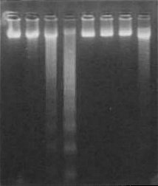
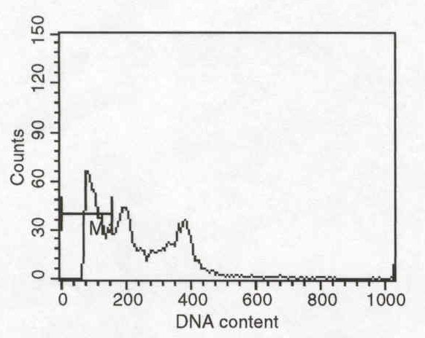
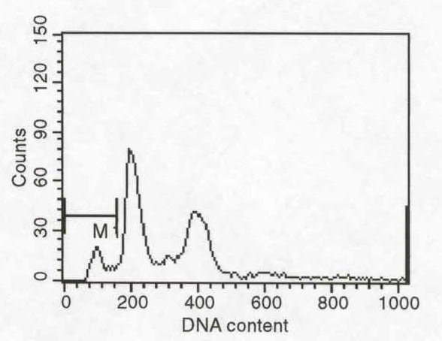
Cells were treated with 200 ng/mL of actinomycin D, which is a well-known inducer of apoptosis in many cell lines, including insect cells. DNA agarose gel electrophoresis and flow cytometric analysis were carried out to investigate the effect of silkworm hemolymph on apoptosis. As shown in Fig. 1(a), DNA fragmentation began to be observed 6 hours after the addition of actinomycin D, and it was clearly observed 9 hours after treatment, when cells were cultured in 10% FBS medium without silkworm hemolymph. In the medium supplemented with 5% FBS and 5% silkworm hemolymph, however, only slightly fragmented DNA was observed 13 hours after treatment. In flow cytometric analysis, the sub-G1 fraction, which is denoted by M1 in Fig. 1 (b) and (c), represents apoptotic bodies. The data shown in Fig. 1 (b) and (c) are results at 13 hours after treatment. The percentage of the sub-G1 area was about 35.7% in a 10% FBS medium, while it was about 8.5% in a 5% FBS/5% silkworm hemolymph medium. Cells have been treated with actinomycin D at several different concentrations, such as 100, 200 and 300 ng/mL, and similar effects of silkworm hemolymph were obtained in every case. Cells were also treated with camptothecin and staurosporine and the same anti-apoptotic activity of silkworm hemolymph were observed. As mentioned earlier, it was speculated that silkworm hemolymph might inhibit baculovirus-induced apoptosis by increasing anti-apoptotic viral gene expressions. However, all the above results show that silkworm hemolymph inhibits the Sf9 cell apoptosis induced by chemical inducers as well as baculovirus, indicating that silkworm hemolymph has anti-apoptotic components in itself, such as 30K protein, which we have previously purified.
(a)
10% FBS medium
5% FBS/5% SH medium
0
6
9
13
0
6
9
13
Time (h)
(b)
(c)

Fig. 1 Effect of silkworm hemolymph on actinomycin D-induced Sf9 cell apoptosis.
Actinomycin D, camptothecin, and staurosporine induce apoptosis in somewhat different ways but all of these mechanisms involve caspase-3 as a key executioner caspase in mammalian cells. Although the induction mechanism for apoptosis is not well understood in insect cell systems, there may exist analogous caspase cascade, such as Sf-caspase-1 activation, in the insect cell system. A tetrapeptide, Ac-DEVD-AMC, was used as a substrate to investigate whether the chemicals listed above induce Sf-caspase-1 activation and whether silkworm hemolymph inhibits this activation. Figure 2 shows that actinomycin D, camptothecin, and staurosporine all promoted Sf-caspase-1 activation and silkworm hemolymph inhibited this activation. These results indicate that silkworm hemolymph works as a direct or upstream inhibitor of Sf-caspase-1.
To determine whether silkworm hemolymph is a direct inhibitor of Sf-caspase-1, we added silkworm hemolymph to the apoptotic lysate of cells cultured in a 10% FBS medium and measured the in vitro activity of Sf-caspase-1. But the activity of Sf-caspase-1 was not decreased by silkworm hemolymph. This indicates that silkworm hemolymph is not a direct inhibitor of Sf-caspase-1 but rather an upstream inhibitor in a Sf-caspase cascade mechanism.
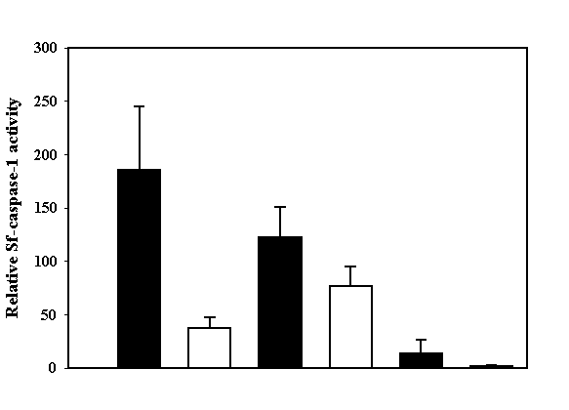
Actinomycin D
Camptothecin
Staurosporine
10% FBS medium
5% FBS/5% SH medium

Fig. 2 Effect of silkworm hemolymph on Sf-caspase-1 activities.

Effect of silkworm hemolymph on mammalian cell apoptosis
In mammalian cells such as HeLa, CHO, and Jurkat, staurosporine causes cytochrome c release from mitochondria followed by activation of caspase-9 and then caspase-9 activates caspase-3 sequentially. To determine where the silkworm hemolymph participates in this cascade reaction, caspase-3 and -9 enzymatic assay were accomplished. Figure 3 shows relative caspase-3 activities in each medium. Staurosporine promoted caspase-3 activation and as in the insect cell, silkworm hemolymph inhibited this activation. Activation of caspase-9 which activates caspase-3 was also inhibited by silkworm hemolymph (Figure 4). From these results, anti-apoptotic activity of silkworm hemolymph seems to lie on the upstream of caspase-9 activation.
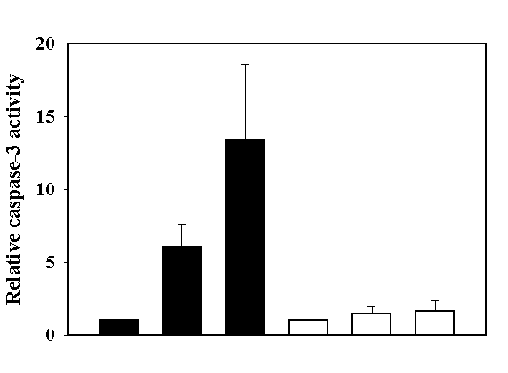
10% FBS medium
5% FBS/5% SH medium
0 hr
5 hr
10 hr
0 hr
5 hr
10 hr

Figure 3. Effect of silkworm hemolymph on caspase-3 activities.

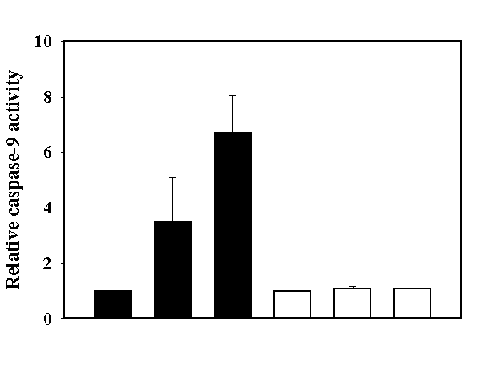
10% FBS medium
5% FBS/5% SH medium
0 hr
5 hr
10 hr
0 hr
5 hr
10 hr

Figure 4. Effect of silkworm hemolymph on caspase-9 activities.

결론
Silkworm hemolymph contains anti-apoptotic components which inhibits apoptosis induced by various chemicals such as actinomycin D, camptothecin, and staurosporine. These were accompanied by the inhibition of Sf-caspase-1 and caspase-3, -9 in insect and mammalian cells, respectively. Silkworm hemolymph is an inhibitor in upstream events in both insect and mammalian cells, and the biochemical and molecular mechanisms of silkworm hemolymph in the upstream apoptosis events require further investigation.
참고문헌
- Rhee, W. J., Kim, E. J., and Park, T. H. Biotechnol. Prog. 15, 1028-1032 (1999).
- Rhee, W. J. and Park, T. H. Biochem. Biophys. Res. Commun. 271, 186-190 (2000).
- Rhee, W. J. and Park, T. H. J. Microbiol. Biotechnol. 11, 853-857 (2001).
- Kim, E. J., Rhee, W. J., and Park, T. H. Biochem. Biophys. Res. Commun. 285, 224-228 (2001).
화학공학의 이론과 응용 제8권 제1호 2002년

