초임계 유체 용매를 포함한 플루오르 고분자 혼합물와의 열역학적
상거동 연구

신정수 유영호 변헌수
여수대학교 공과대학 화학공학과

Thermodynamic Phase Behavior of Fluoropolymers Mixtures with
Supercritical Fluid Solvents

Jung-Soo Shin, Y. H. Yoo, and Hun-Soo Byun
Department of Chemical Engineering, Yosu National University, Chonnam 550-749, S. Korea

Introduction
Supercritical fluid solvents have been used in polymer processes such as monomer polymerization[1], fractionation[2], extraction[3], swelling[4] and sustainable industries[5, 6]. Also, supercritical fluid solvents are an attractive alternative to incompressible organic liquid solvents, since they can have liquidlike dissolving power while exhibiting transport properties of a gas. Particularly, supercritical carbon dioxide has been touted as the solvent of choice for many industrial applications because it is nonhazardous, inexpensive, nonflammable, nontoxic, and readily available.
Fluoropolymers are useful for a wide range of applications since they possess a unique combination of chemical, mechanical, and electrical properties. Fluoropolymers solubility depends on the number of fluorinated side groups and on the molecular weight of the hydrocarbon main chain. Especially, poly(vinylidene fluoride) (PVDF) and poly(vinyl fluoride) (PVF) is an important polymer due to its chemical resistance, hard(good) mechanical properties and unique electrical properties[7,8]. In the reported research of related in this work, Lora et al.[9] recently reported on the solubility of poly(vinyl fluoride) and poly(vinylidene fluoride) in supercritical CH₂F₂ and CO₂ and in CO₂ with acetone, dimethyl ether, and ethanol. The experimental data of reported cloud-point are presented at temperature to 245 ºC and pressure to 2700 bar for the binary and ternary systems. Also, Mertdogan et al.[10,11] reported on the solubility of poly(tetrafluoroethylene-co-19 mol% hexafluoropropylene) in supercritical CO₂ and halogenated supercritical solvents, and cosolvency effect of SF₆ on the solubility of poly(tetrafluoroethylene -co-19 mol % hexafluoropropylene) in supercritical CO₂ and CHF₃.
In this work, high pressure phase behavior of fluoropolymers (PVDF: Mw = 180,000 and 275,000) in compressed liquid and supercritical CO2, CHF3, dimethyl ether and CHClF2, with CO2 in ethanol, propanol, butanol, pentanol, heptanol and octanol were measured at temperature 40 – 200 ºC and pressures as high as 2500 bar.
Also, the comparison of solubility curve are presented for PVF (Mw = 60,000, 80,000 and 120,000) in supercritical dimethyl ether and CHClF2.

Experimental section
The cloud-point curves for the fluoropolymer- supercritical low molecular weight hydrocarbon mixtures are determined at pressures up to 2,800 bar and temperatures to 250 ^{O}C. Figure 1 shows the schematic diagram of the experimental apparatus used for the fluoropolymer -SCF solvent phase behavior studies.
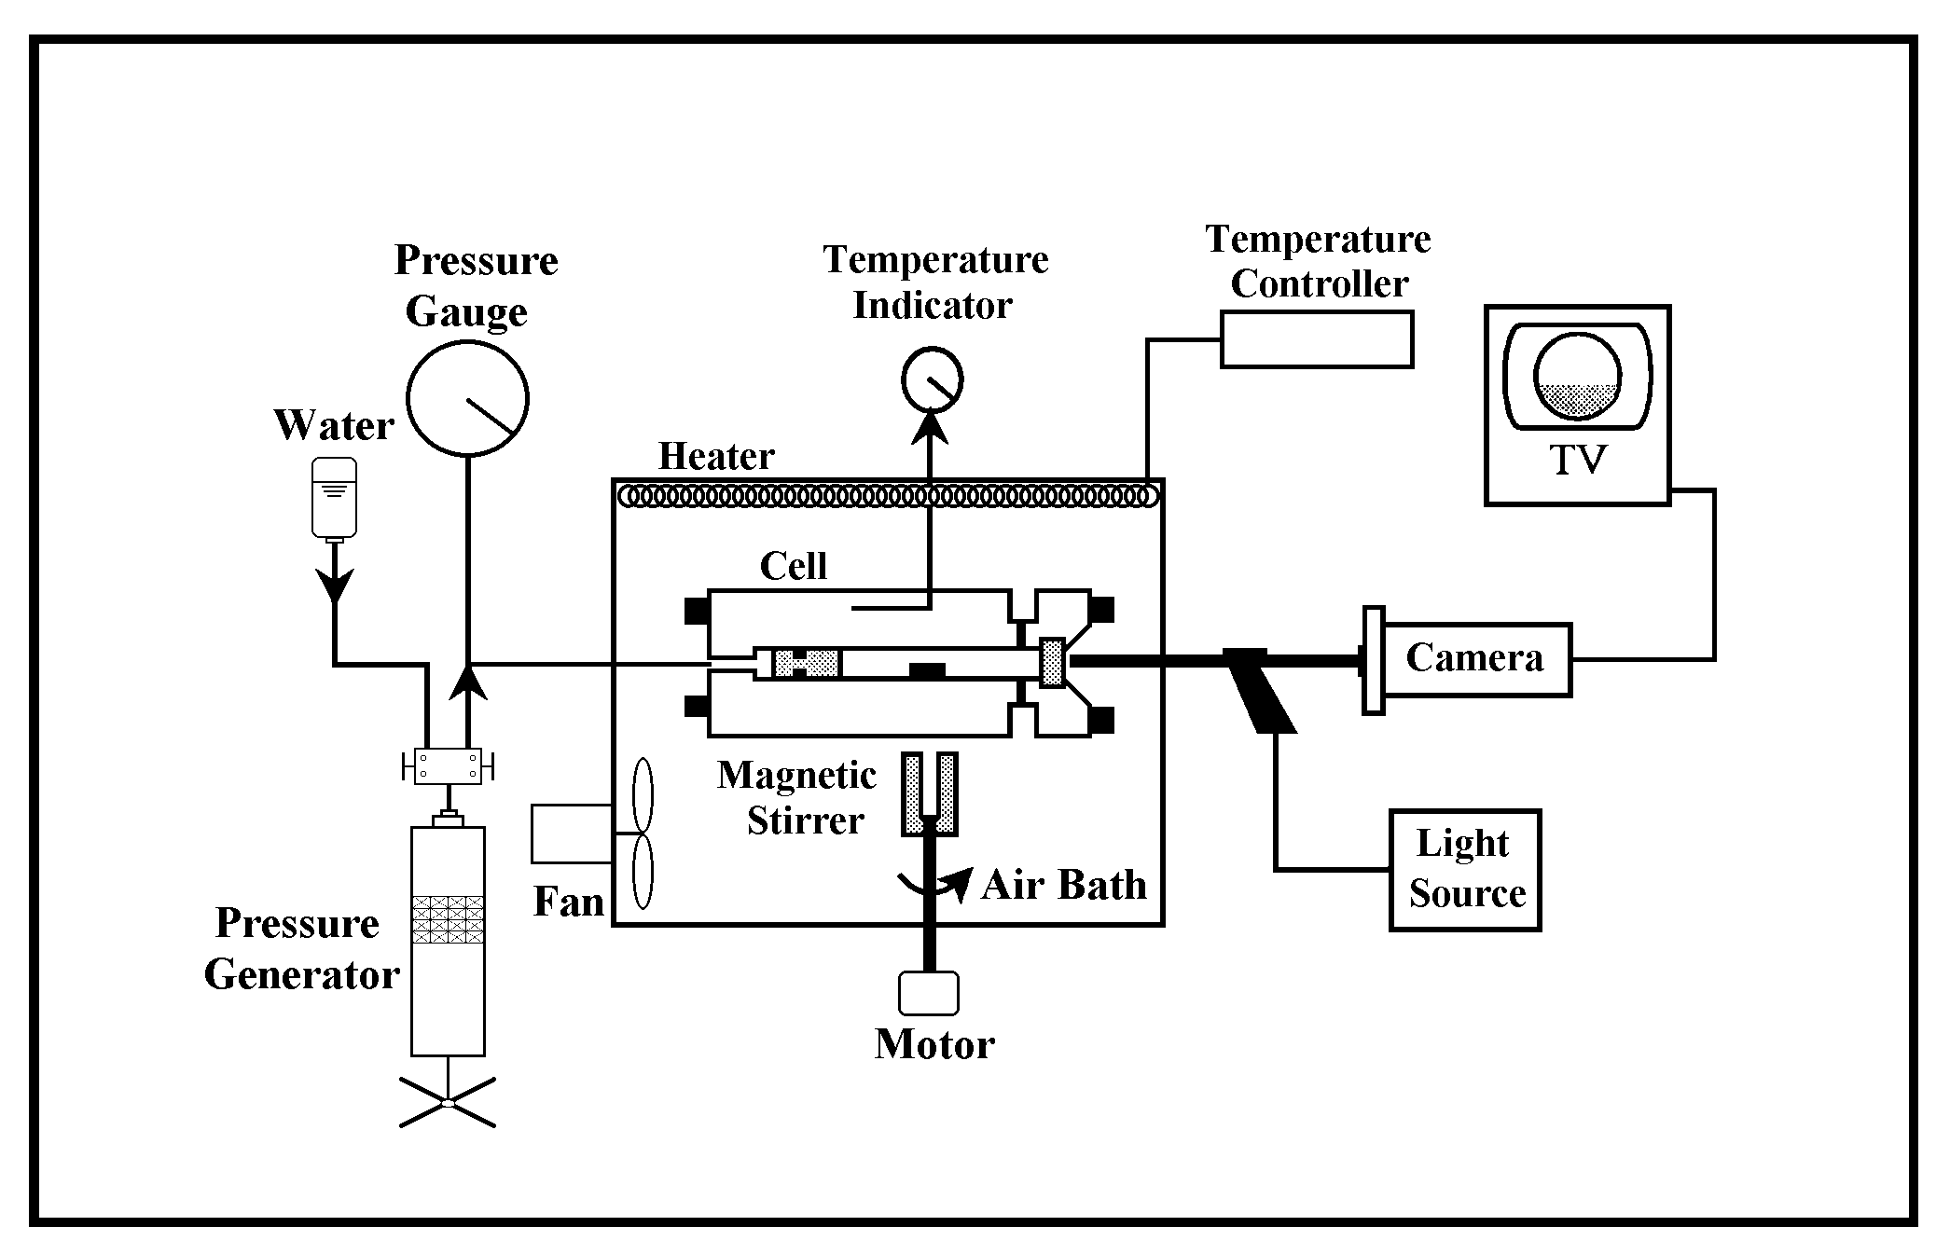
Experimental cloud-point data is obtained by using a high-pressure, variable- volume view cell. The variable-volume cell used to obtain the cloud-point curves is a static-type with a 1.59cm I.D., an O.D. of 7.0cm, and a working volume of ~28cm³. A 1.9cm thick sapphire
Figure 1. The experimental apparatus used for the this work
window is fitted in the front part of the cell to allow observation of the phases. Typically 0.500 ± 0.002 g of fluoropolymer are loaded into the cell which is subsequently purged at room temperature with the solvent of interest at 3 to 6 bar to remove any entrapped air and organic solvents. Generally, 7.0 to 10.0 ± 0.020 g of solvent are transferred into the cell gravimetrically using a high-pressure bomb. For the fluoropolymer – solvent - monomer systems, the liquid monomer is transferred into the cell to within ± 0.002 g using a syringe. The fluoropolymer mixture is compressed to the desired operating pressure by moving a piston located within the cell. The piston is moved using water pressurized by a high-pressure generator (HIP Inc., model 37-5.75-60). The pressure of the mixture is measured with a Heise gauge (Dresser Ind., model CM-108952, 0 to 3,450 bar, accurate to within ± 3.5 bar). The temperature of the cell is measured using a platinum-resistance thermometer (Thermometrics Corp., Class A) connected to a digital multimeter (Yokogawa, model 7563, accuracy to within ± 0.005%). The system temperature is typically maintained to within ± 0.2 ^{O}C below 200 ^{O}C, and ± 0.4 ^{O}C above 200 ^{O}C. The mixture inside the cell can be viewed on a video monitor using a camera coupled to a borescope (Olympus Corp., model F100-038-000-50) placed against the outside of the sapphire window. A fiberoptic cable connected to a high density illuminator (Dolan-Jenner Industries, Inc., model 180) and to the borescope is used to transmit light into the cell. The solution in the cell is well mixed using a magnetic stir bar activated by an external magnet beneath the cell.

Results and discussion
The impact of polymer backbone architecture on fluoropolymer solubility in supercritical fluid solvents is studied by systematically varying the chemical type of the repeat units in the main chain. A variable-volume view cell, capable of operating to high temperatures and high pressures, was designed and implemented to meet these extreme operating conditions. Cloud-point experimental data were presented at temperatures to 215 ºC and pressures at 2,500 bar for poly(vinyl fluoride) and poly(vinylidene fluoride) in CO₂, CHClF₂, and dimethyl ether, and with CO2 in ethanol, propanol, butanol, pentanol, heptanol and octanol. Poly(vinyl fluoride) does not dissolve in CO₂ even at 215 ºC and 2,500 bar, but poly(vinylidene fluoride) does dissolve in CHClF₂ at 185 ºC and pressures of 800 bar.
Figure 2 and Figure 3 shows the cloud-point behavior of the poly(vinylidene fluoride) [Mw = 180,000 and 275,000] – carbon dioxide, dimethyl ether, fluoroform and CHClF₂ systems initial reference for binary poly(vinylidene fluoride) [Mw = 180,000 and 275,000] - supercritical fluid solvents phase behavior. As shown in Figure 2 and Figure3, The carbon dioxide and fluoroform are a poor quality solvents for poly(vinylidene fluoride) because pressures in the range of 1500 bar are needed to obtain a single phase.
Figure 2. The phase behavior of poly(vinylidene fluoride) Figure 3. The experimental cloud-point data
[Mw=180,000]-solvents system poly(vinylidene fluoride)[Mw=275,000]- solvents system

Figure 4 shows the experimental cloud-point data of the ternary poly(vinylidene fluoride) – CHF₃ – CHClF₂ system. Also, CHClF₂ is used as a cosolvent to reduce the impact of dipolar CHF₃-CHF₃ interaction on the poly(vinylidene fluoride)-CHF₃ phase behavior. Figure 4 shows that CHClF2 has a dramatic impact on the location of the cloud-point curve. Cloud-point pressures drop from 1900 bar to 1700 bar at 200 ºC with the addition of 9 wt% CHClF₂.

The addition of 19 wt% CHClF2 further lowers the cloud-point pressures to about 1500 bar. The phase behavior curve of poly(vinylidene fluoride) – CHF₃ – 40 wt% CHClF₂ system is much closer to the binary poly(vinylidene fluoride) – CHClF₂ curve than to the poly(vinylidene fluoride) – CHF₃ behavior even though the solution is composed of a greater percent of CHF₃ than CHClF₂.

Figure 4. Effect of CHClF2 as a cosolvent for 5wt%
poly(vinylidene fluoride) in CHF₃ with the crystallization
boundary denoted by the dashed line.

Acknowledgements
This work was supported by Korea Research Foundation Grant (KRF-2002-041- D00105)

Reference
[1] DeSimone, J. M., Guan, Z., Elsbernd, C. S., Science, 257, 945-947(1992).
[2] Mertdogan, C. A., McHugh, M. A., Barth, H. G.,Walls, D. J., Tuminello, W. H.,
Int. J. Polymer Analysis & Characterization, 4, 231-246(1997)
[3] Chang, C. J., Chang, Y. F., Lee, H. Z., Lin, J. Q., Arai, Y., Ind. Eng. Chem. Res., 39, 4521-4525 (2000)
[4] Chun, S. W., Kim, J. D., Korean J. Chem. Eng., 19, 803-807(2002).
[5] Sarbu, T., Styranec, T. J., Beckman, E. J., Ind. Eng. Chem. Res., 39, 4678-4683 (2000)
[6] Perrut, M., Ind. Eng. Chem. Res., 39, 4531-4535(2000).
[7] Newman, B. A., Yoon, K. D., Pae, K. D., Scheinbeim, J. I., J. Appl. Phys., 50, 6095-6100 (1979).
[8] Hsu, C. C., Geil, P. H., J. Appl. Phys., 56, 2404-2411 (1984)
[9] Lora, M., Lim, J. S., McHugh, M. A., J. Phys, Chem. B, 103, 2818-2822 (1999)
[10] Mertdogan, C. A., Byun, H.-S., McHugh, M. A., Tuminello, W. H., Macromolecules, 29, 6548-6555(1996).
[11] Mertdogan, C. A., McHugh, M. A., Tuminello, W. H., J. Appl. Polym. Sci., 74, 2039-2045(1999)

