금속 기판에 자기조립된 단백질 응집체의 분리

이종범, 엄숭호, 최정우, 구기갑
서강대 화학공학과

Segregation of Self-assembled Protein Aggregates on Metal Substrates

Jong Bum Lee, Soong Ho Um, Jeong-Woo Choi, and Kee-Kahb Koo†
Department of Chemical Engineering, Sogang University, Seoul 121-742, Korea

Introduction

Currently, study on the fabrication of the artificial molecular devices based on organic molecules has been extensively made [1-7]. In particular, some model systems for the molecular photodiodes and the electronic diodes have been investigated, using redox proteins including cytocrome c, green fluorescent protein and bacteriorhodopsin [8-10]. The pattern formation of biomolecules in their model devices was made by a self-assembly technique and the current-voltage characteristics and the photo-switching effect of the proposed devices were successfully demonstrated. However, when proteins are adsorbed onto metal substrates, aggregation of proteins due to their nonspecific affinity is the most problematic, because those aggregates reduce the electronic efficiency of the devices [11,12] and thus this issue should be resolved for the long-term stability of the biomolecular devices.
Recently, we have found that ferredoxin can exist as monomers without change in inherent properties when the protein aggregates in solution or on solid surface are treated with a zwitterionic surfactant, CHAPS (3-[(3-cholamidopropyl)dimethylammonio]-1-propanesulfonate). In this paper, we report the fabrication method for the self-assembled ferredoxin monomolecular layer on metal substrates by eliminating the nonspecific adsorption of ferredoxin with CHAPS.

Experimental

Based on the results given above, ferredoxin aggregates on the gold substrate was treated with CHAPS (C/F=200). However, it was very difficult to distinguish between gold grain and protein molecules in the AFM image below 1μm × 1μm of the ferredoxin monolayer on the gold substrate. On the other hand, it has been known that better images of protein on a silicon wafer can be obtained [13] and thus in order to demonstrate indirectly the size of ferredoxin clusters self-assembled on gold substrate, the self-assembled ferredoxin monolayer on a silicon substrate was prepared with CHAPS treatment and the atomic force microscope (AFM) images of ferredoxin aggregates on the silicon substrates were obtained from Autoprobe CP (Park Scientific Instrument). To confirm directly the formation of the ferredoxin monolayer on gold substrate, the redox behavior of the ferredoxin was measured by a cyclic voltammetry system. In this experiments, a ferredoxin/EDC/MUA-modified gold plate, an Ag/AgCl electrode and a platinum electrode as a working electrode, a reference and a counter, respectively.

Results and discussion

Figure 1(A) shows the AFM image of a bare silicon wafer. Figure 1(B) is the image of ferredoxin aggregates on the silicon substrate of 1μm × 1μm pixel without treatment of the surfactant. It is shown that the size of ferredoxin aggregates is an order of 100 nm. Figure 1(C) is the AFM image of ferredoxin monolayer self-assembled on silicon wafer after CHAPS treatment. The size of ferredoxin clusters is clearly shown to be about 5-10 nm, indicating that the CHAPS can remove the nonspecifically adsorbed ferredoxin aggregates and the surface of the substrate is expected to be covered by chemically adsorbed ferredoxin molecules. Therefore, we expect that the morphology of ferredoxin monolayer on the gold substrate with CHAPS treatment would be similar with that shown in Figure 1(C).
Figure 2 shows cyclic voltammogram for a ferredoxin monolayer-coated gold surface in 100 mM Trizma buffer solution (pH = 7.5, 0.1 M KCl). Applied voltage in the present experiments was from -0.8 V to -0.3 V with a scan rate of 20 mV/s, considering that the standard electrode potential of ferredoxin was -0.441 eV [14]. When the potential went over the energy state of the redox protein, reduction potential at -0.59 V was generated between redox molecule and gold electrode, and when the voltage reversed, the oxidation potential at -0.4 V was asymmetrically obtained. However, no characteristic peak was observed in the control experiments from the bare gold electrode or free ferredoxin molecules in buffer solution.
This result clearly demonstrates that there exists the difference between oxidation and reduction potentials and also indicates that large potential at the gold electrode needs to overcome this band gap, because the gold electrode does not oxidize readily. In addition, there was no difference in the cyclic voltammograms obtained from the electrodes with ferredoxin monolayer and with the ferredoxin aggregates. From this result, it is known that CHAPS treatment does not affect the electronic property of ferredoxin molecule.

Conclusions

It was shown that segregation of protein aggregates nonspecifically adsorbed on the metal substrates with CHAPS treatment is possible by providing a high-resolution AFM image of the self-assembled monolayer with 5-10 nm sized ferredoxin molecules on the (100) surface of the silicon substrate. The electric property of ferredoxin monolayer self-assembled on the gold surface with CHAPS treatment was also shown to remain intact by the cyclic voltammetry measurements. Those results demonstrate a new way for the fabrication of a self-assembled protein monomolecular layer using a surfactant without degradation of the inherent properties of a protein. Experiments on the segregation phenomenon of redox proteins with various surfactants are underway for the fabrication of a biomolecular device with diverse protein monomers.

Acknowledgement
This work was supported by Korea Research Foundation Grant (KRF-2002-005-D00003).

References
1. A. Bachtold, P. Hadley, T. Nakanishi, and C. Dekker, Science, 294, 1317 (2001).
2. D. Gittins, D. Bethell, D. J. Schiffrin, and R. Nichols, Nature, 408, 67 (2000).
3. R. Dagani, Chemical & Engineering News, 42, 27 (2000).
4. E. P. Friis, J. E. T. Andersen, Y. I. Kharkats, A. M. Kuznetsov, R. J. Nichols, J. D. Zhang and J. Ulstrup, Proc. Natl. Acad. Sci. USA., 96, 1379 (1999).
5. C. Joachim, J. K. Gimzewski, and A. Aviram, Nature, 408, 541 (2000).
6. D. L. Klein, R. Roth, A. K. L. Lim, A. P. Alivisatos, and P. L. McEuen, Nature, 389, 699 (1997).
7. J. Chen, M. A. Reed, A. M. Rawlett and J. M. Tour, Science, 286, 1550 (1999).
8. J. W. Choi, Y. S. Nam, S. J. Park, W. H. Lee, D. H. Kim, and M. Fujihira, Biosensors and Bioelectronics, 16, 819 (2001).
9. J. W. Choi, S. J. Park, Y. S. Nam, W. H. Lee and M. Fujihira, Colloids and Surfaces B: Biointerfaces, 23, 295 (2002).
10. J. W. Choi, Y. S. Nam, B. S. Kong, H. G. Choi, W. H. Lee and M. Fujihira, Colloids and Surfaces B: Biointerfaces, 23, 263 (2002).
11. A. Baszkin and W. Norde, Physical Chemistry of Biological Interfaces, 1st Edn., p. 49, Marcel
Dekker, New York (2000).
12. D. Bollag, M. D. Rozycki, and S. J. Eedelstein, Protein Methods, p. 1,Willey-Liss, New York (1996).
13. L. M. Demers, D.S. Ginger, S.J. Park, Z. Li, S.M. Chung, and C.A. Mirkin ,Science, 296, 1836 (2002).
14. M. A. B. Christopher and O.B. Maria, Electrochemistry: Principle, Methods, and Applications, 1st
Edn., p 367, Oxford University Press, Oxford (1994).

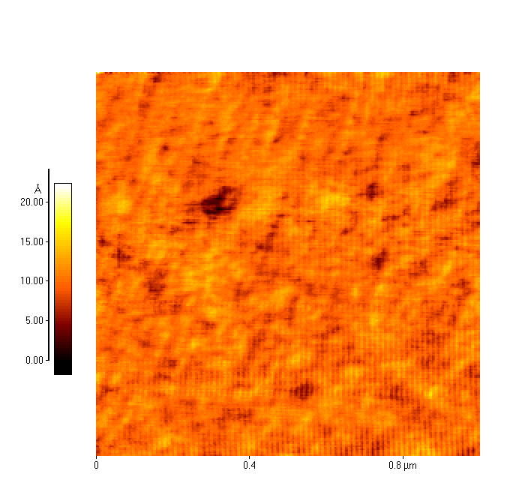
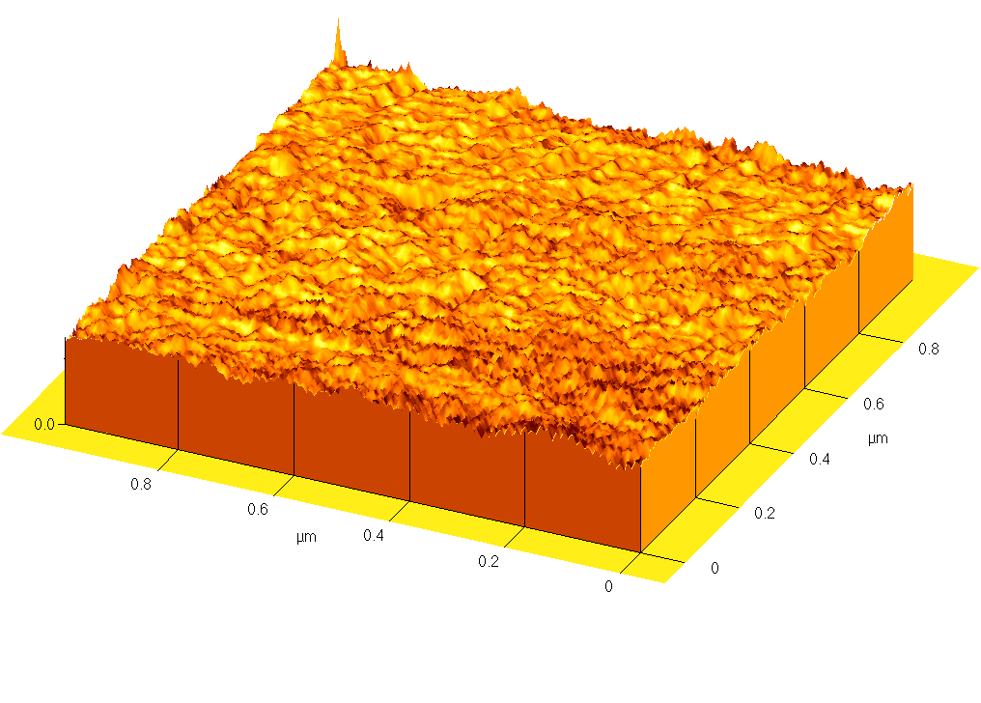
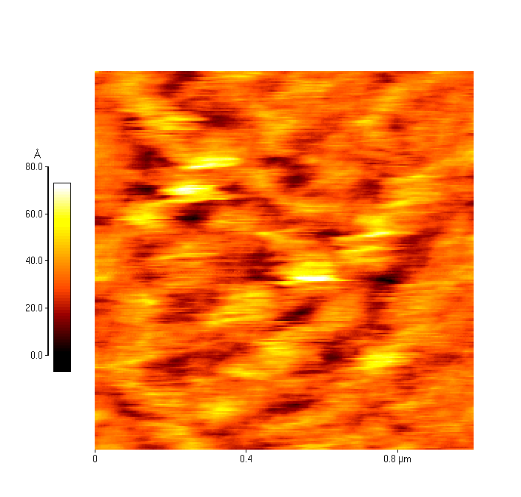
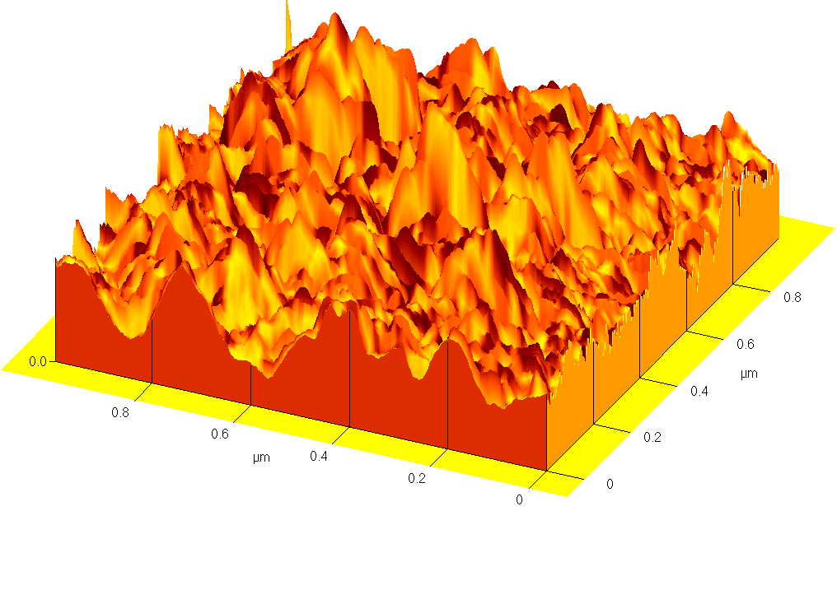
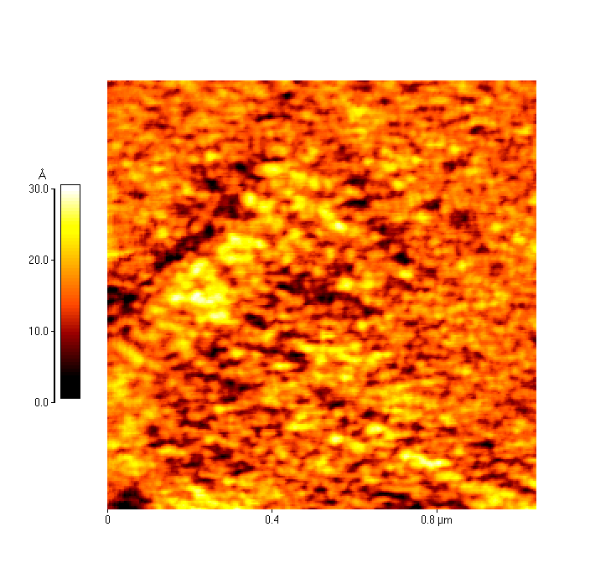
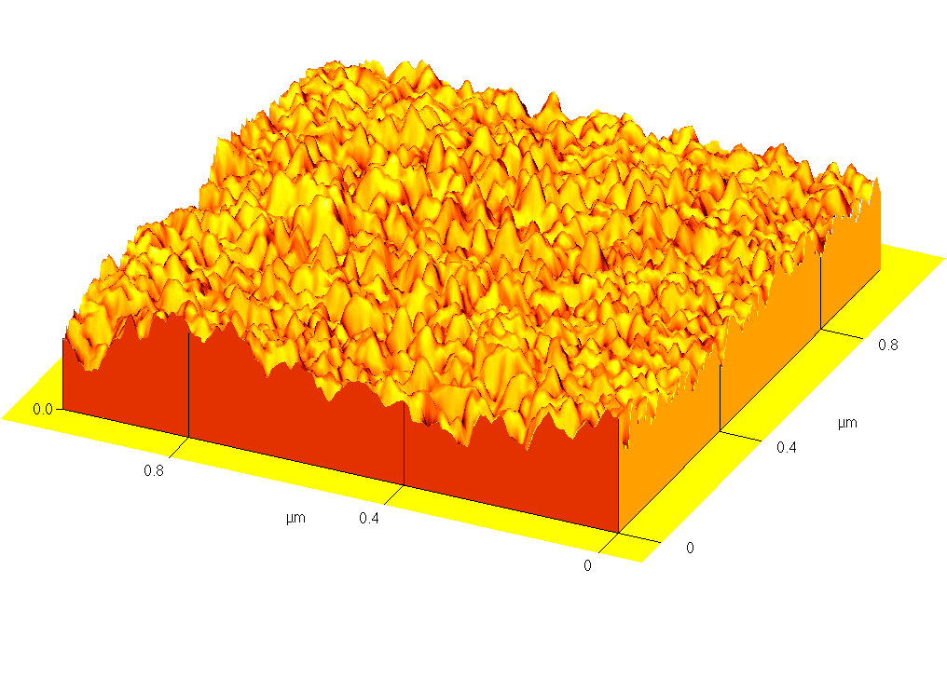
AE
BE
CE

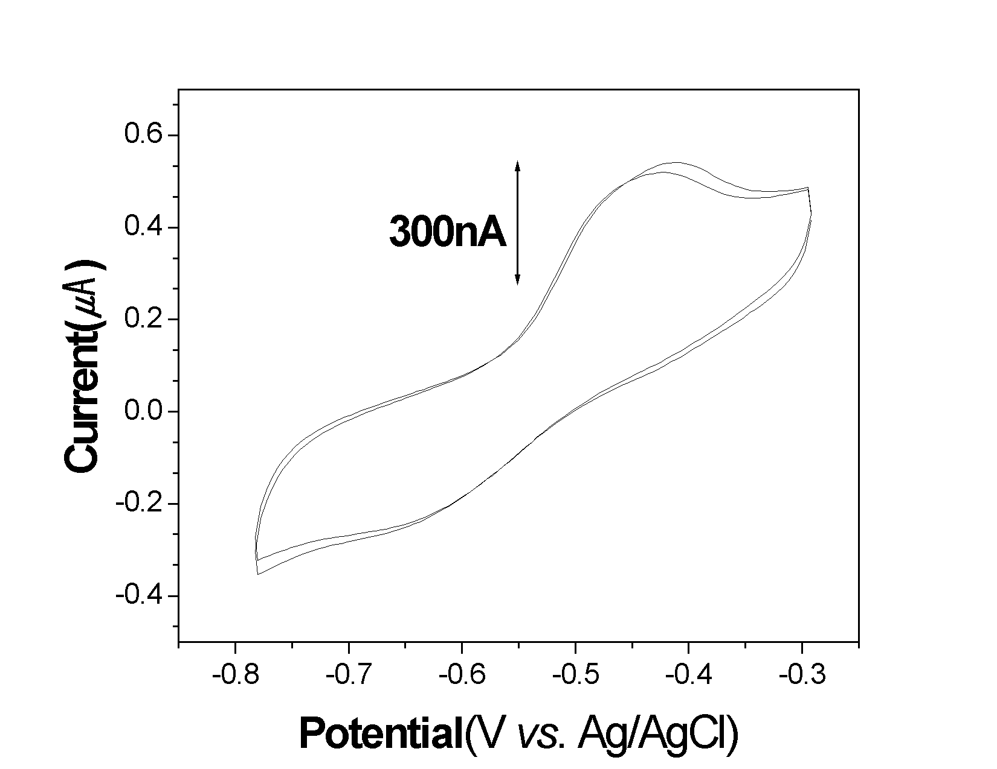
Figure 1. AFM images of the silicon wafer surface (A); modified with ferredoxin aggregates (B); coated with ferredoxin monomer after treated with CHAPS (C).

Figure 2. Cyclic voltammograms of ferredoxin monolayer-modified gold electrode in 100 mM Tris-HCl buffer solution with pH 7.5 after treated with CHAPS.

